11S3112 | Pengujian dan Penjaminan Mutu Perangkat Lunak

Laporan Proyek

Pengujian Aplikasi Web StockUnlimited

Oleh

|  |  |  |  |  |  |
| --- | --- | --- | --- | --- | --- |
| NIM / Nama | : | 1. | 11S17011 | / | Triska P.U. Pangaribuan |
|  |  | 2. | 11S17041 | / | Joshua A. Sinaga |
| Nomor Kelompok | : | StockUnlimited | | | |
| Program Studi | : | S1 - Informatika | | | |
| Dosen Pengampu | : | [Dr. Arlinta Christy Barus, ST., M.InfoTech](https://cis.del.ac.id/hrdx/dosen/view?q=CeKNhDNatkjK5_pcWpKSkOTr8ij6NgF-f7A2b99ECfU) | | | |
| Asisten Dosen | : | 1. | [Apria Theovani Nainggolan, S.Kom](https://cis.del.ac.id/hrdx/staf/view?q=yLvSkhmQkkj_5hBctek96_1gL6QFFc-siOi6WT_mI-c) | | |
|  |  | 2. | [Romasi Gohana Sibarani, S.Kom](https://cis.del.ac.id/hrdx/staf/view?q=xrZeF5gwEvsSbm2KaxAIvlf-JiWlZR3Jlfd05JjkHUo) | | |



Fakultas Informatika dan Teknik Elektro

Institut Teknologi Del

T.A. 2019/2020

# **Pendahuluan**

## BDD

BDD adalah singkatan dari Behavior Driven Development, yang merupakan penyempurnaan dari TDD (Test Driven Development), dimana test yang dilakukan tidak hanya dimengerti oleh programmer, melainkan sudah menggunakan natural language ( mudah dimengerti oleh customer, developer, dan QAs).

Test case yang digunakan yaitu Given – When – Then (GWT).

Supporting Tool : Cucumber

(Dan dalam hal ini kami melakukan pengujian terhadap aplikasi StockUnlimited)

## ATDD

ATDD (Acceptance Test-Driven Development) merupakan metodologi pengujian yang melibatkan stake-holders seperti customer, developer, dan tester dalam proses pengujian aplikasi. ATDD melengkapi team dengan sebuah pandangan yang lebih jelas tentang bagaimana end-productakan bekerja, dan memperkenankan setiap orang untuk saling berkolaborasi dalam menentukan kualitas dari perangkat lunak yang sedang dikembangkan. Melalui metodologi ini, stake-holdersdiharapkan memahami seluruh proses pengujian. Untuk melakukan test driven dibutuhkan toolsyang mendukun, seperti Robot Framework.

Siklus ATDD dapat dilihat pada gambar berikut.

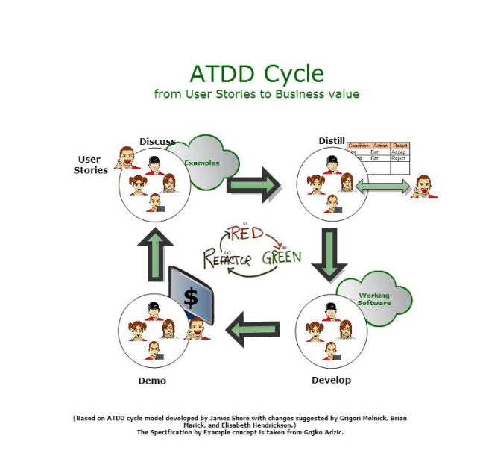

NOTE

Karena kelompok kami melakukan change password, menyebabkan test automasi yang dilakukan dengan password yang lama hanya dapat sekali automasi. Dan test automasi setelah change password (seperti button) telah ter automasi dengan password yang baru (hasil change password yang telah dilakukan).

## **Category Partition**

### Fungsi Login

* Categories and Choices

|  |  |  |
| --- | --- | --- |
| Username | Email | Valid |
|  | Invalid |

|  |  |
| --- | --- |
| Password | Valid |
| Invalid |

* Constraints

*Tidak ada.*

* Test Frame

| **No** | **Username** | **Password** |
| --- | --- | --- |
| 1 | Email Valid | Password Valid |
| 2 | Email Valid | Password Invalid |
| 3 | Email Invalid | Password Valid |
| 4 | Email Invalid | Password Invalid |

* Test Cases yang mengacu kepada Test Frame

| **No** | **Username** | **Password** |
| --- | --- | --- |
| 1 | trispangrib@gmail.com | Pangaribuan99 |
| 2 | trispangrib @gmail.com | ABCDA |
| 3 | [trisp@gmail.com](mailto:trisp@gmail.com) | Pangaribuan99 |
| 4 | [trisp@gmail.com](mailto:trisp@gmail.com) | ABCDA |

### 1.3.2 Fungsi Searching (Vectors)

* Categories and Choices

|  |  |  |
| --- | --- | --- |
| Searching | Vectors | Valid |
|  | Invalid |

* Constraints

*Tidak ada.*

* Test Frame

| **No** | **Searching** |
| --- | --- |
| 1 | Vectors Valid |
| 2 | Vectors Invalid |

* Test Cases yang mengacu kepada Test Frame

| **No** | **Searching** |
| --- | --- |
| 1 | workbook |
| 2 | forte |

### 1.3.3 Fungsi Searching (Audio)

* Categories and Choices

|  |  |  |
| --- | --- | --- |
| Searching | Audio | Valid |
|  | Invalid |

* Constraints

*Tidak ada.*

* Test Frame

| **No** | **Searching** |
| --- | --- |
| 1 | Audio Valid |
| 2 | Audio Invalid |

* Test Cases yang mengacu kepada Test Frame

| **No** | **Searching** |
| --- | --- |
| 1 | ariana music |
| 2 | ariana grande |

### 1.3.4 Fungsi Searching (Fonts)

* Categories and Choices

|  |  |  |
| --- | --- | --- |
| Searching | Fonts | Valid |
|  | Invalid |

* Constraints

*Tidak ada.*

* Test Frame

| **No** | **Searching** |
| --- | --- |
| 1 | Fonts Valid |
| 2 | Fonts Invalid |

* Test Cases yang mengacu kepada Test Frame

| **No** | **Searching** |
| --- | --- |
| 1 | sans serif |
| 2 | Times New |

NOTE

Karena kelompok kami melakukan change password, menyebabkan test automasi yang dilakukan dengan password yang lama hanya dapat sekali automasi. Dan test automasi setelah change password (seperti button) telah ter automasi dengan password yang baru (hasil change password yang telah dilakukan).

### 1.3.5 Fungsi Security

* Categories and Choices

|  |  |  |
| --- | --- | --- |
|  | Old Password | Valid |
|  | Invalid |
| Security | New | Valid |
|  | Password | Invalid |
|  | Confirm | Valid |
|  | Password | Invalid |

* Constraints

*Tidak ada.*

* Test Frame

|  |  |  |  |
| --- | --- | --- | --- |
| **No.** | **Old Password** | **New Password** | **Confirm Password** |
| 1 | Password Valid | Password Valid | Password Valid |
| 2 | Password Valid | Password Invalid | Password Invalid |
| 3 | Password Valid | Password Valid | Password Invalid |
| 4 | Password Invalid | Password Invalid | Password Invalid |
| 5 | Password Valid | Password Invalid | Password Valid |
| 6 | Password Invalid | Password Valid | Password Valid |
| 7 | Password Invalid | Password Invalid | Password Valid |
| 8 | Password Invalid | Password Valid | Password Invalid |

* Test Cases yang mengacu kepada Test Frame

|  |  |  |  |
| --- | --- | --- | --- |
| **No.** | **Old Password** | **New Password** | **Confirm Password** |
| 1 | Pangaribuan99 | Triska4499 | Triska4499 |
| 2 | Triska4499 | Tri | Tri |
| 3 | Triska4499 | Pangaribuan99 | Tri |
| 4 | Password Invalid | Tri | Tri |
| 5 | Triska4499 | - | Pangaribuan99 |
| 6 | jika | Pangaribuan99 | Pangaribuan99 |
| 7 | jika | - | Pangaribuan99 |
| 8 | - | Pangaribuan99 | - |

### 1.3.6 Fungsi FIND OUT MORE

* Categories and Choices

FIND OUT MORE

* Constraints

*Tidak ada.*

* Test Frame

|  |  |
| --- | --- |
| No. | FIND OUT MORE |
| 1. | Button FIND OUT MORE valid |

* Test Cases yang mengacu kepada Test Frame

|  |  |
| --- | --- |
| No. | FIND OUT MORE |
| 1. | Click FIND OUT MORE button |

### 1.3.7 Fungsi New Images

* Categories and Choices

New Images

* Constraints

*Tidak ada.*

* Test Frame

|  |  |
| --- | --- |
| No. | New Images |
| 1. | Button New Images valid |

* Test Cases yang mengacu kepada Test Frame

|  |  |
| --- | --- |
| No. | New Images |
| 1. | New Images valid |

### 1.3.8 Fungsi SEE PLANS & PRICING

* Categories and Choices

SEE PLANS & PRICING

* Constraints

*Tidak ada.*

* Test Frame

|  |  |
| --- | --- |
| No. | SEE PLANS & PRICING |
| 1. | Button SEE PLANS & PRICING valid |

* Test Cases yang mengacu kepada Test Frame

|  |  |
| --- | --- |
| No. | SEE PLANS & PRICING |
| 1. | Click SEE PLANS & PRICING button |

### 1.3.9 Fungsi My Account

* Categories and Choices

My Account

* Constraints

*Tidak ada.*

* Test Frame

|  |  |
| --- | --- |
| No. | My Account |
| 1. | Button My Account valid |

* Test Cases yang mengacu kepada Test Frame

|  |  |
| --- | --- |
| No. | My Account |
| 1. | Click My Account button |

### 1.3.10 Fungsi Favorites

* Categories and Choices

Favorites

* Constraints

*Tidak ada.*

* Test Frame

|  |  |
| --- | --- |
| No. | Favorites |
| 1. | Button Favorites valid |

* Test Cases yang mengacu kepada Test Frame

|  |  |
| --- | --- |
| No. | Favorites |
| 1. | Click Favorites button |

# **Implementasi Pengujian**

## **Pembentukan Test Cases**

Uraikan pembentukan test case untuk setiap fungsi mengikuti tahapan yang telah dijelaskan sebelumnya.

### Fungsi Login

* Categories and Choices

|  |  |  |
| --- | --- | --- |
| Username | Email | Valid |
|  | Invalid |

|  |  |
| --- | --- |
| Password | Valid |
| Invalid |

* Constraints

*Tidak ada.*

* Test Frame

| **No** | **Username** | **Password** |
| --- | --- | --- |
| 1 | Email Valid | Password Valid |
| 2 | Email Valid | Password Invalid |
| 3 | Email Invalid | Password Valid |
| 4 | Email Invalid | Password Invalid |

* Test Cases yang mengacu kepada Test Frame

| **No** | **Username** | **Password** |
| --- | --- | --- |
| 1 | trispangrib@gmail.com | Pangaribuan99 |
| 2 | trispangrib @gmail.com | ABCDA |
| 3 | trisp@gmail.com | Pangaribuan99 |
| 4 | trisp@gmail.com | ABCDA |

### Fungsi Searching (Vectors)

* Categories and Choices

|  |  |  |
| --- | --- | --- |
| Searching | Vectors | Valid |
|  | Invalid |

* Constraints

*Tidak ada.*

* Test Frame

| **No** | **Searching** |
| --- | --- |
| 1 | Vectors Valid |
| 2 | Vectors Invalid |

* Test Cases yang mengacu kepada Test Frame

| **No** | **Searching** |
| --- | --- |
| 1 | workbook |
| 2 | forte |

### Fungsi Searching (Audio)

* Categories and Choices

|  |  |  |
| --- | --- | --- |
| Searching | Audio | Valid |
|  | Invalid |

* Constraints

*Tidak ada.*

* Test Frame

| **No** | **Searching** |
| --- | --- |
| 1 | Audio Valid |
| 2 | Audio Invalid |

* Test Cases yang mengacu kepada Test Frame

| **No** | **Searching** |
| --- | --- |
| 1 | ariana music |
| 2 | ariana grande |

### Fungsi Searching (Fonts)

* Categories and Choices

|  |  |  |
| --- | --- | --- |
| Searching | Fonts | Valid |
|  | Invalid |

* Constraints

*Tidak ada.*

* Test Frame

| **No** | **Searching** |
| --- | --- |
| 1 | Fonts Valid |
| 2 | Fonts Invalid |

1. Test Cases yang mengacu kepada Test Frame

| **No** | **Searching** |
| --- | --- |
| 1 | sans serif |
| 2 | Times New |

### Fungsi Security

NOTE

Karena kelompok kami melakukan change password, menyebabkan test automasi yang dilakukan dengan password yang lama hanya dapat sekali automasi. Dan test automasi setelah change password (seperti button) telah ter automasi dengan password yang baru (hasil change password yang telah dilakukan).

* Categories and Choices

|  |  |  |
| --- | --- | --- |
|  | Old Password | Valid |
|  | Invalid |
| Security | New | Valid |
|  | Password | Invalid |
|  | Confirm | Valid |
|  | Password | Invalid |

* Constraints

*Tidak ada.*

* Test Frame

|  |  |  |  |
| --- | --- | --- | --- |
| **No.** | **Old Password** | **New Password** | **Confirm Password** |
| 1 | Password Valid | Password Valid | Password Valid |
| 2 | Password Valid | Password Invalid | Password Invalid |
| 3 | Password Valid | Password Valid | Password Invalid |
| 4 | Password Invalid | Password Invalid | Password Invalid |
| 5 | Password Valid | Password Invalid | Password Valid |
| 6 | Password Invalid | Password Valid | Password Valid |
| 7 | Password Invalid | Password Invalid | Password Valid |
| 8 | Password Invalid | Password Valid | Password Invalid |
| 9 | [BLANKED] | [BLANKED] | [BLANKED] |

* Test Cases yang mengacu kepada Test Frame

|  |  |  |  |
| --- | --- | --- | --- |
| **No.** | **Old Password** | **New Password** | **Confirm Password** |
| 1 | Pangaribuan99 | Triska4499 | Triska4499 |
| 2 | Triska4499 | Tri | Tri |
| 3 | Triska4499 | Pangaribuan99 | Tri |
| 4 | Password Invalid | Tri | Tri |
| 5 | Triska4499 | - | Pangaribuan99 |
| 6 | jika | Pangaribuan99 | Pangaribuan99 |
| 7 | jika | - | Pangaribuan99 |
| 8 | - | Pangaribuan99 | - |
| 9 | - | - | - |

### Fungsi Find Out More

* Categories and Choices

FIND OUT MORE

* Constraints

*Tidak ada.*

* Test Frame

|  |  |
| --- | --- |
| No. | FIND OUT MORE |
| 1. | Button FIND OUT MORE  valid |

* Test Cases yang mengacu kepada Test Frame

|  |  |
| --- | --- |
| No. | FIND OUT MORE |
| 1. | Click FIND OUT MORE button |

### Fungsi New Images

* Categories and Choices

New Images

* Constraints

*Tidak ada.*

* Test Frame

|  |  |
| --- | --- |
| No. | New Images |
| 1. | Button New Images valid |

* Test Cases yang mengacu kepada Test Frame

|  |  |
| --- | --- |
| No. | New Images |
| 1. | Click New Images button |

### Fungsi SEE PLANS & PRICING

* Categories and Choices

SEE PLANS & PRICING

* Constraints

*Tidak ada.*

* Test Frame

|  |  |
| --- | --- |
| No. | SEE PLANS & PRICING |
| 1. | Button SEE PLANS & PRICING valid |

* Test Cases yang mengacu kepada Test Frame

|  |  |
| --- | --- |
| No. | SEE PLANS & PRICING |
| 1. | Click SEE PLANS & PRICING button |

### Fungsi My Account

* Categories and Choices

My Account

* Constraints

*Tidak ada.*

* Test Frame

|  |  |
| --- | --- |
| No. | My Account |
| 1. | Button My Account valid |

* Test Cases yang mengacu kepada Test Frame

|  |  |
| --- | --- |
| No. | My Account |
| 1. | Click My Account button |

### Fungsi Favorites

* Categories and Choices

Favorites

* Constraints

*Tidak ada.*

* Test Frame

|  |  |
| --- | --- |
| No. | Favorites |
| 1. | Button Favorites valid |

* Test Cases yang mengacu kepada Test Frame

|  |  |
| --- | --- |
| No. | Favorites |
| 1. | Click Favorites button |

## **Pengujian Menggunakan Cucumber**

### Fungsi Login

1. Test Case 1 (Email Valid, Password Valid)

* Scenario

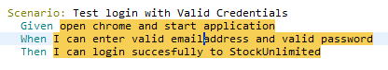

* Step Definition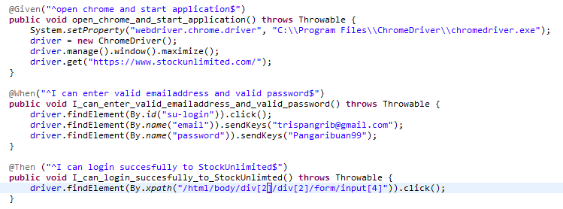
* Test Runner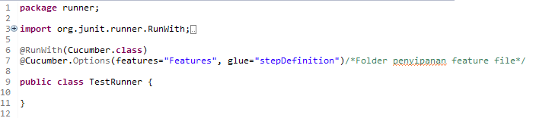
* Console setelah Running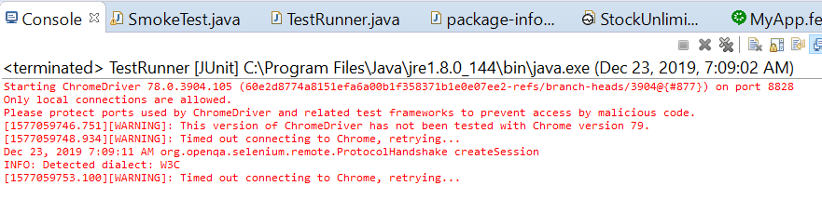
* Snippet Browser saat Testing

Dashboard sebelum login:

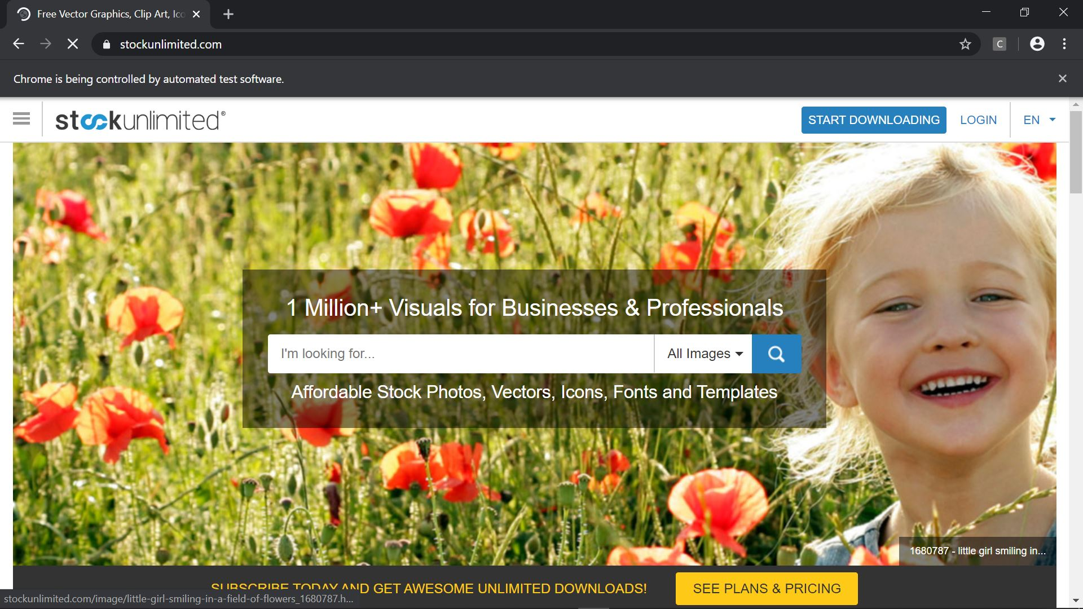

Form Login

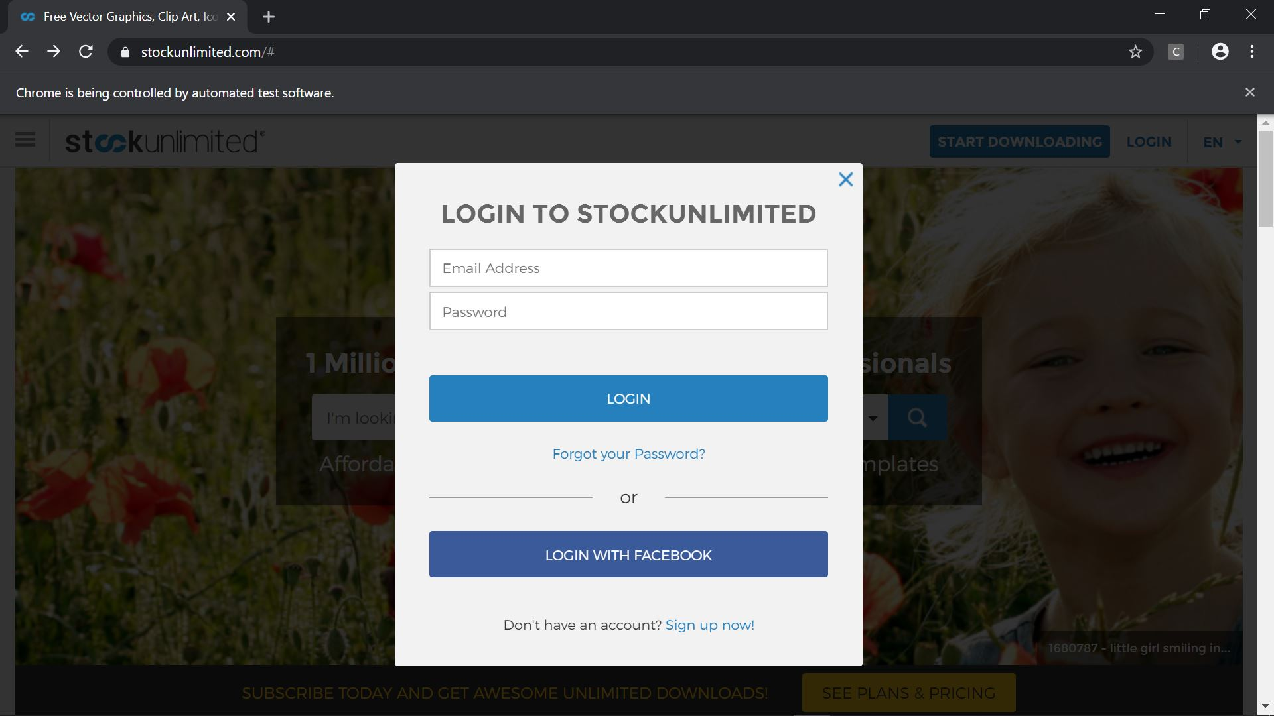

Email dan password sudah diisi

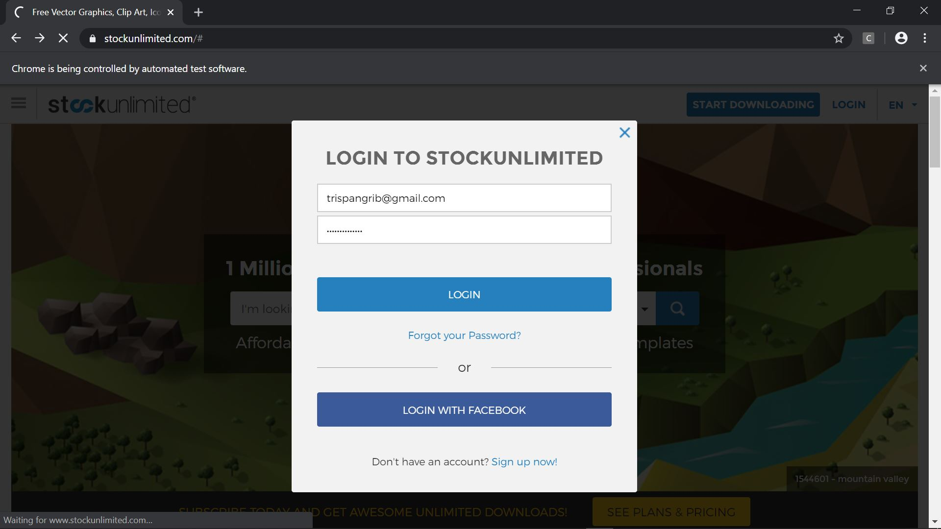

Hasil setelah email dan password dimasukkan (valid)

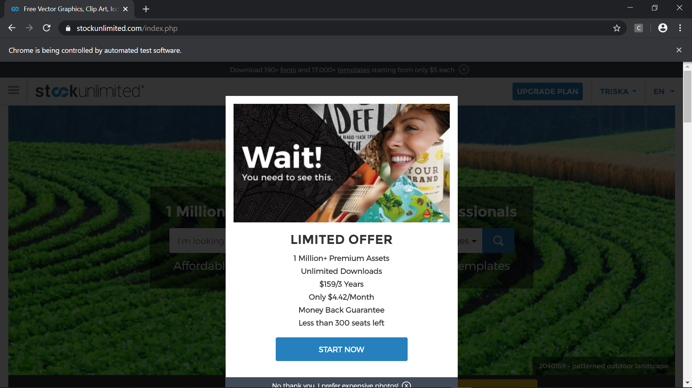

1. Test Case 2 (Email Valid, Password Invalid)

* Scenario



* Step Definition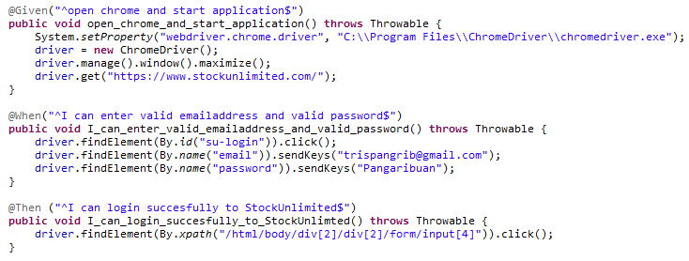
* Test Runner
* Console setelah Running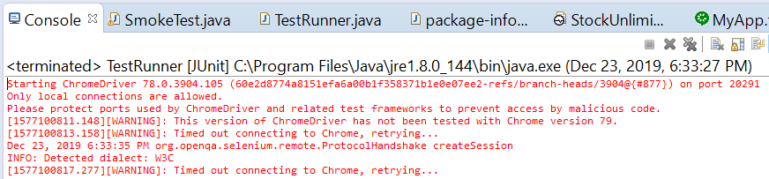

Snippet Browser saat Testing Dashboard sebelum login:

Dashboard sebelum Login

Form Login



Email dan password sudah diisi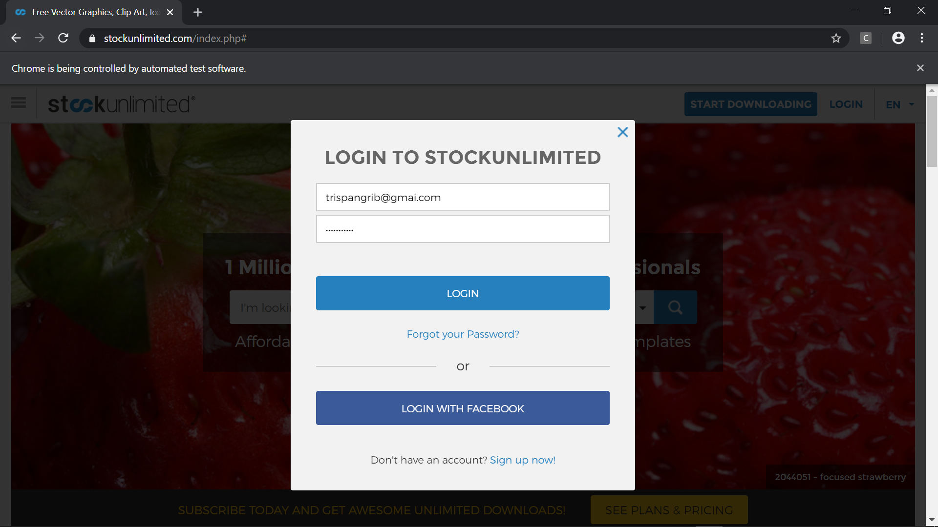

Hasil setelah email dan password dimasukan (invalid)

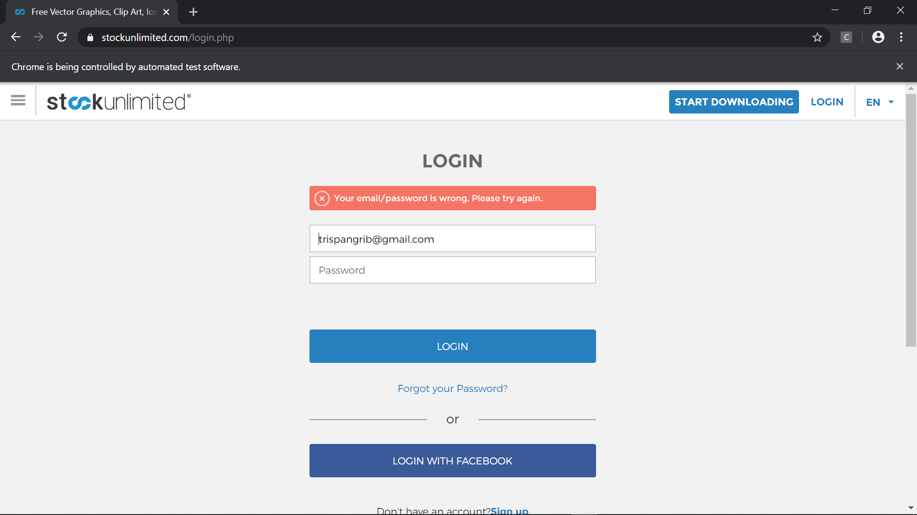

1. Test Case 3 (Email Invalid, Password Valid)

* Scenario



* Step Definition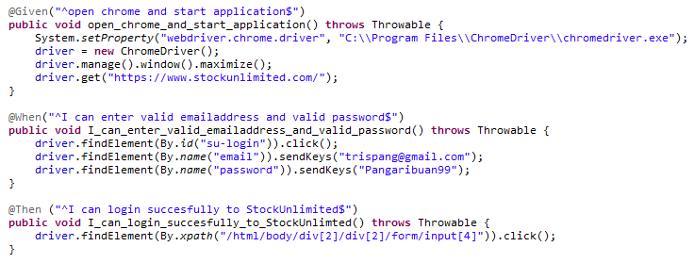
* Test Runner
* Console setelah Running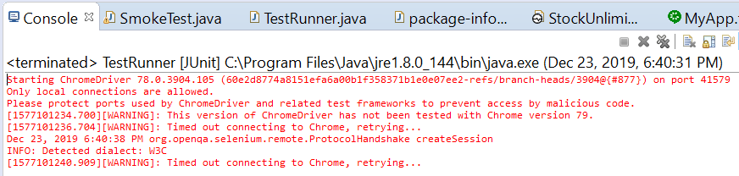
* Snippet Browser saat Testing

Dashboard sebelum Login

Form Login



Email dan password sudah diisi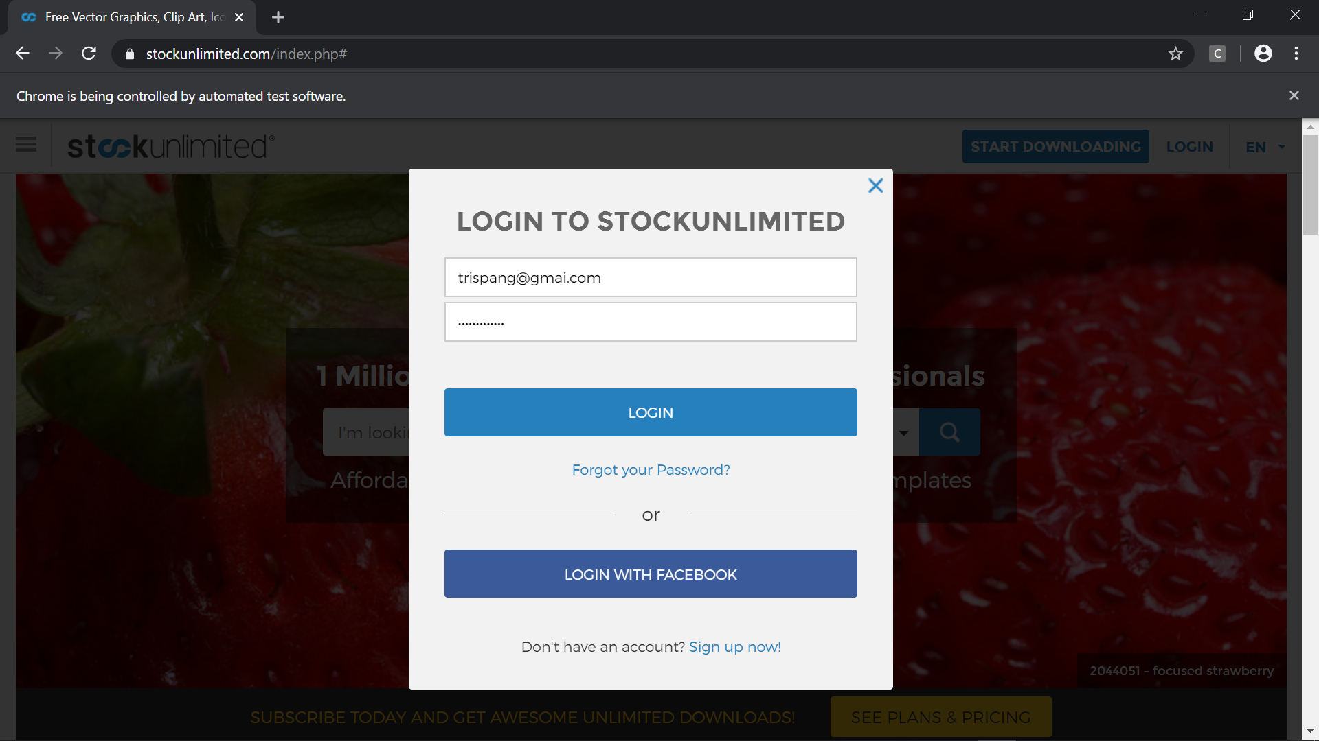

Hasil setelah email dan password dimasukan (invalid)

* 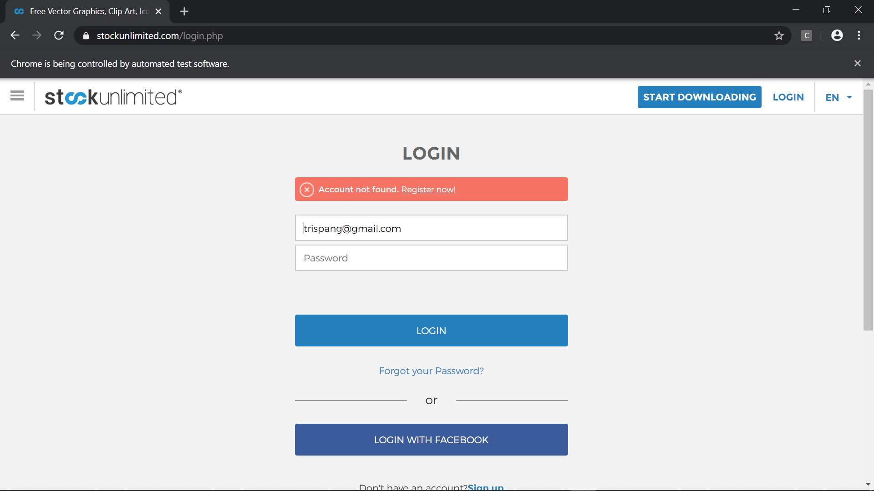

1. Test Case 4 (Email Invalid, Password Invalid)

* Scenario



* Step Definition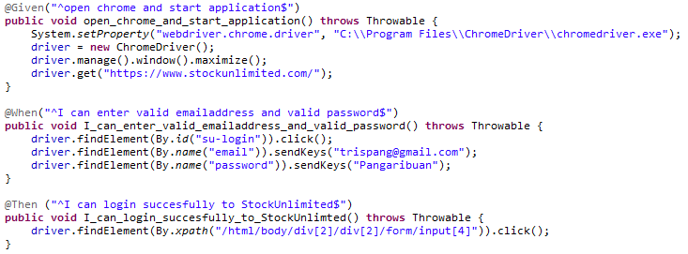
* Test Runner
* Console setelah Running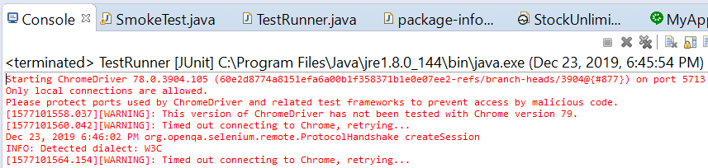
* Snippet Browser saat Testing

Dashboard sebelum Login

Form Login



Email dan password sudah diisi 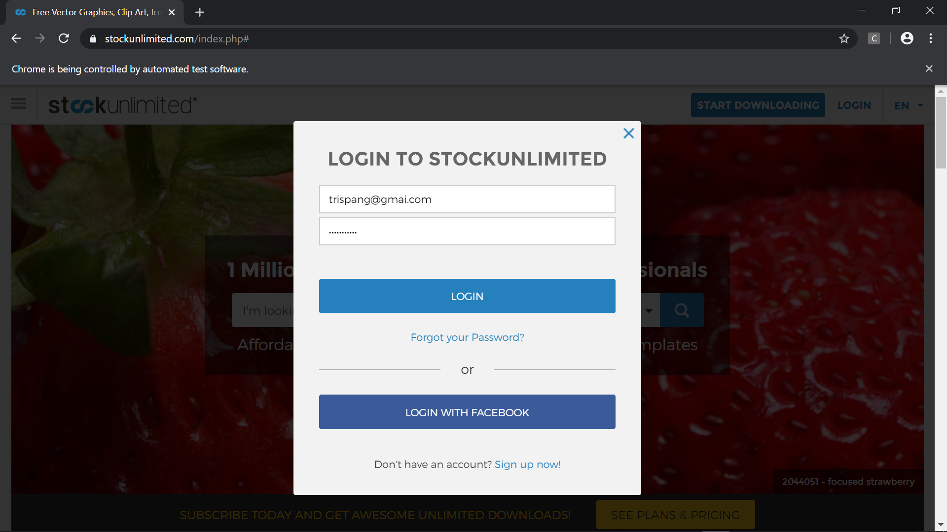

Hasil setelah email dan password dimasukan (invalid)

* 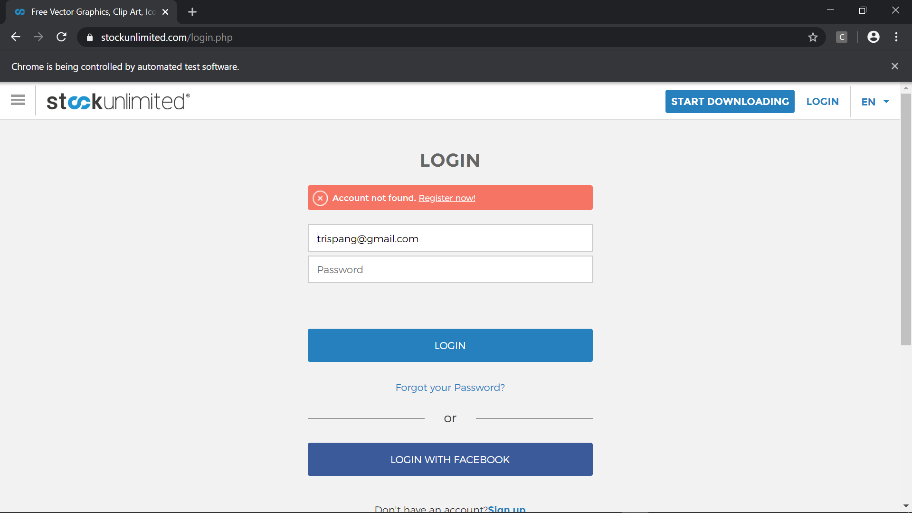

1. Test Case 5 (Blanked, Blanked)

* Scenario



* Step Definition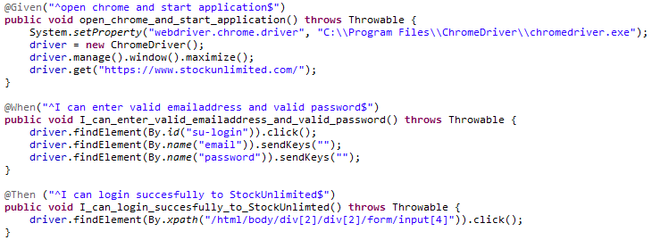
* Test Runner
* Console setelah Running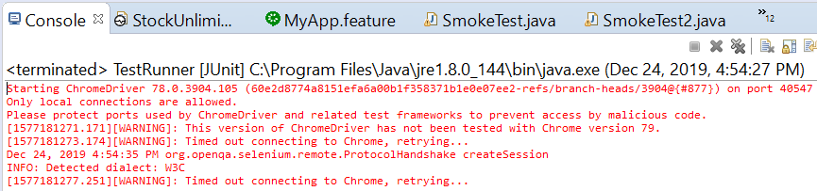
* Snippet Browser saat Testing

Dashboard sebelum Login

Form Login



Email dan password sudah diisi

Hasil setelah email dan password dimasukan

* 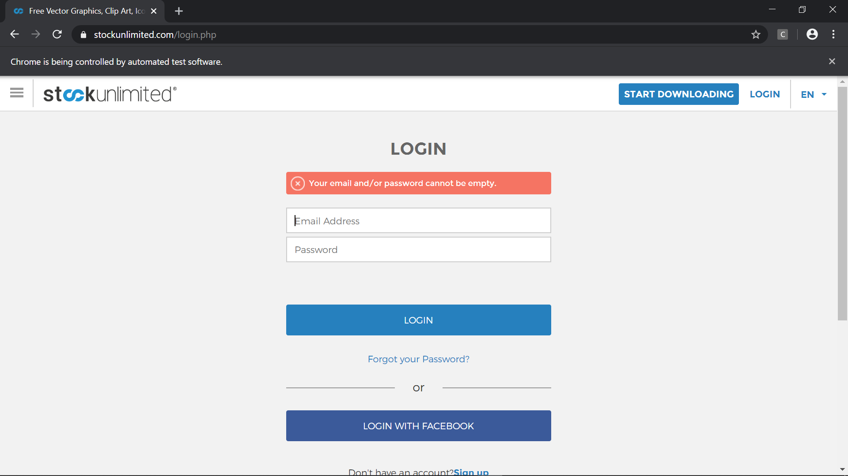

### Fungsi Searching (Vector)

1. Test Case 1 (Valid)

* Scenario

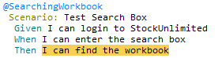

* Step Definition 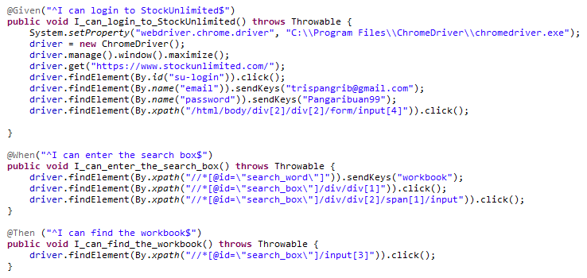
* Test Runner
* Console setelah Running 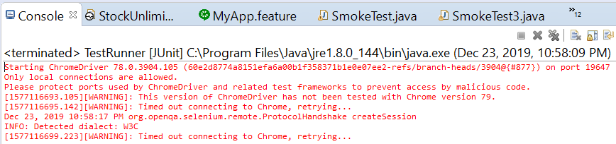
* Snippet Browser saat Testing

Dashboard sebelum Login

Form Login



Email dan password sudah diisi

Mengisi kitak pencarian dengan workbook dan vector

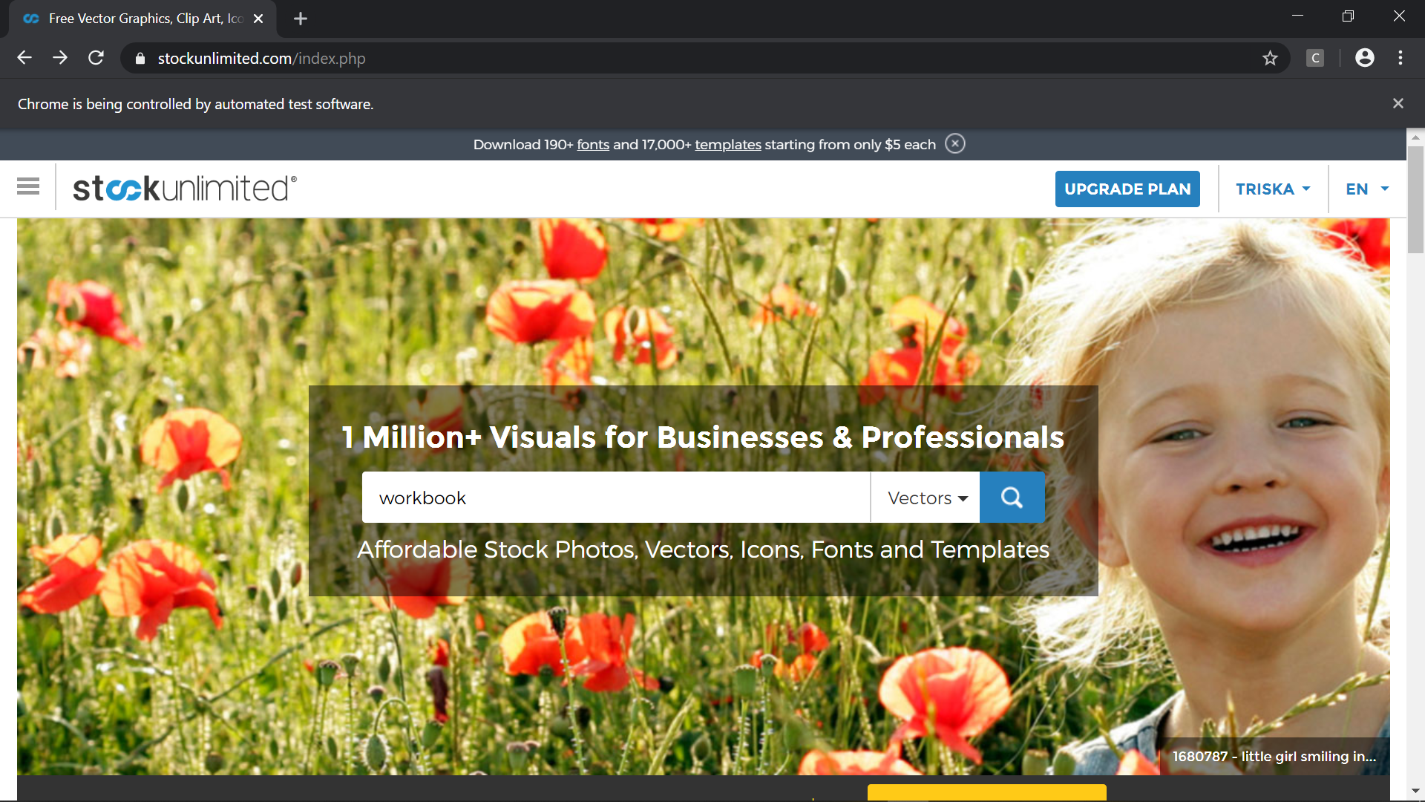

Hasil dari pencarian workbook (vector)

* 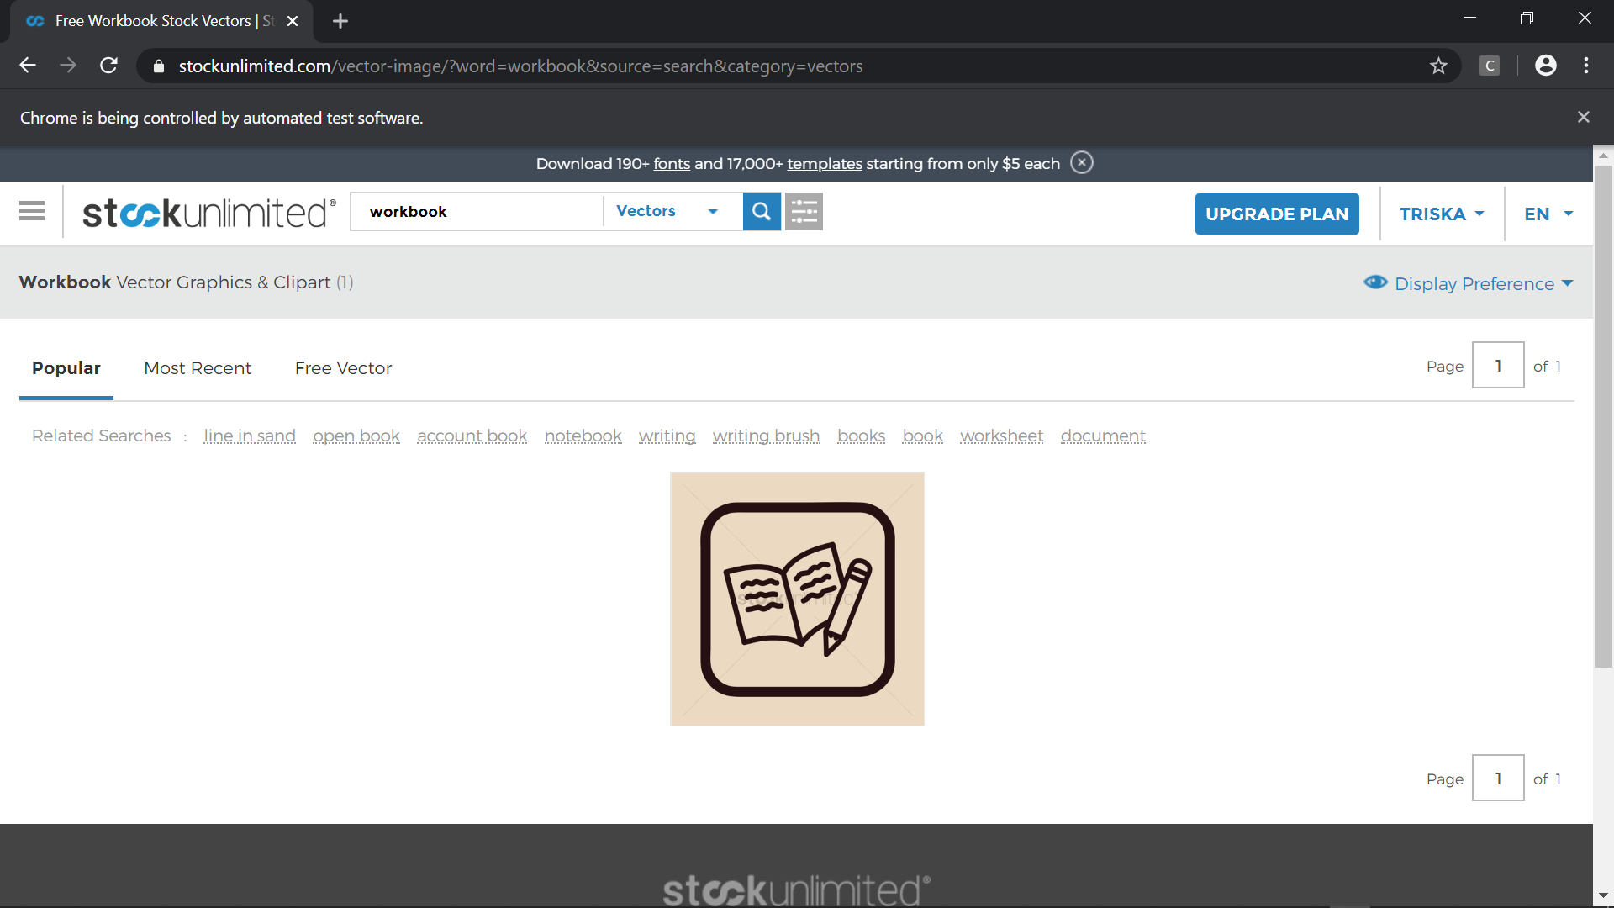

1. Test Case 2 (Invalid)

* Scenario



* Step Definition 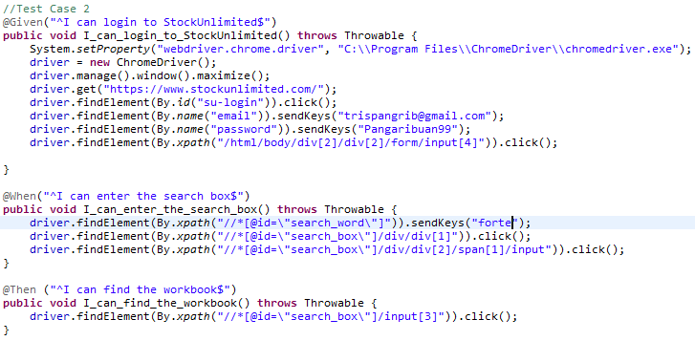
* Test Runner
* Console setelah Running 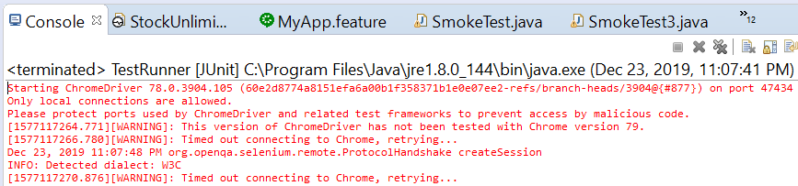
* Snippet Browser saat Testing

Dashboard sebelum Login

Form Login



Email dan password sudah diisi

Mengisi kotak pencarian dengan forte (invalid) dan vector

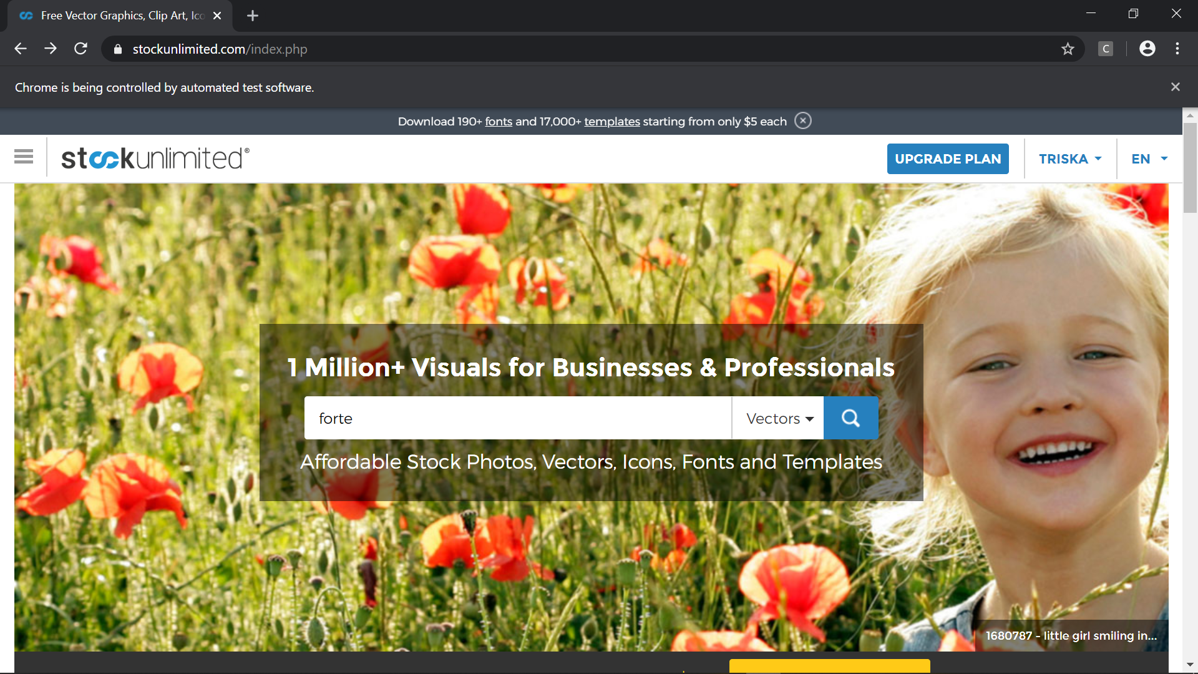

Hasil pencarian (invalid)

* 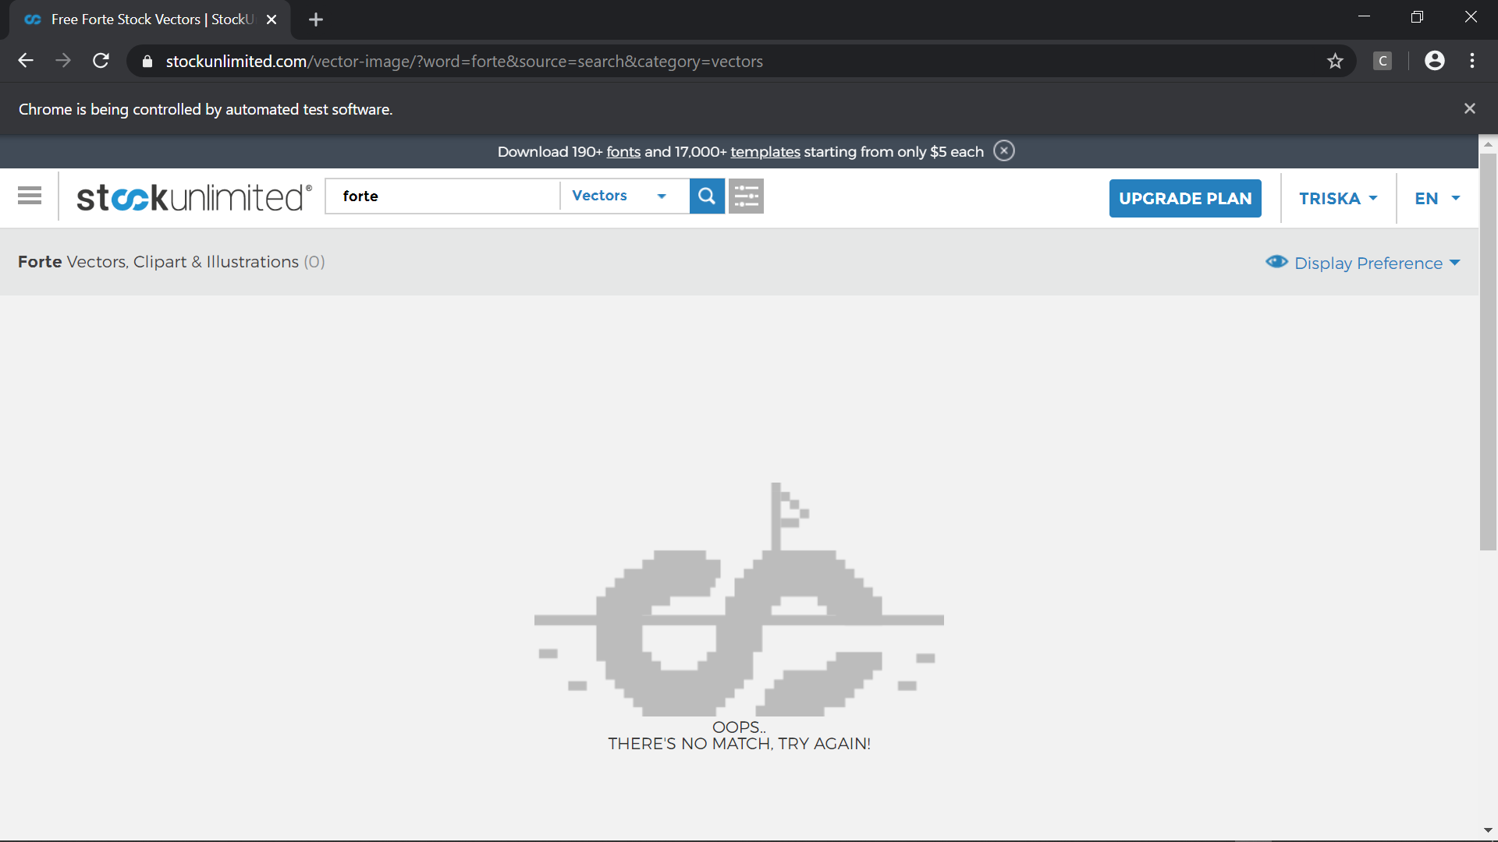

### Fungsi Searching (Audio)

1. Test Case 1 (Valid)

* Scenario

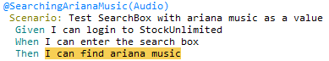

* Step Definition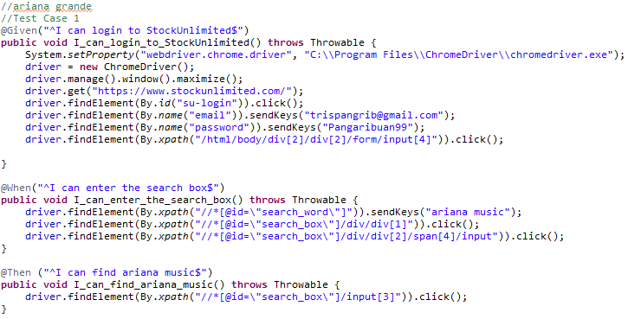
* Test Runner
* Console setelah Running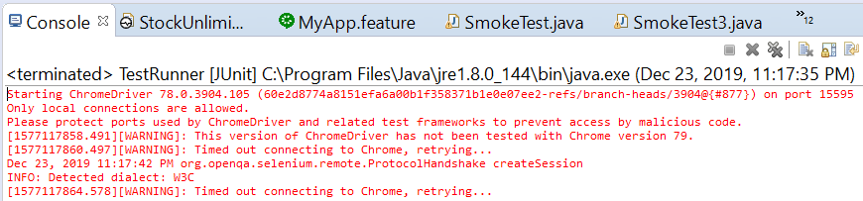
* Snippet Browser saat Testing

Dashboard sebelum Login

Form Login



Email dan password sudah diisi

Mengisi kotak pencarian dengan ariana music dan audio

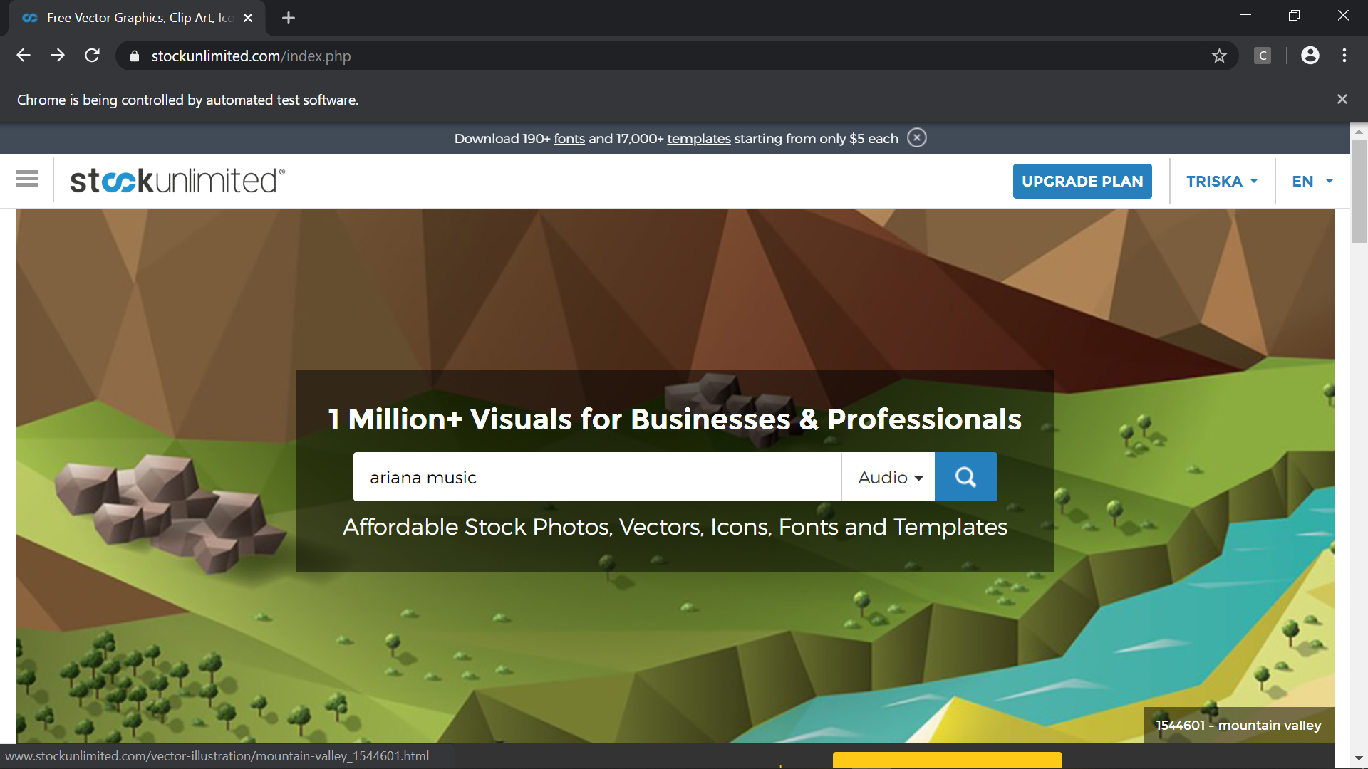

Hasil pencarian ariana music (audio)

* 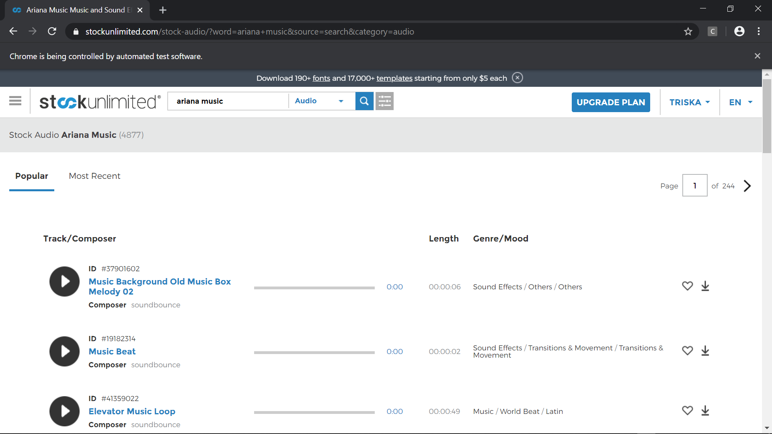

1. Test Case 2 (Invalid)

* Scenario



* Step Definition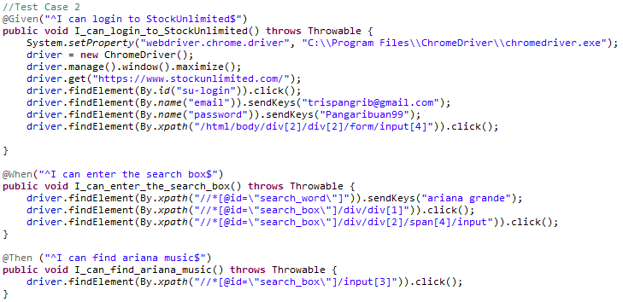
* Test Runner
* Console setelah Running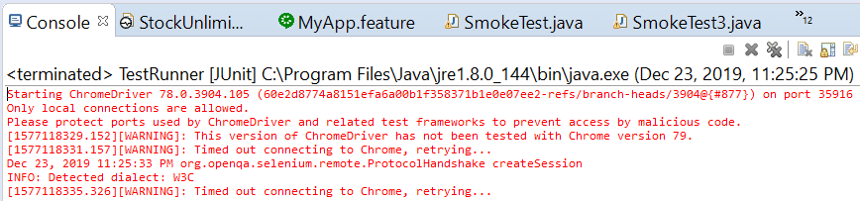
* Snippet Browser saat Testing

Dashboard sebelum Login

Form Login



Email dan password sudah diisi

Mengisi kotak pencarian Ariana grande (invalid) dan audio

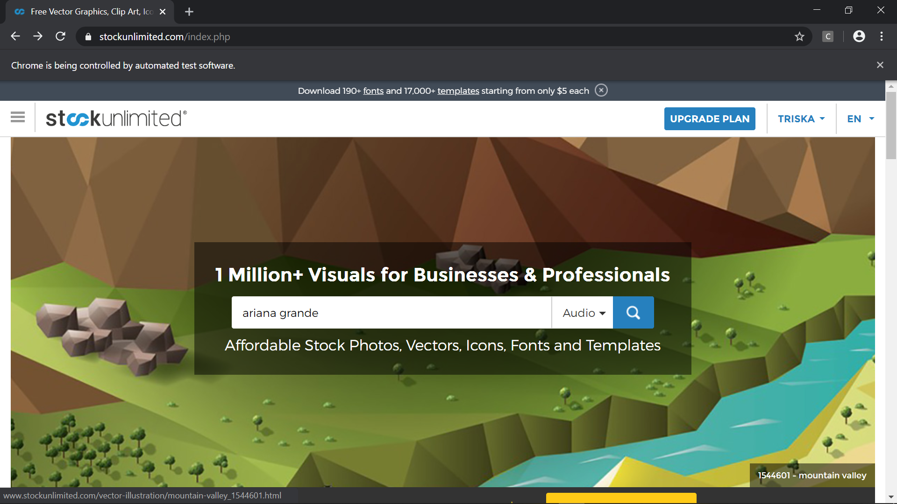

Hasil pencarian (invalid)

* 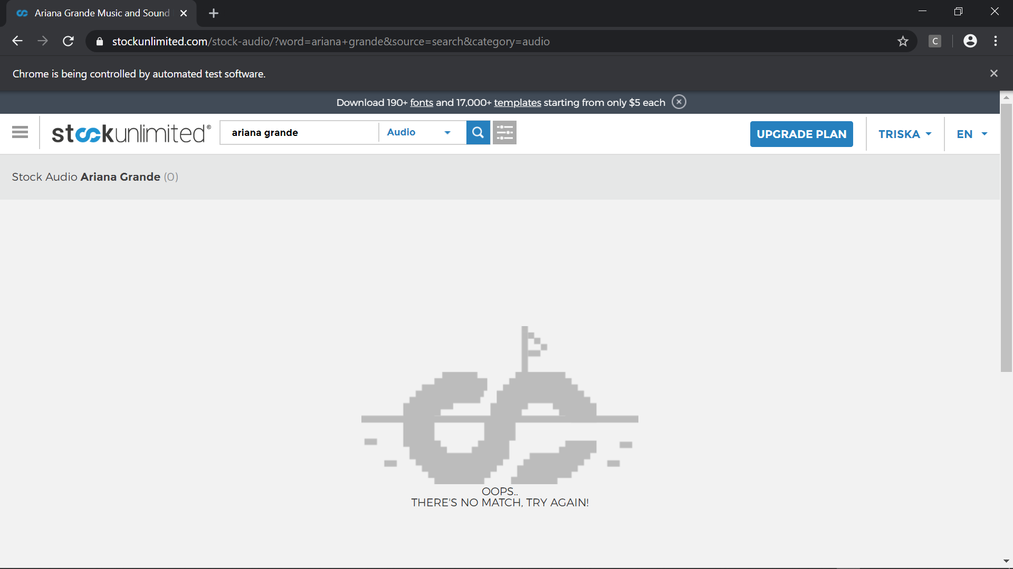

### Fungsi Searching (Fonts)

1. Test Case 1 (Valid)

* Scenario

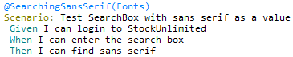

* Step Definition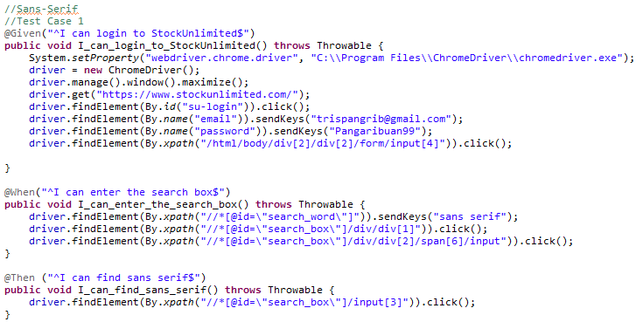
* Test Runner
* Console setelah Running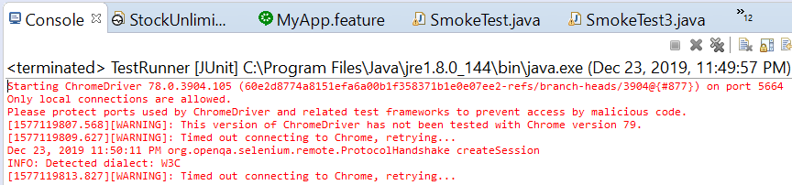
* Snippet Browser saat Testing

Dashboard sebelum Login

Form Login



Email dan password sudah diisi

Mengsi kotak pencarian dengan sans serif dan fonts 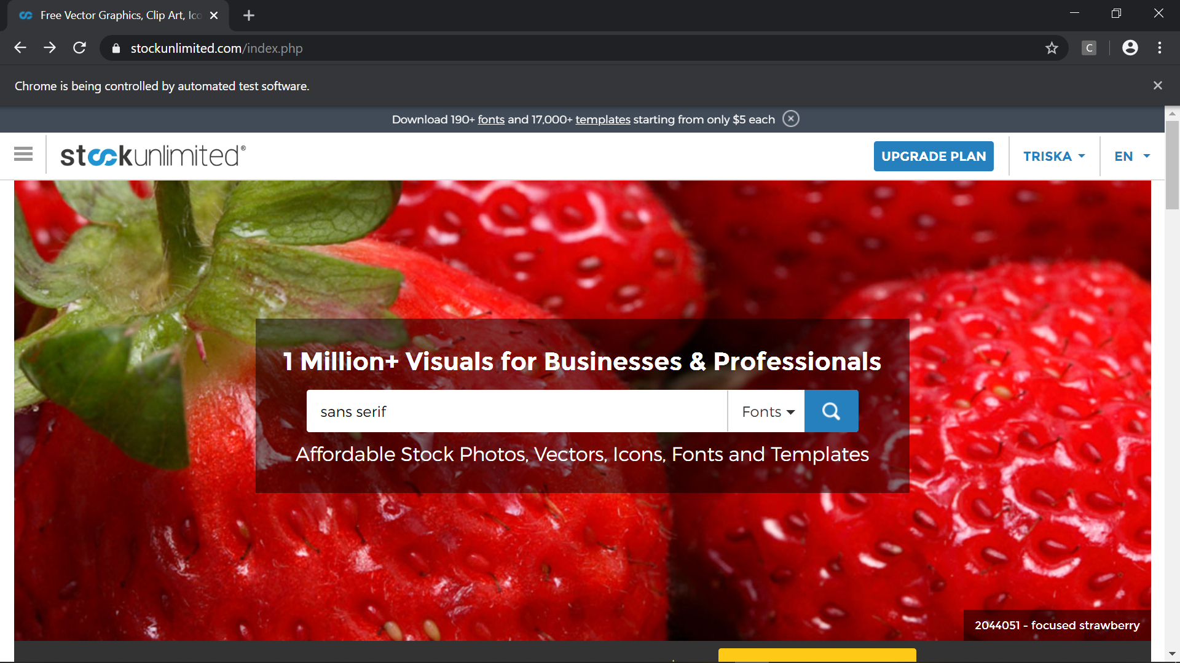

Hasil pencarian sans serif (fonts)

* 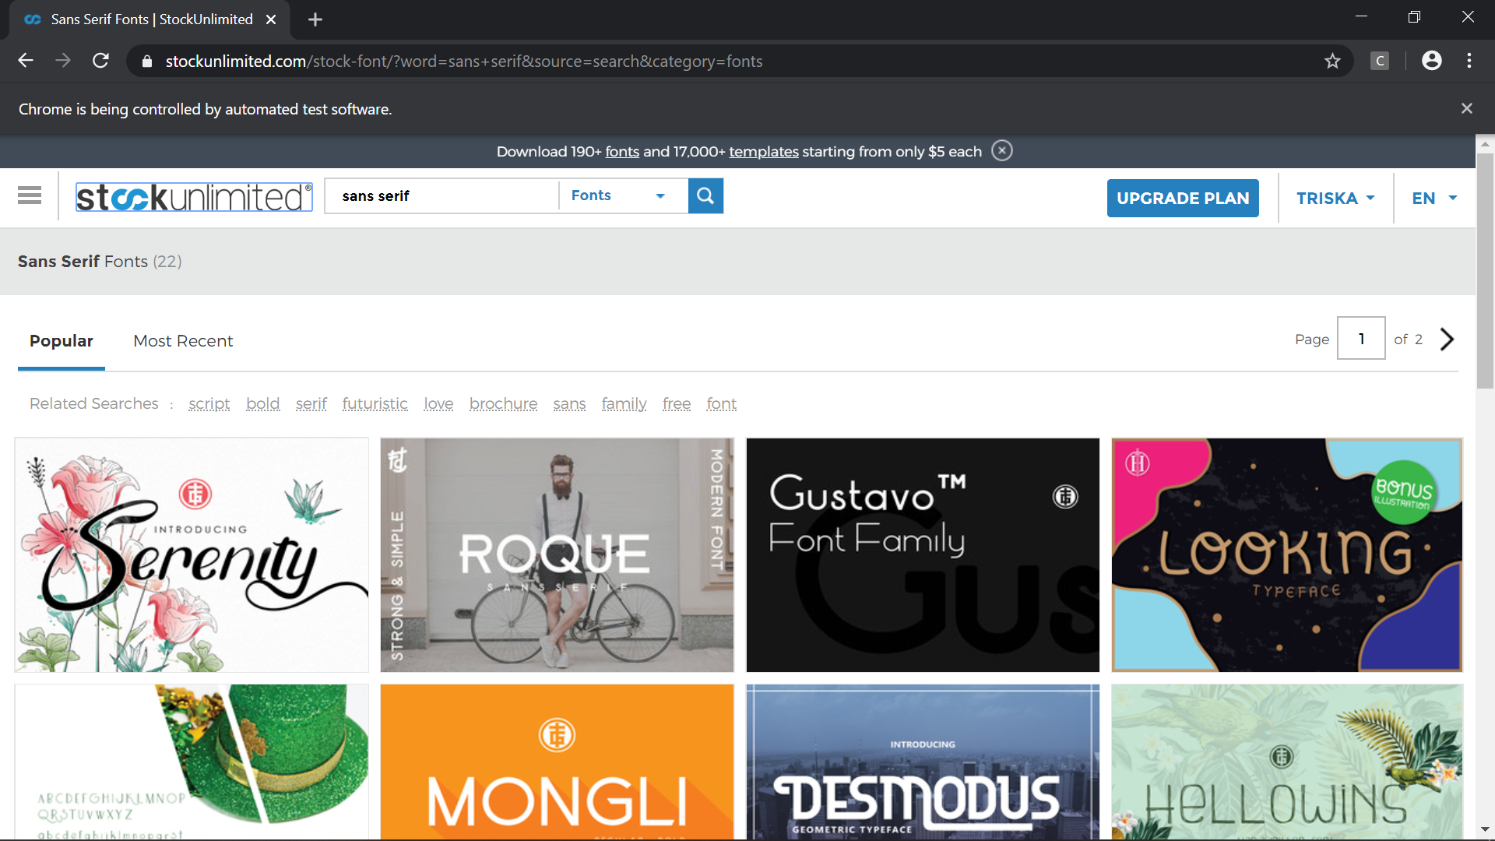

1. Test Case 2 (Invalid)

* Scenario



* Step Definition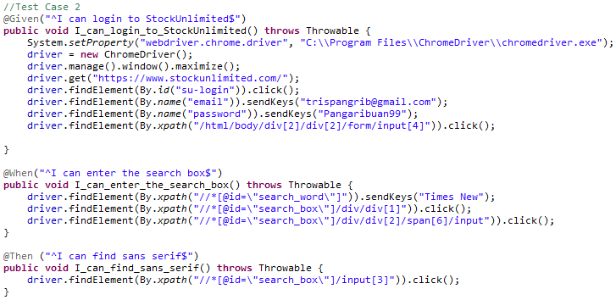
* Test Runner
* Console setelah Running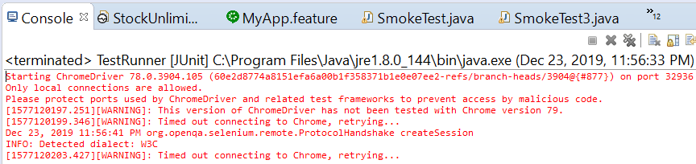
* Snippet Browser saat Testing

Dashboard sebelum Login

Form Login



Email dan password sudah diisi

Mengisi kotak pencaerian dengan Times New (invalid) dan fonts

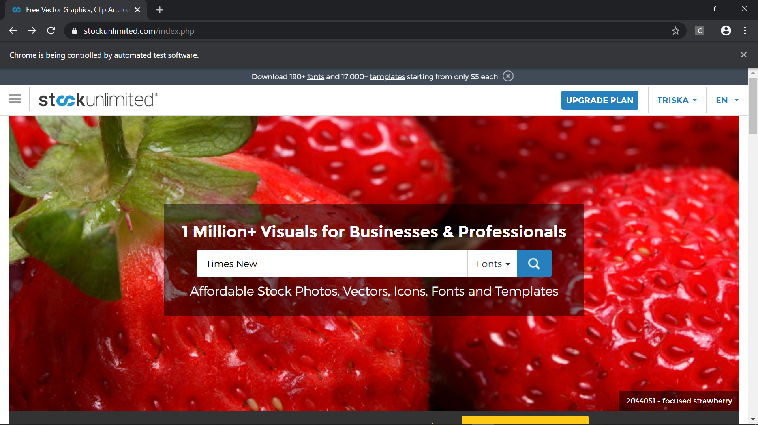

Hasil pencarian (invalid)

* 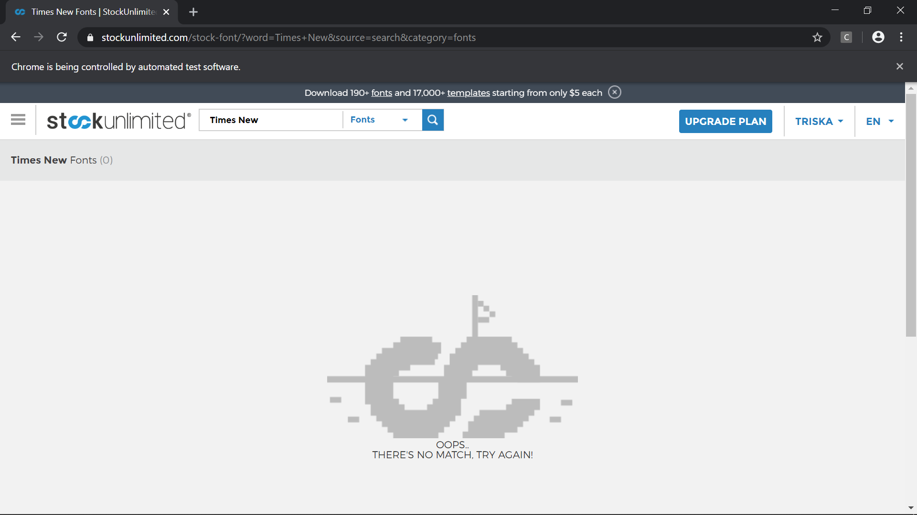

### Fungsi Security

1. Test Case 1 (OP:Valid, NP:Valid, PC:Valid)

* Scenario

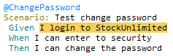

* Step Definition 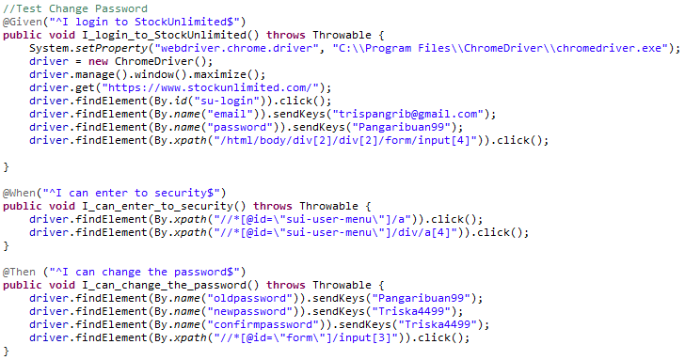
* Test Runner
* Console setelah Running 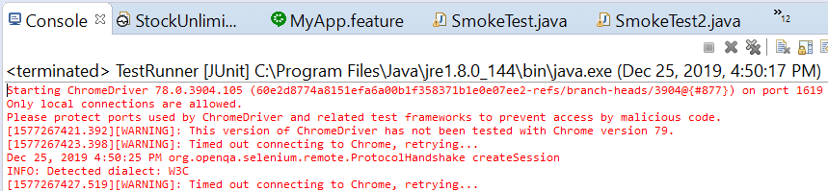
* Snippet Browser saat Testing

Dashboard sebelum Login

Form Login



Email dan password sudah diisi

Meng-*klik* menu profil (TRISKA) *dropdown* dan meng-*klik* SECURITY

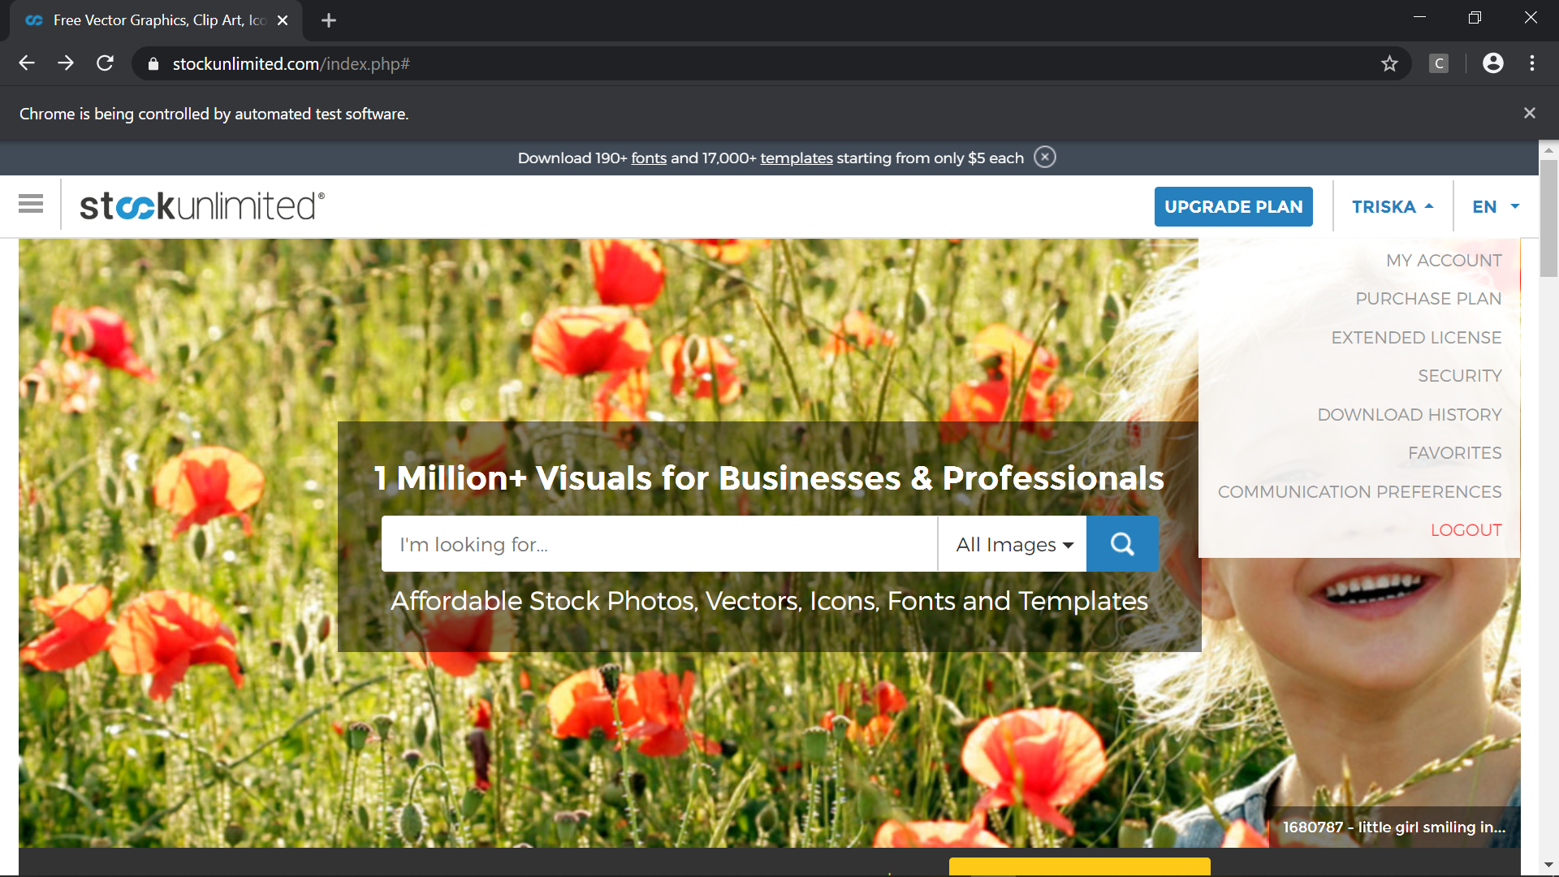

Hasil setelah meng-*klik* SECURITY

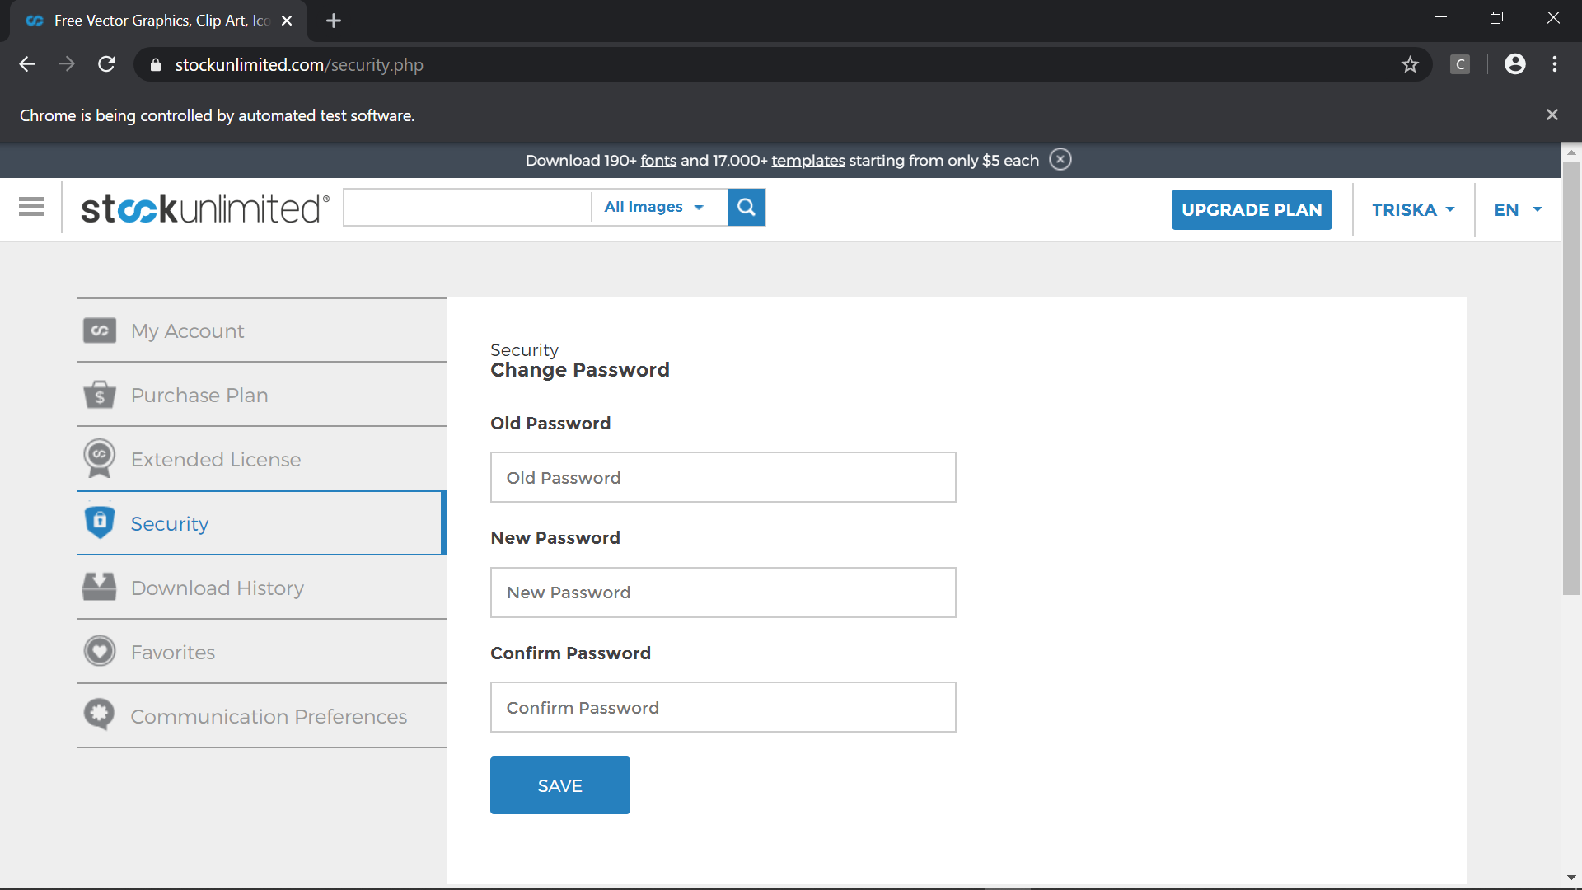

Hasil setelah form ganti password diIsi (valid)

* 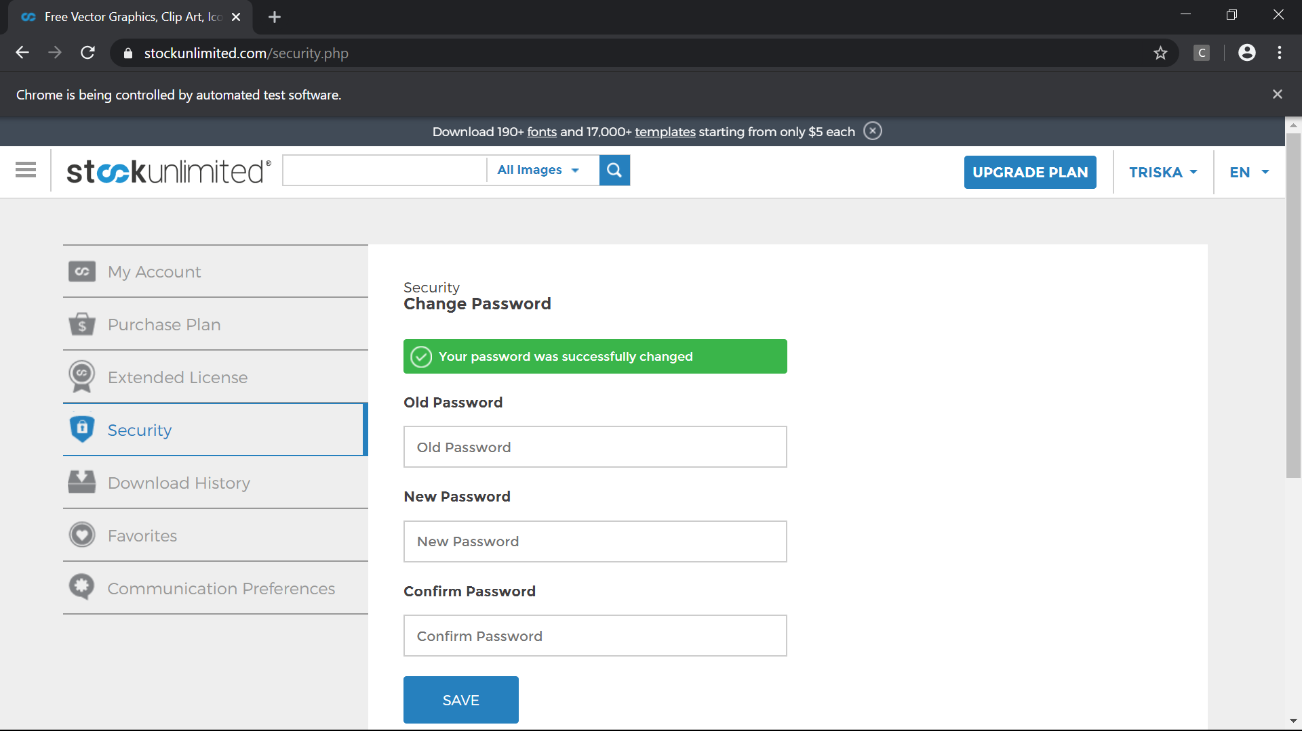

1. Test Case 2 (OP:Valid, NP:Invalid, PC:Invalid)

* Scenario



* Step Definition 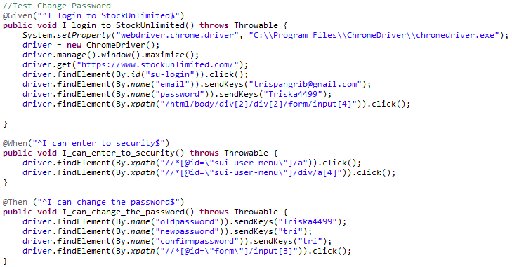
* Test Runner
* Console setelah Running 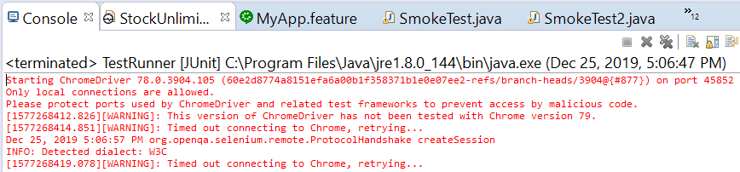
* Snippet Browser saat Testing

Dashboard sebelum Login

Form Login



Email dan password sudah diisi

.meng-*klik* menu profil (TRISKA) *dropdown* dan meng-*klik* SECURITY



Hasil setelah meng-*klik* SECURITY



Hasil setelah form ganti password diIsi (invalid)

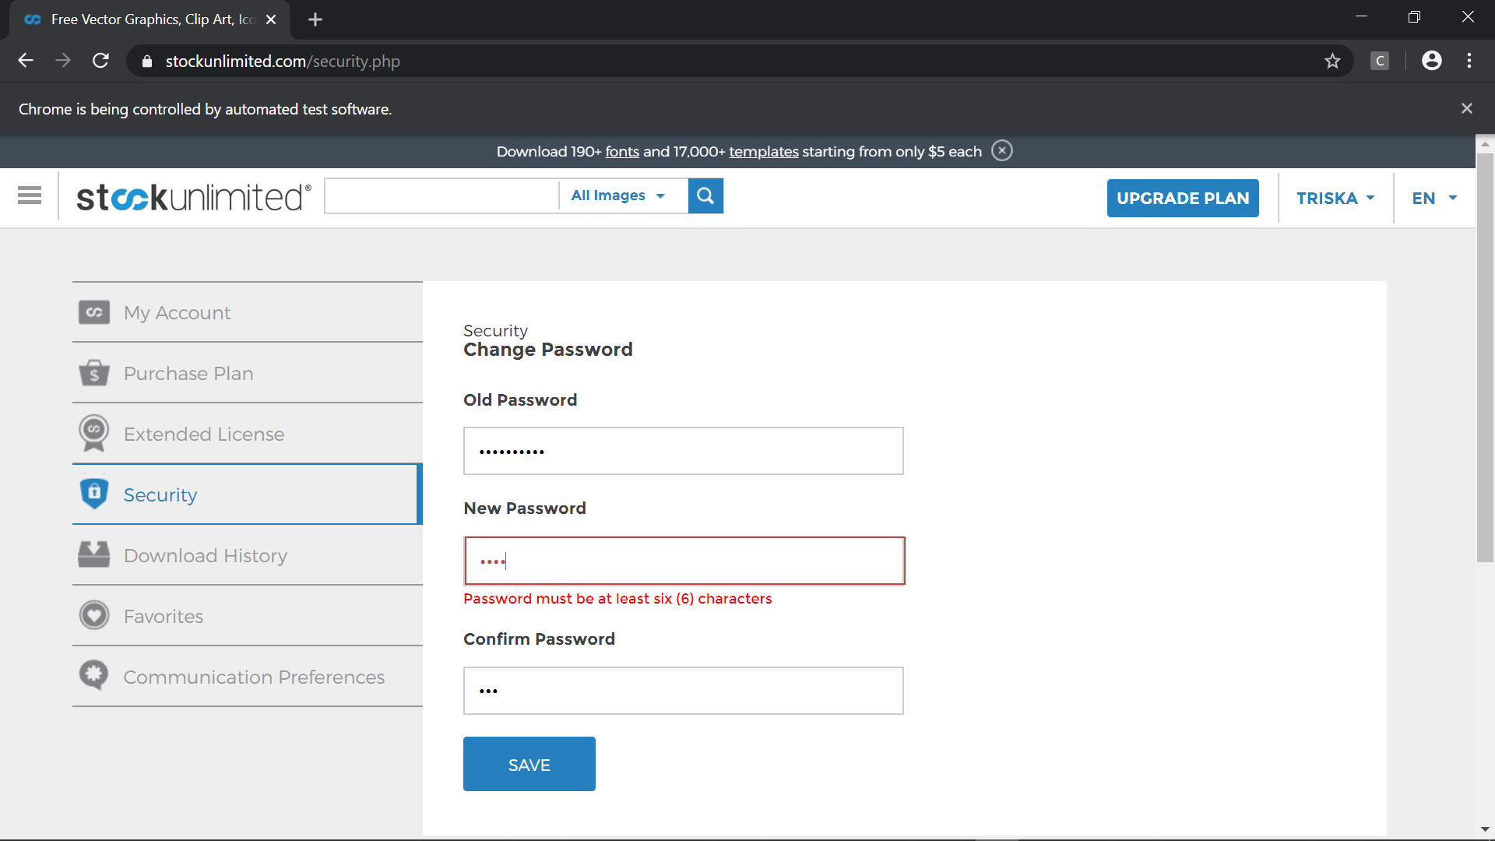

1. Test Case 3 (OP:Valid, NP:Valid, PC:Invalid)

* Scenario



* Step Definition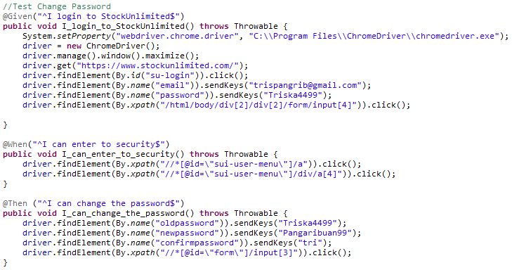
* Test Runner
* Console setelah Running
* Snippet Browser saat Testing

Dashboard sebelum Login

Form Login



Email dan password sudah diisi

.meng-*klik* menu profil (TRISKA) *dropdown* dan meng-*klik* SECURITY



Hasil setelah meng-*klik* SECURITY



Hasil setelah form ganti password diIsi (invalid)

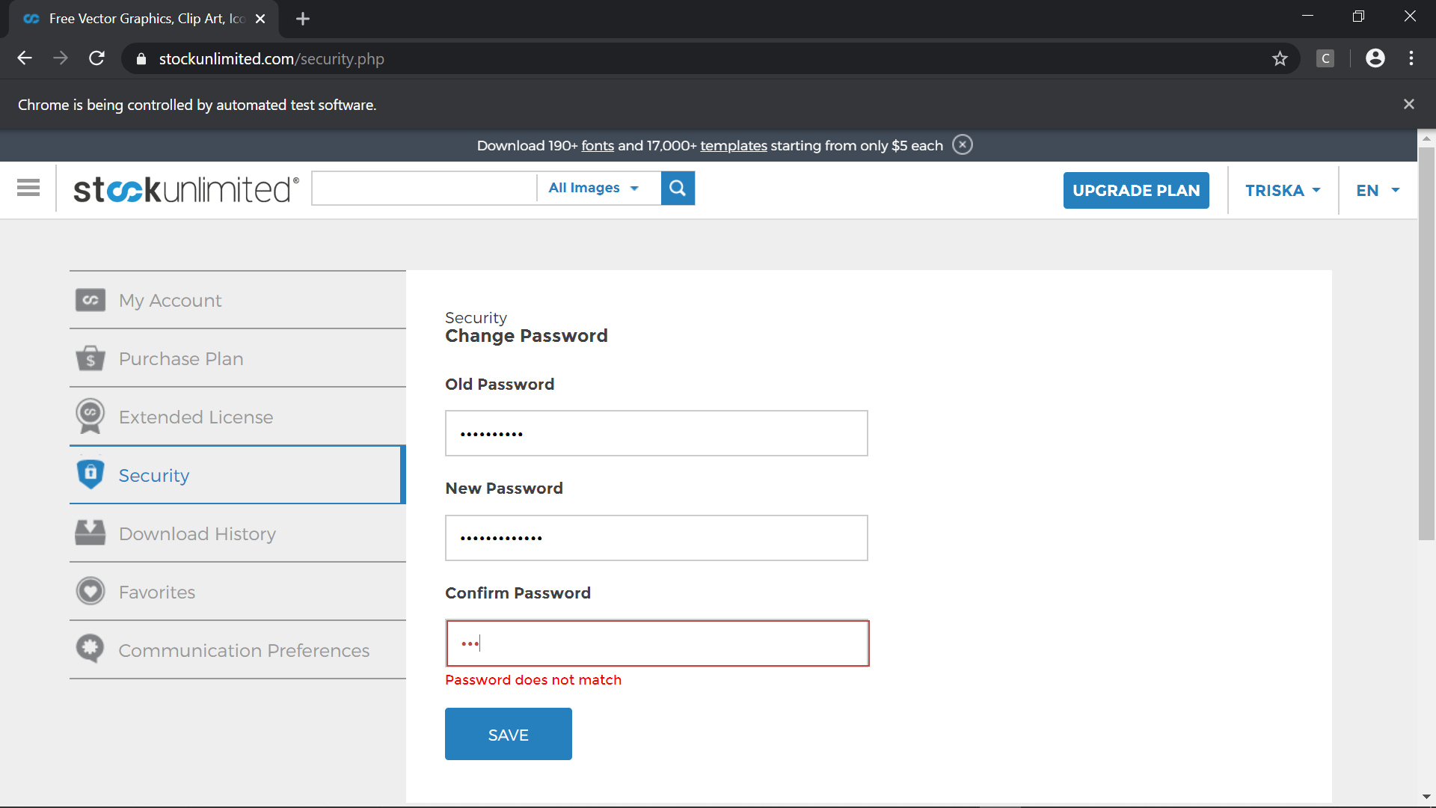

1. Test Case 4 (OP:Invalid, NP:Invalid, PC:Invalid)

* Scenario



* Step Definition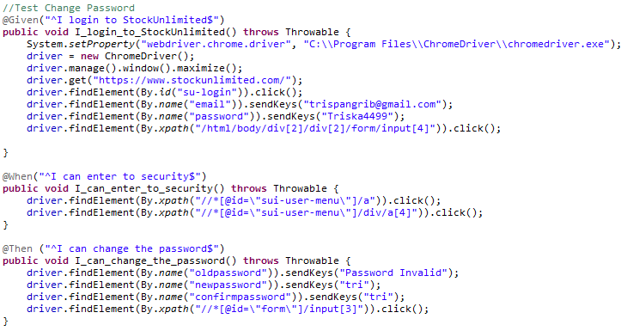
* Test Runner
* Console setelah Running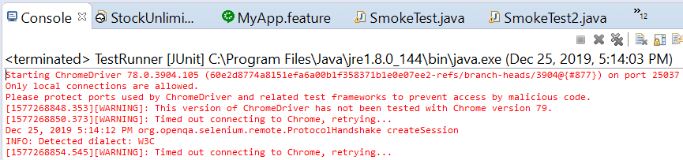
* Snippet Browser saat Testing

Dashboard sebelum Login

Form Login



Email dan password sudah diisi

.meng-*klik* menu profil (TRISKA) *dropdown* dan meng-*klik* SECURITY



Hasil setelah meng-*klik* SECURITY



Hasil setelah form ganti password diIsi (invalid)

* 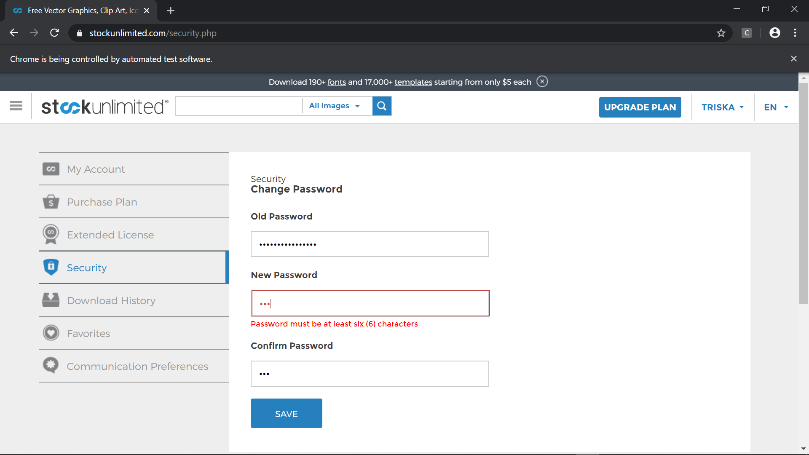

1. Test Case 5 (OP:Valid, NP:Invalid, PC:Valid)

* Scenario



* Step Definition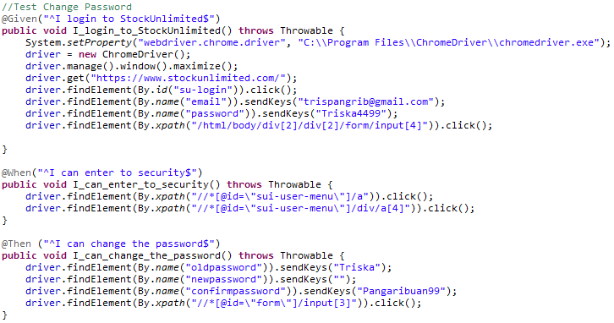
* Test Runner
* Console setelah Running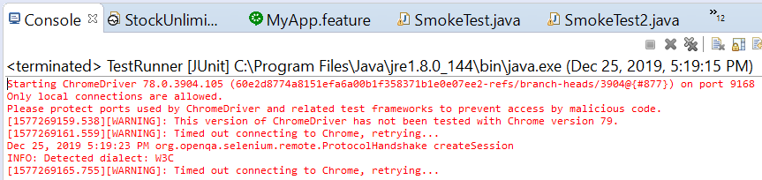
* Snippet Browser saat Testing

Dashboard sebelum Login

Form Login



Email dan password sudah diisi

.meng-*klik* menu profil (TRISKA) *dropdown* dan meng-*klik* SECURITY



Hasil setelah meng-*klik* SECURITY



Hasil setelah form ganti password diIsi (invalid)

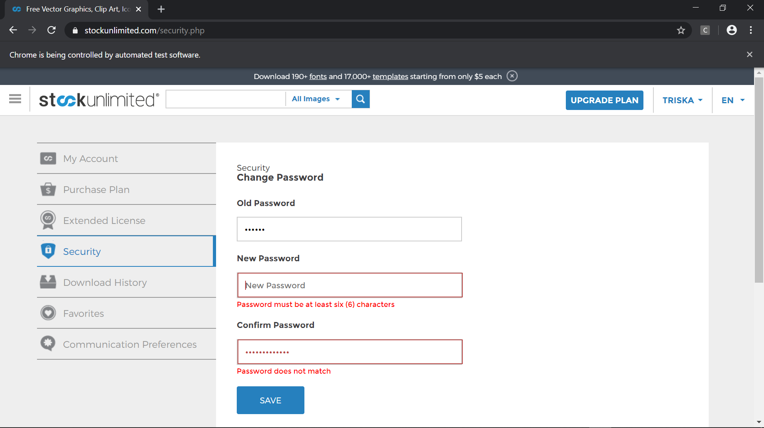

1. Test Case 6 (OP:Invalid, NP:Valid, PC:Valid)

* Scenario



* Step Definition 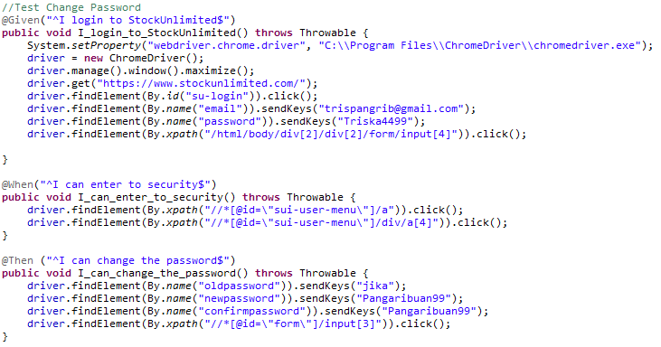
* Test Runner
* Console setelah Running 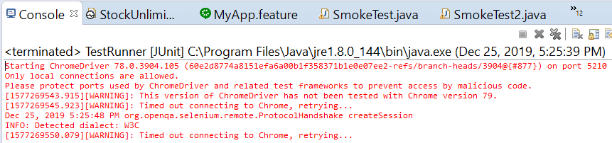
* Snippet Browser saat Testing

Dashboard sebelum Login

Form Login



Email dan password sudah diisi

.meng-*klik* menu profil (TRISKA) *dropdown* dan meng-*klik* SECURITY



Hasil setelah meng-*klik* SECURITY



Hasil setelah form ganti password diIsi (invalid)

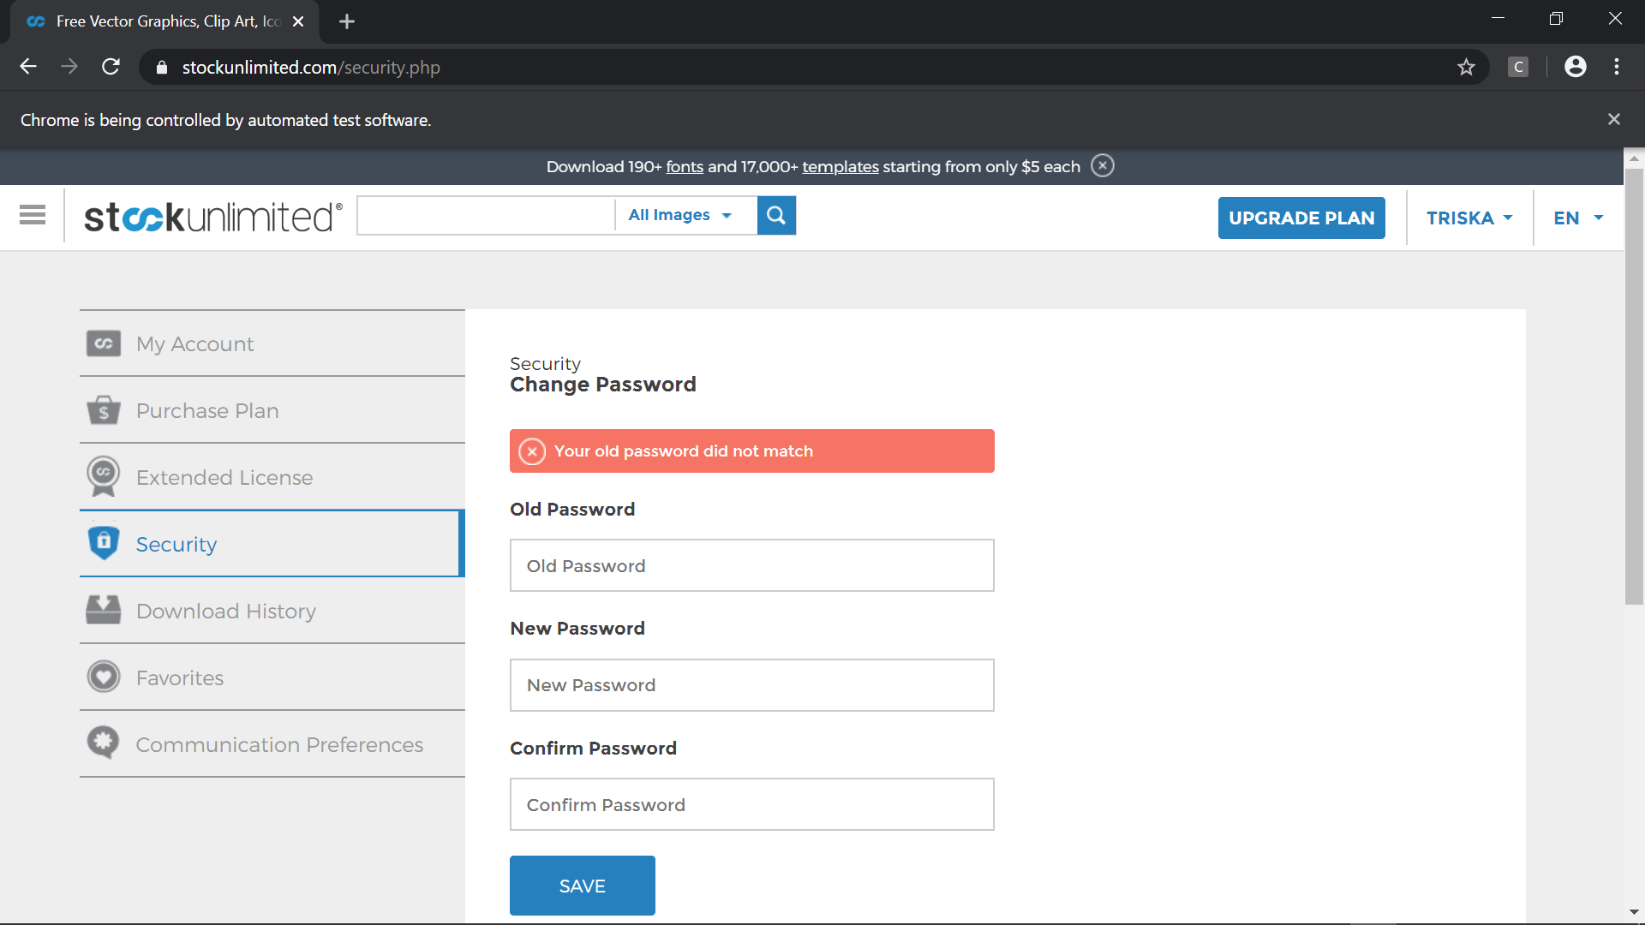

1. Test Case 7 (OP:Invalid, NP:Invalid, PC:Valid)

* Scenario



* Step Definition 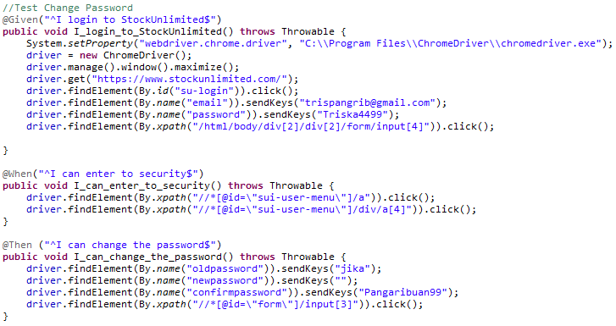
* Test Runner
* Console setelah Running 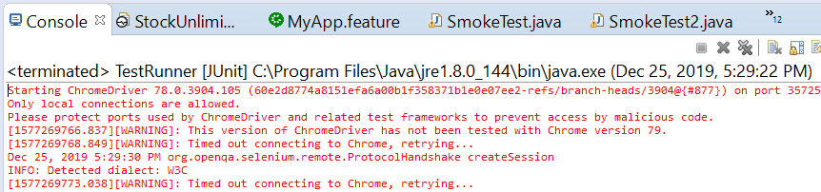
* Snippet Browser saat Testing

Dashboard sebelum Login

Form Login



Email dan password sudah diisi

.meng-*klik* menu profil (TRISKA) *dropdown* dan meng-*klik* SECURITY



Hasil setelah meng-*klik* SECURITY



Hasil setelah form ganti password diIsi (invalid)

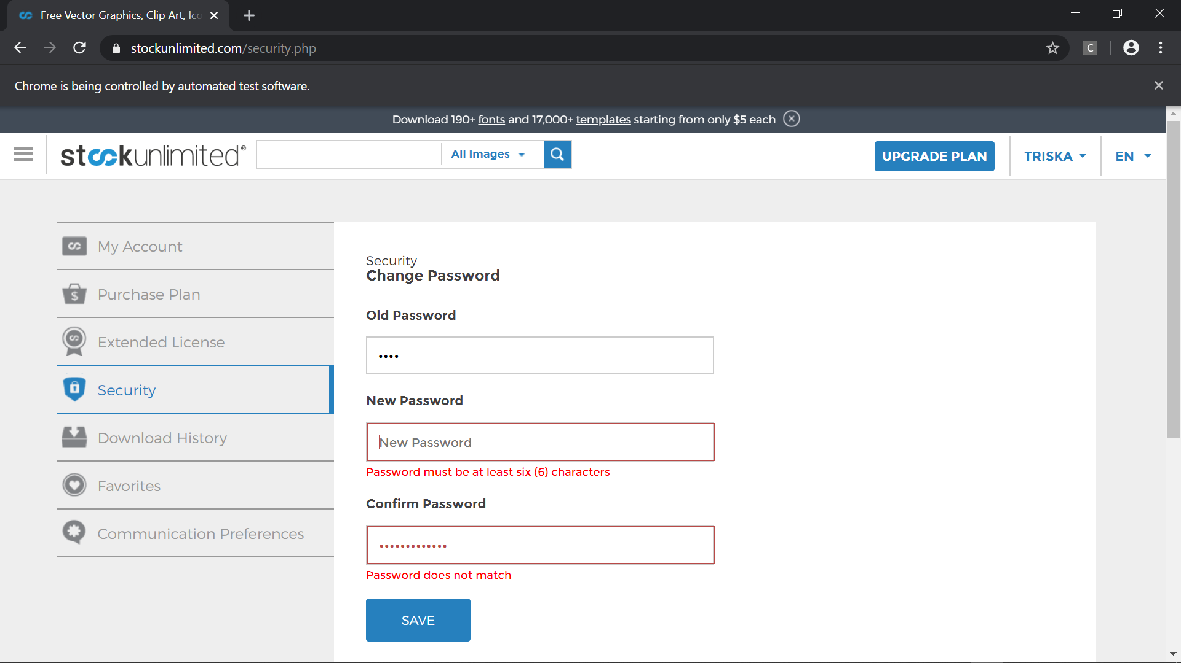

1. Test Case 8 (OP:Invalid, NP:Valid, PC:Invalid)

* Scenario



* Step Definition 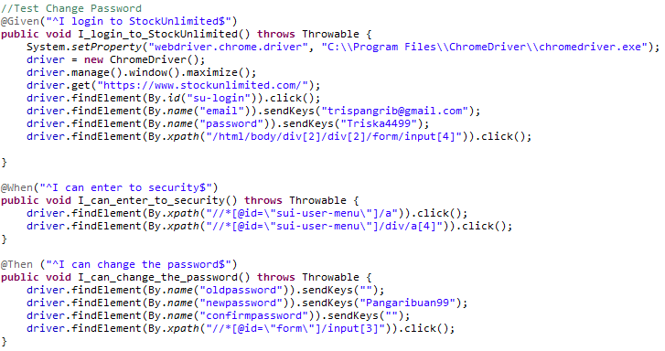
* Test Runner
* Console setelah Running 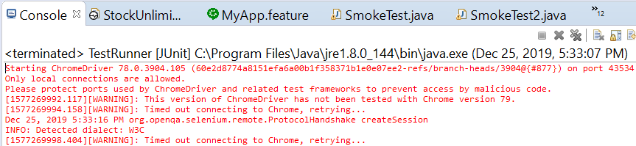
* Snippet Browser saat Testing

Dashboard sebelum Login

Form Login



Email dan password sudah diisi

.meng-*klik* menu profil (TRISKA) *dropdown* dan meng-*klik* SECURITY



Hasil setelah meng-*klik* SECURITY



Hasil setelah form ganti password diIsi (invalid)

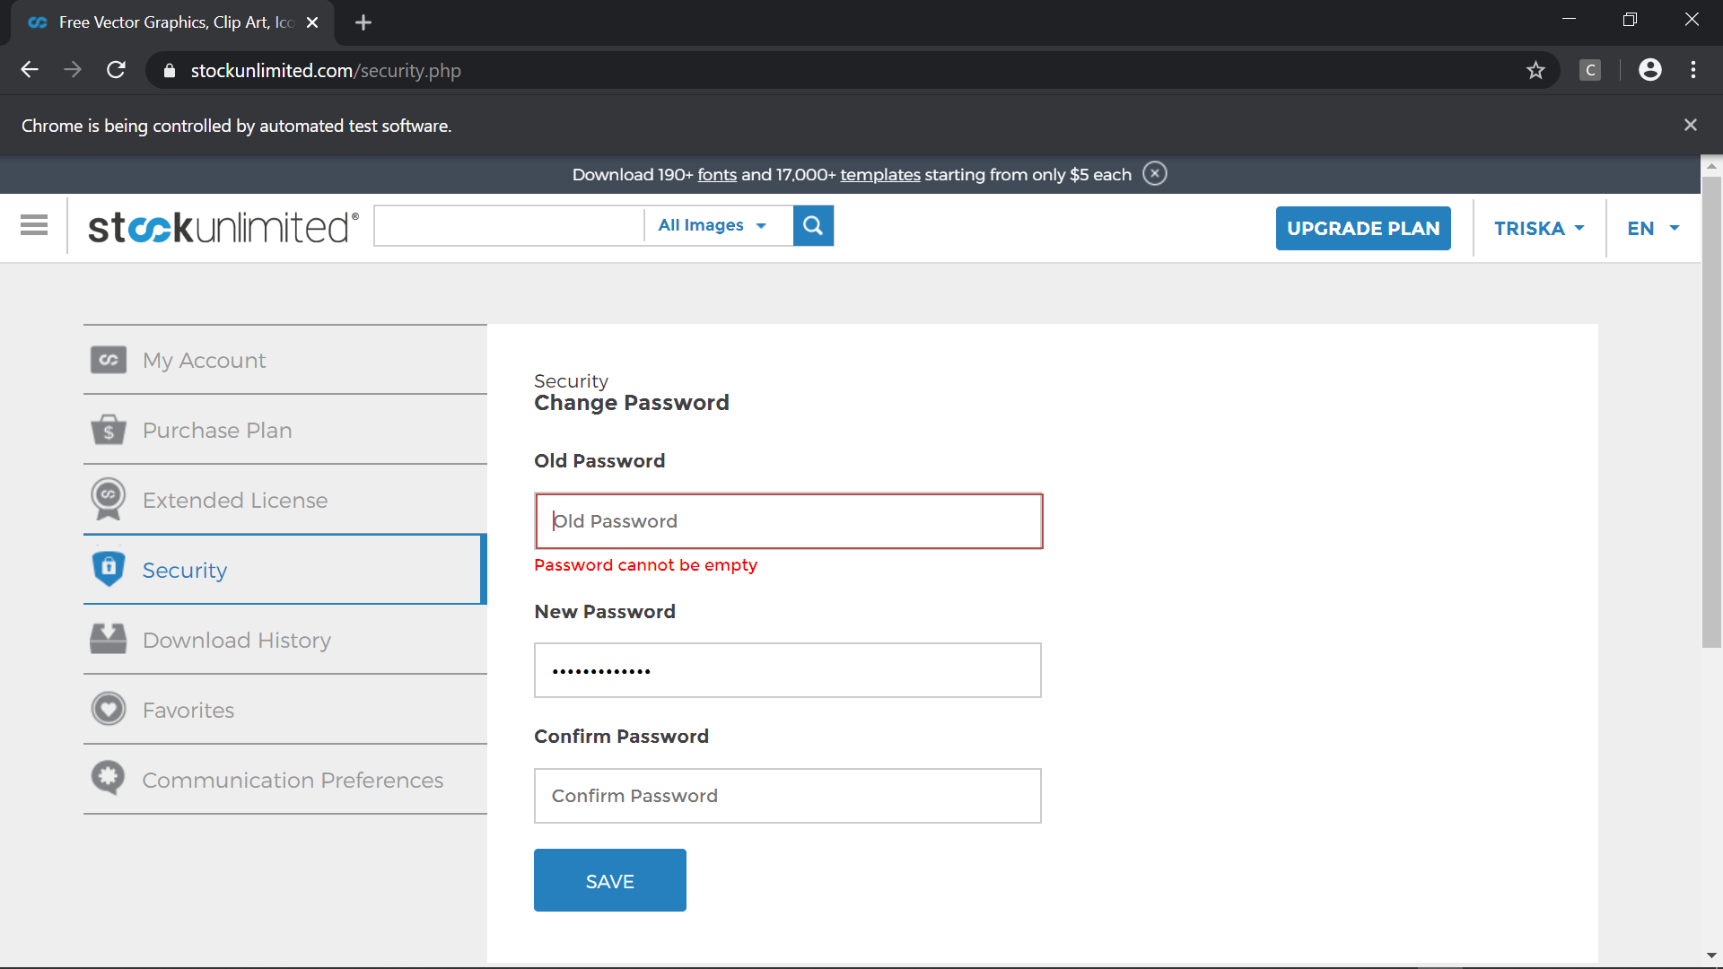

1. Test Case 9 (Blanked, Blanked, Blanked)

* Scenario



* Step Definition 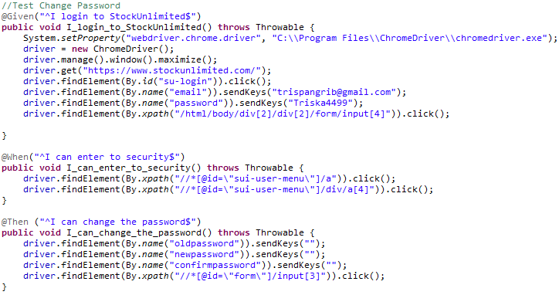
* Test Runner
* Console setelah Running 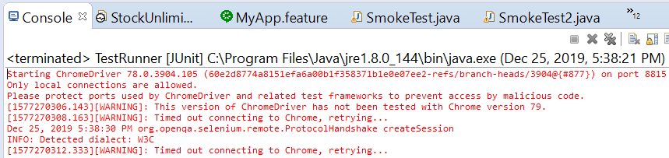
* Snippet Browser saat Testing

Dashboard sebelum Login

Form Login



Email dan password sudah diisi

.meng-*klik* menu profil (TRISKA) *dropdown* dan meng-*klik* SECURITY

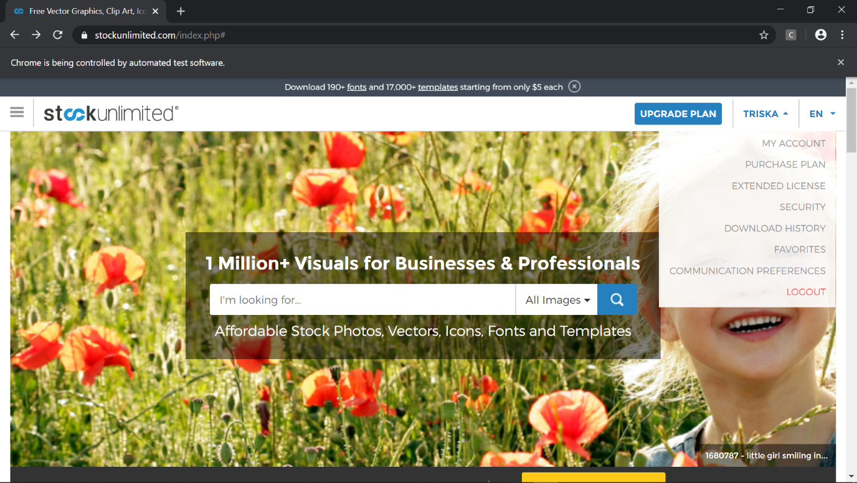

Hasil setelah meng-*klik* SECURITY

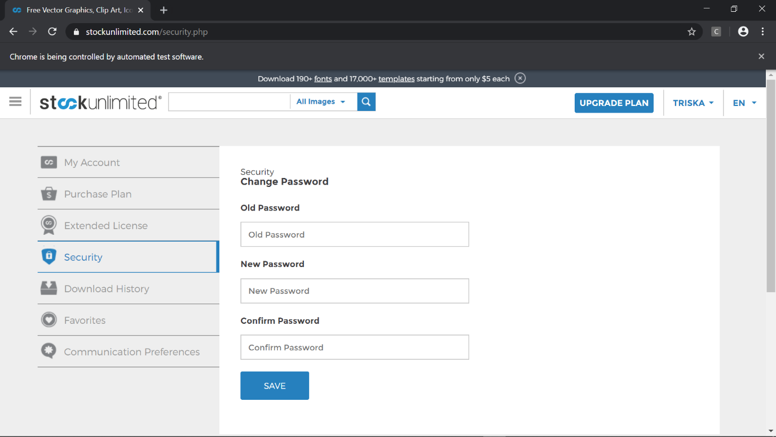

Hasil setelah form ganti password tanpa masukan (invalid)

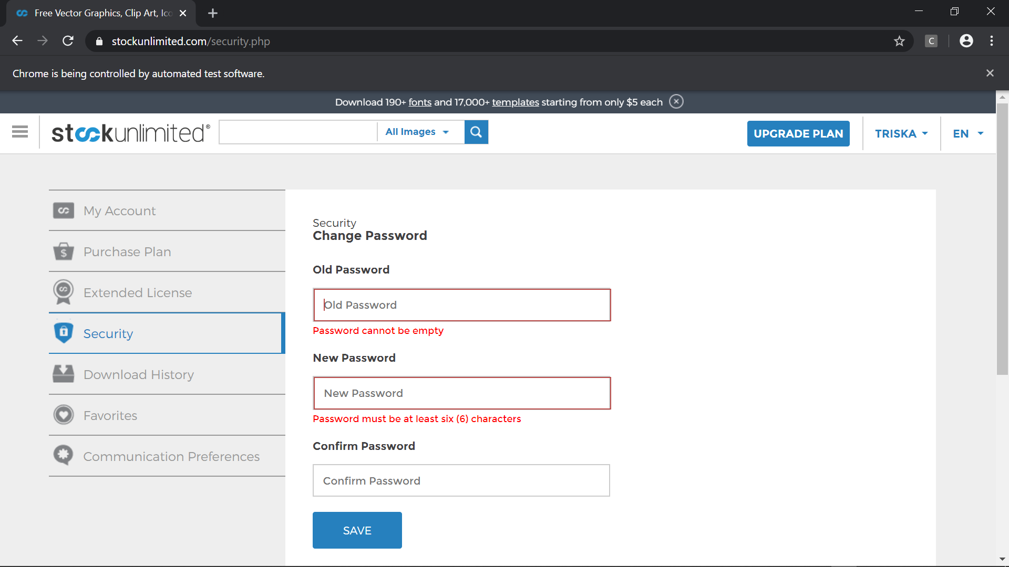

### Fungsi Find Out More

Test Case

* Scenario

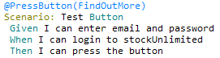

* Step Definition 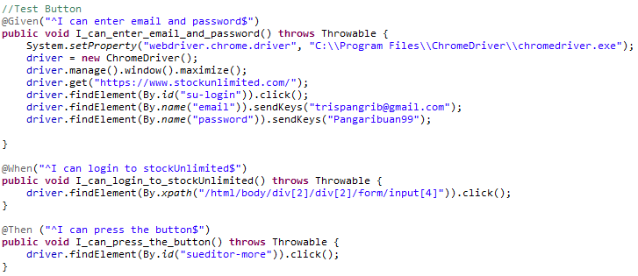
* Test Runner
* Console setelah Running 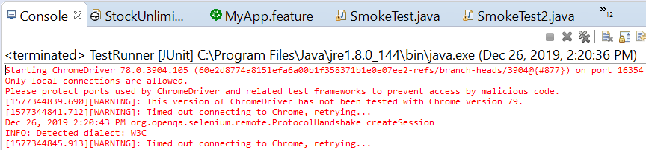
* Snippet Browser saat Testing

Dashboard sebelum Login

Form Login



Email dan password sudah diisi

Meng-*klik* Find Out More

* 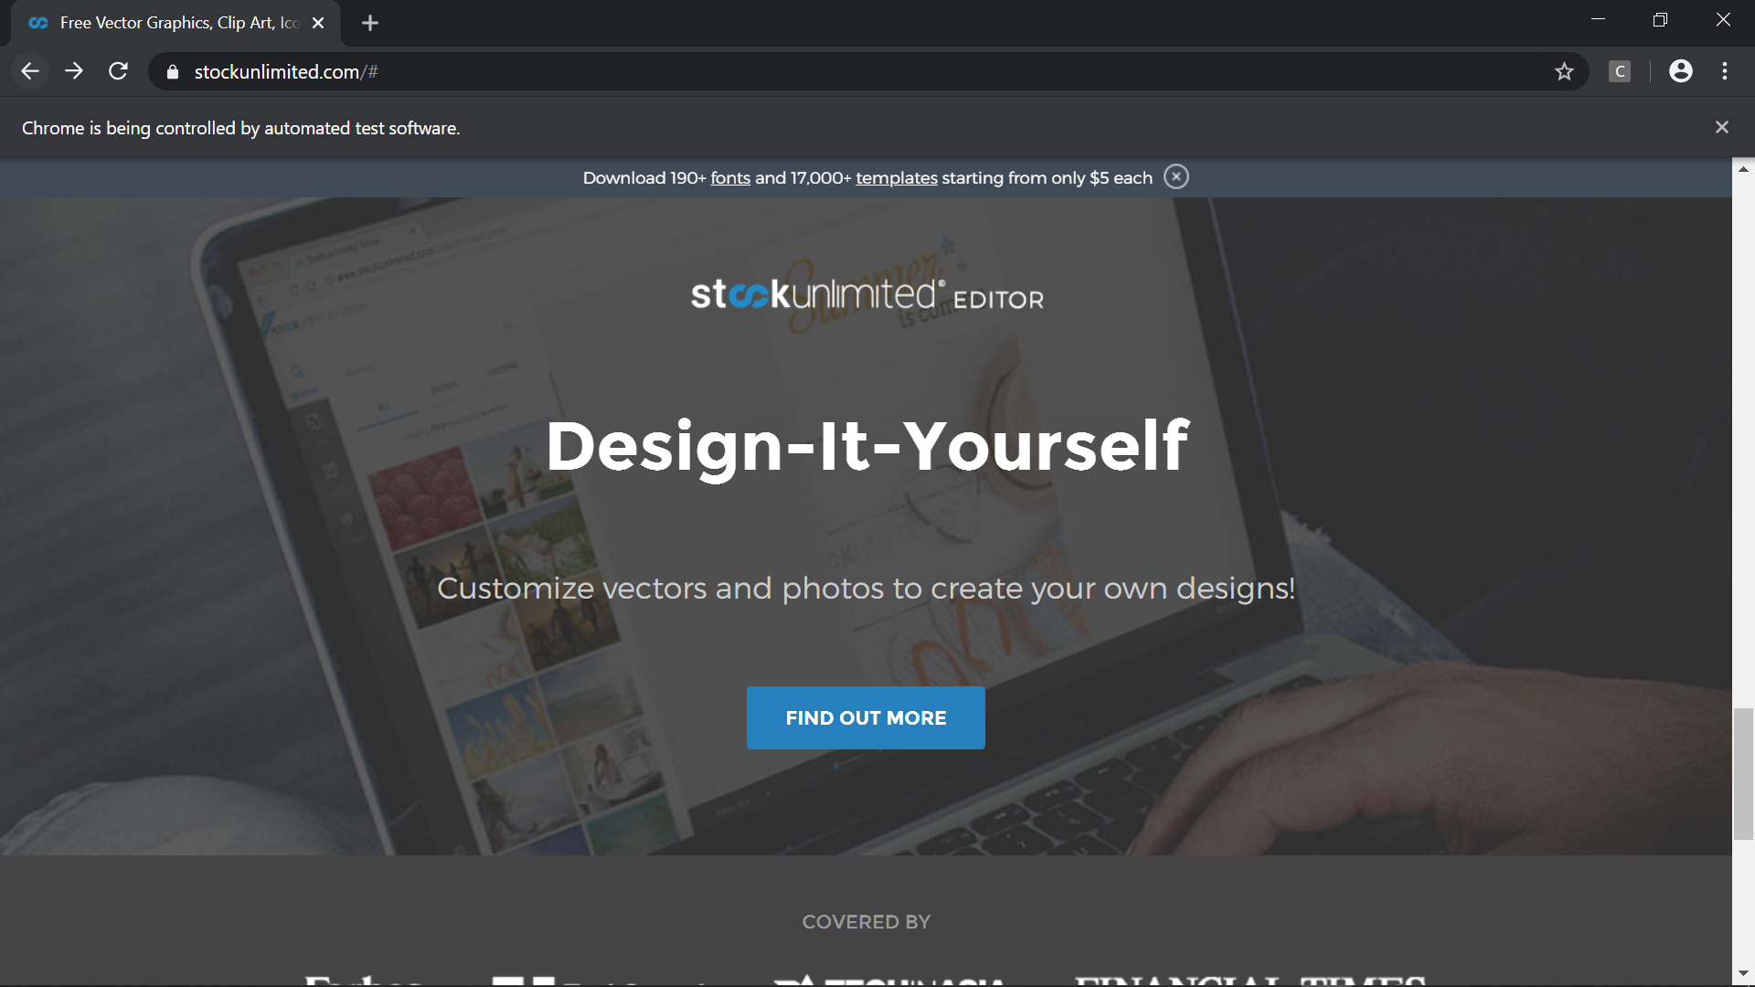

Hasil stelah meng-*klik* Find Out More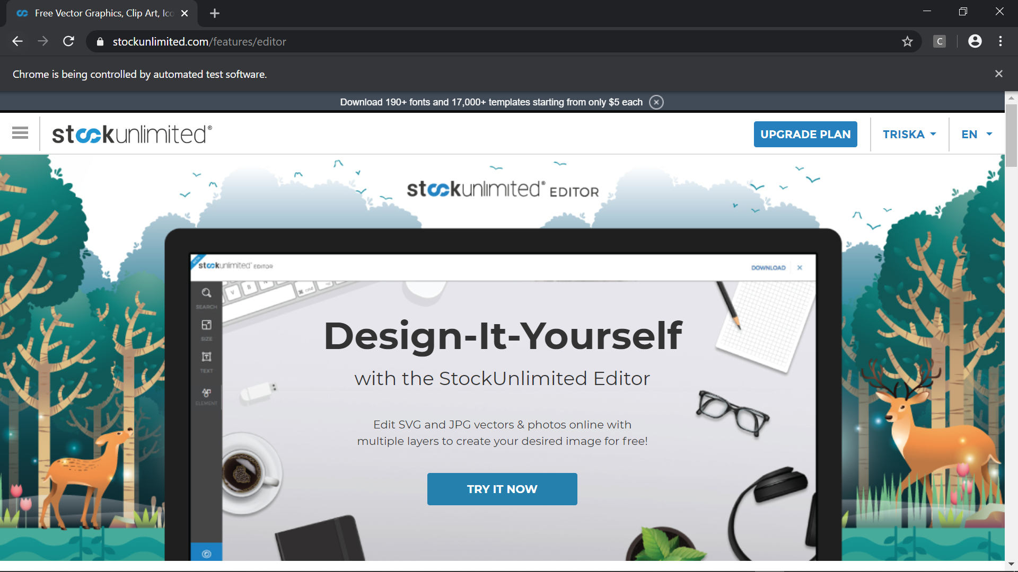

### Fungsi New Images

Test Case

* Scenario

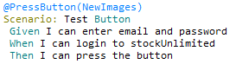

* Step Definition 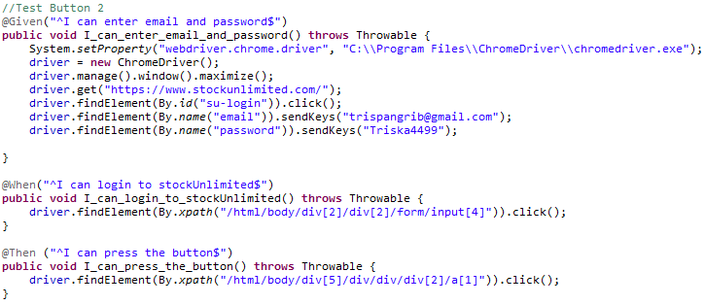
* Test Runner
* Console setelah Running 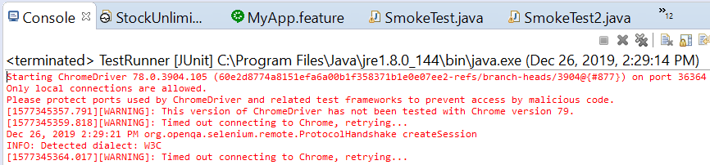
* Snippet Browser saat Testing

Dashboard sebelum Login

Form Login



Email dan password sudah diisi

Meng-*klik* New Images 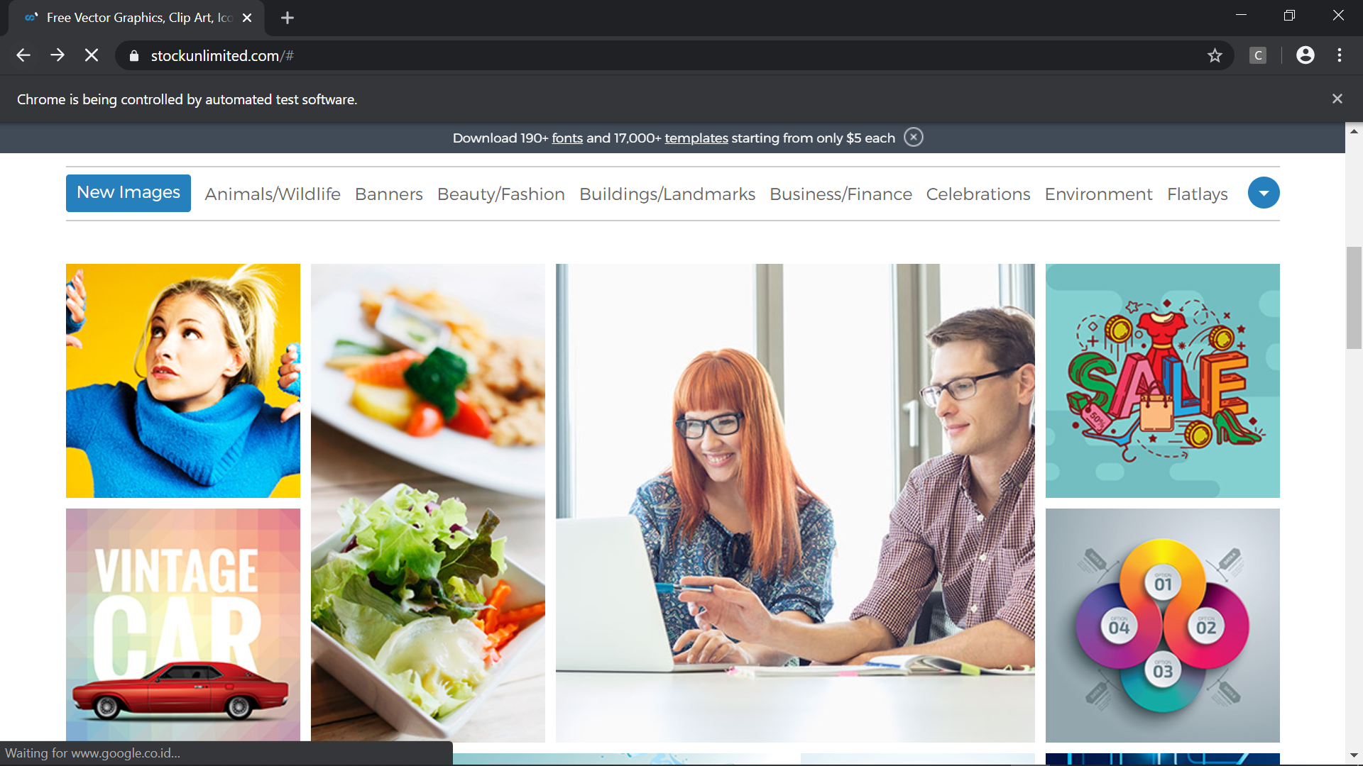

Hasil stelah meng-*klik* New Images

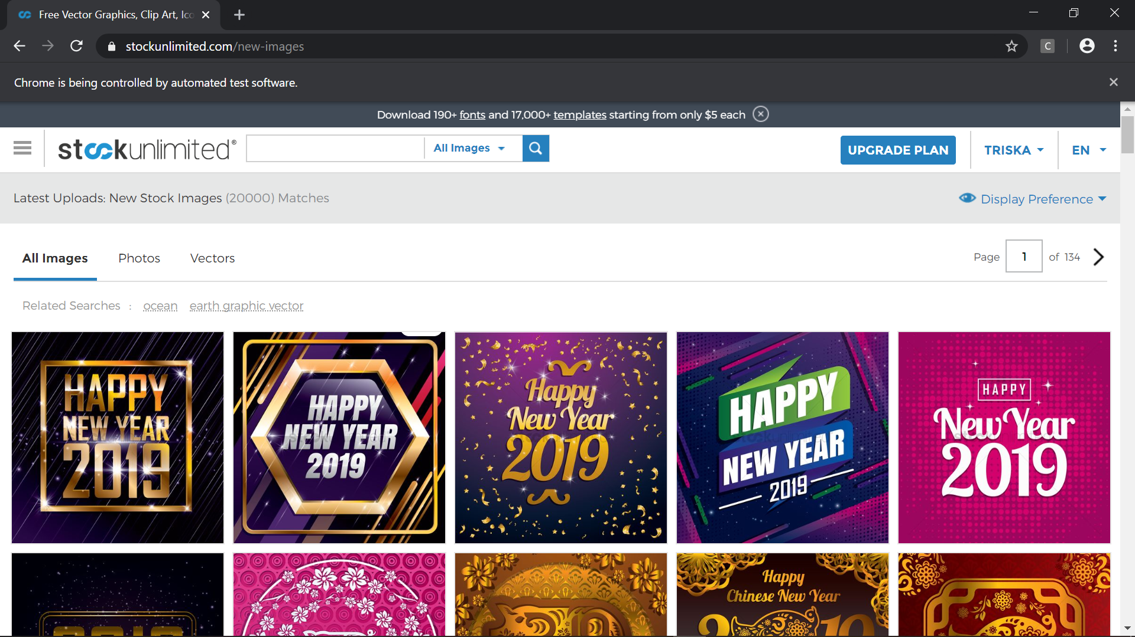

### Fungsi SEE PLANS & PRICING

Test Case

* Scenario

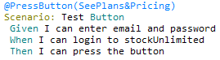

* Step Definition 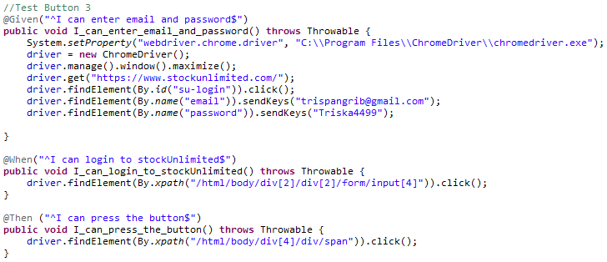
* Test Runner
* Console setelah Running 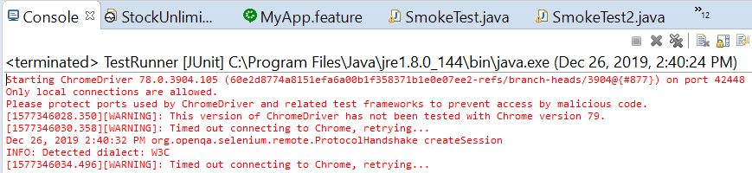
* Snippet Browser saat Testing

Dashboard sebelum Login

Form Login



Email dan password sudah diisi

Meng-*klik* UPGRADE PLAN

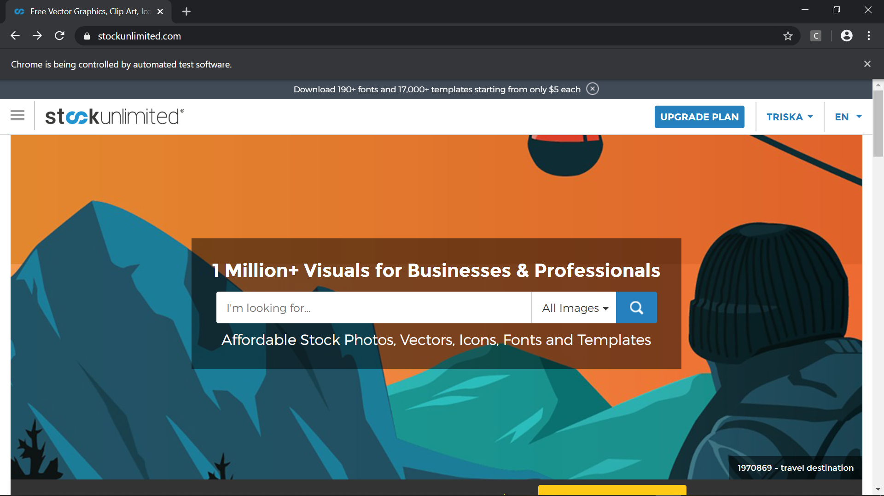

Hasil setelah meg-*klik* UPGRRAD PLAN

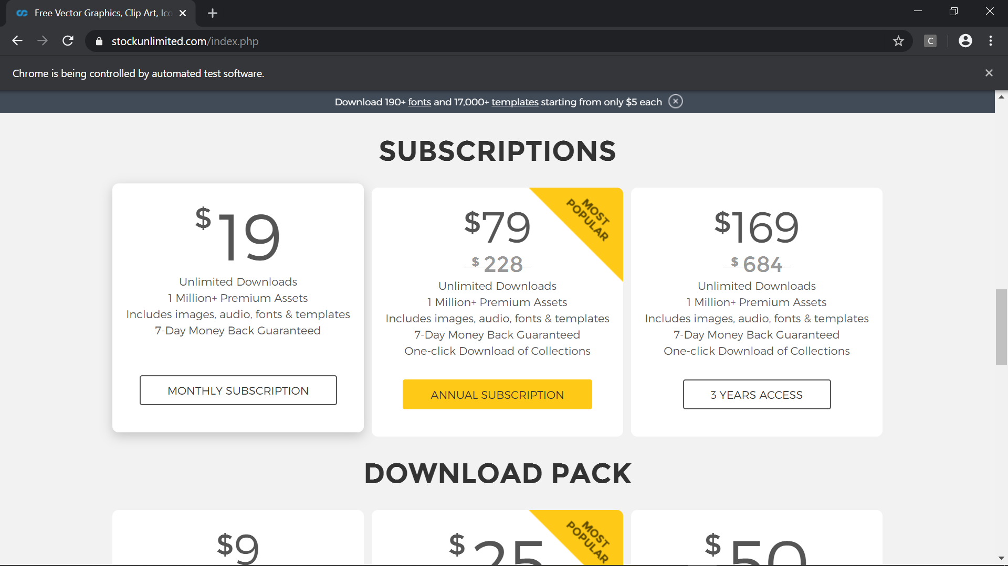

### Fungsi My Account

Test Case

* Scenario

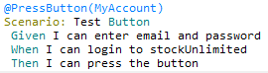

* Step Definition 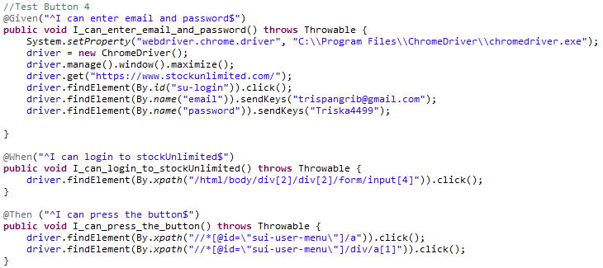
* Test Runner
* Console setelah Running 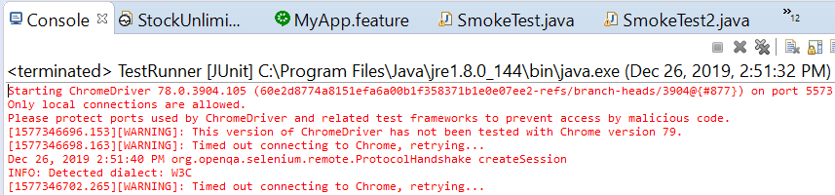
* Snippet Browser saat Testing

Dashboard sebelum Login

Form Login



Email dan password sudah diisi

Meng*-klik* menu profil (TRISKA) *drodown*  dan meng-*klik* MY ACCOUNT

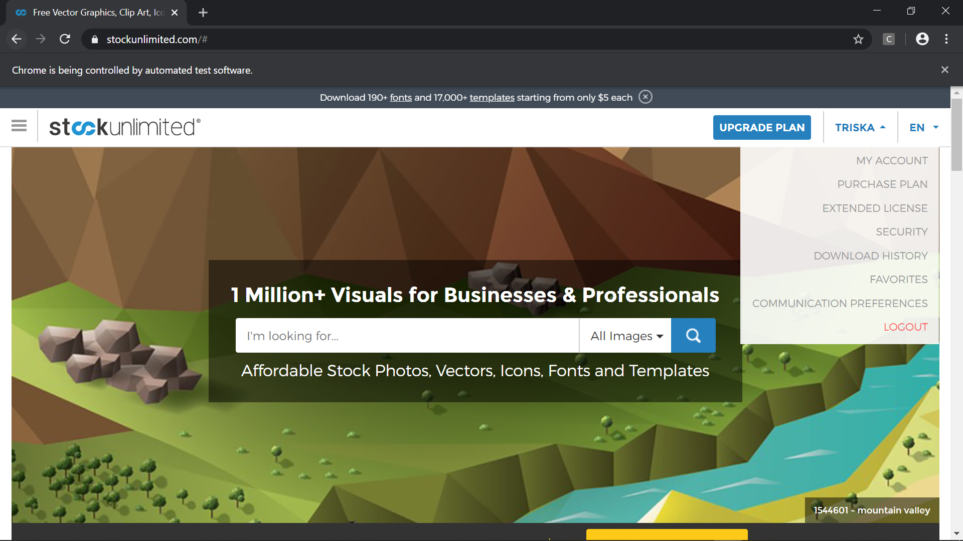

Hasil setelah meg-*klik* MY ACCOUNT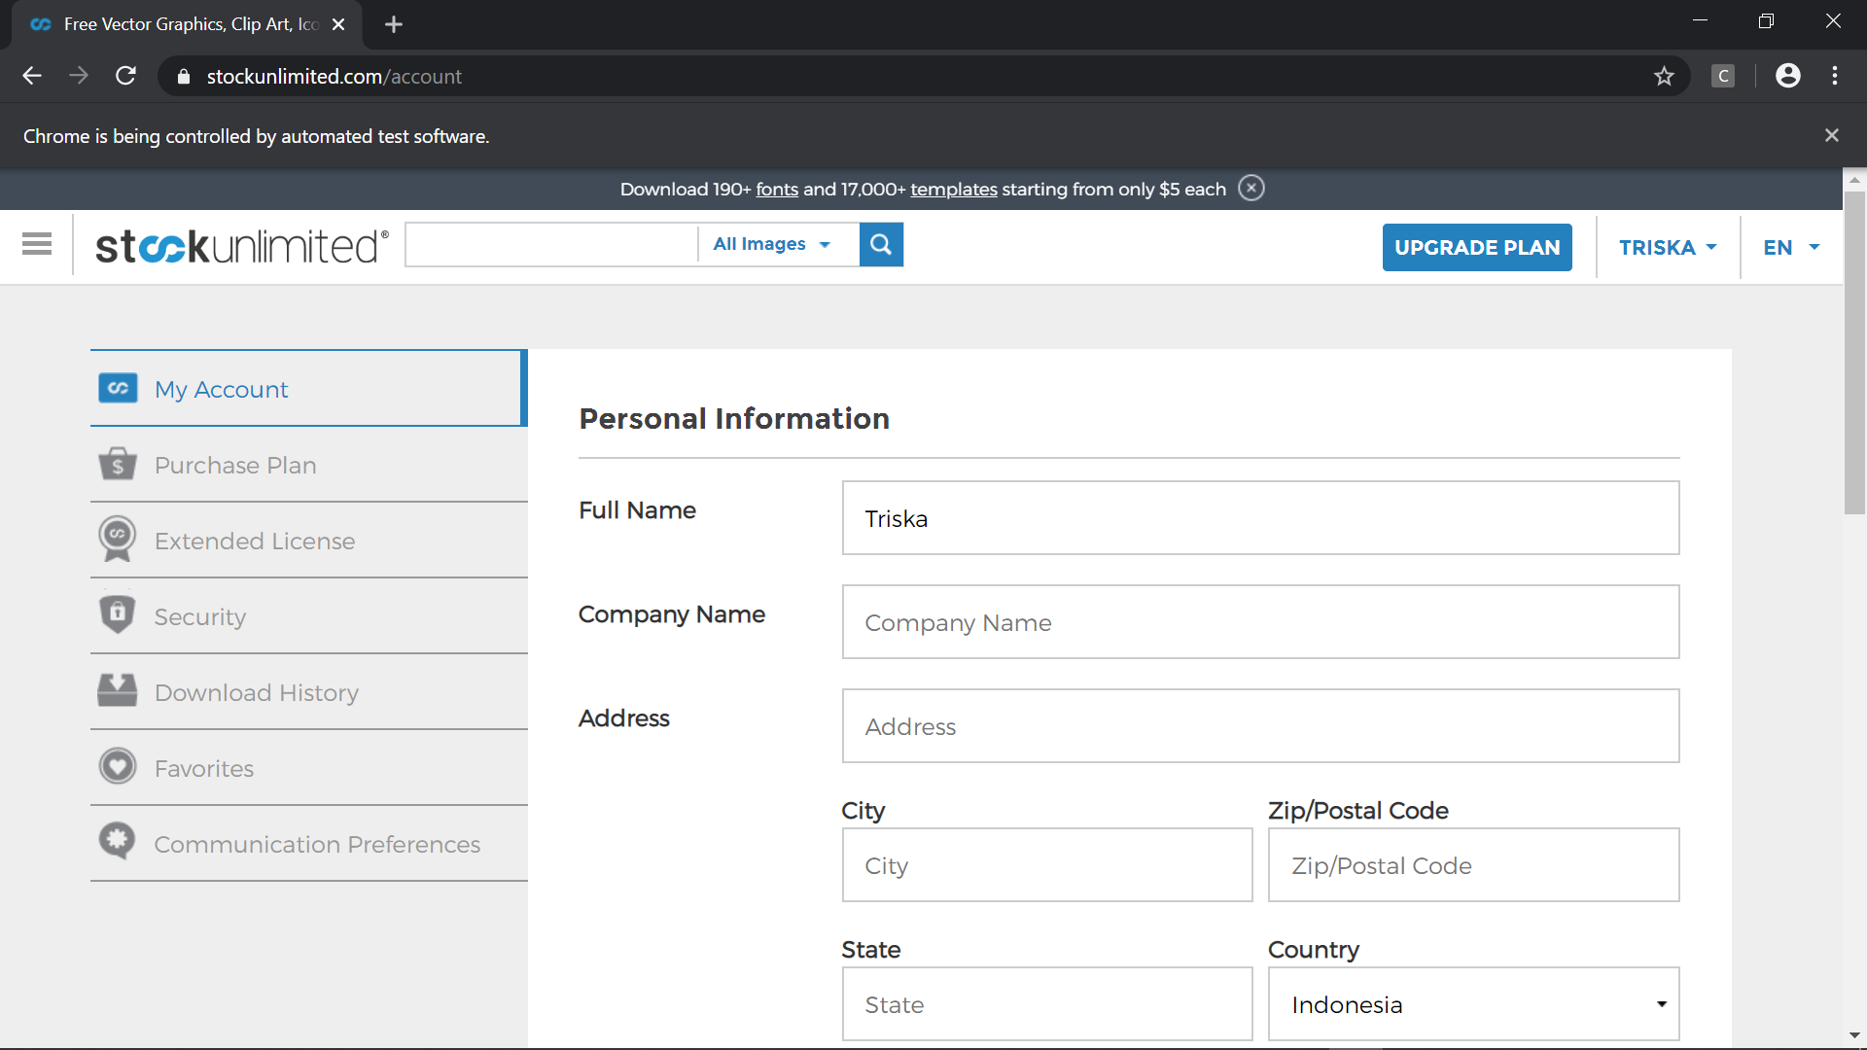

### Fungsi Favorites

Test Case

* Scenario

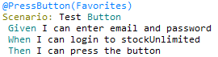

* Step Definition 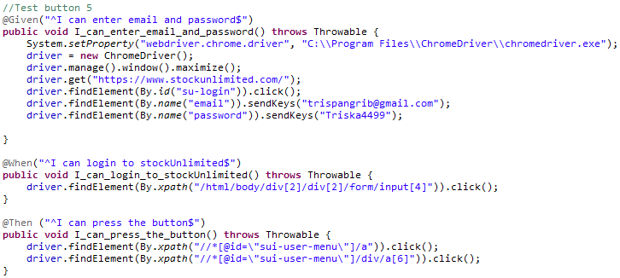
* Test Runner
* Console setelah Running 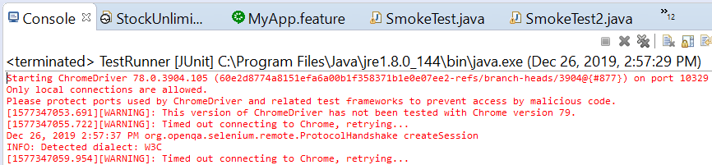
* Snippet Browser saat Testing

Dashboard sebelum Login

Form Login



Email dan password sudah diisi

Meng*-klik* menu profil (TRISKA) *drodown*  dan meng-*klik* MY FAVORITES



Hasil setelah meg-*klik* MY FAVORITES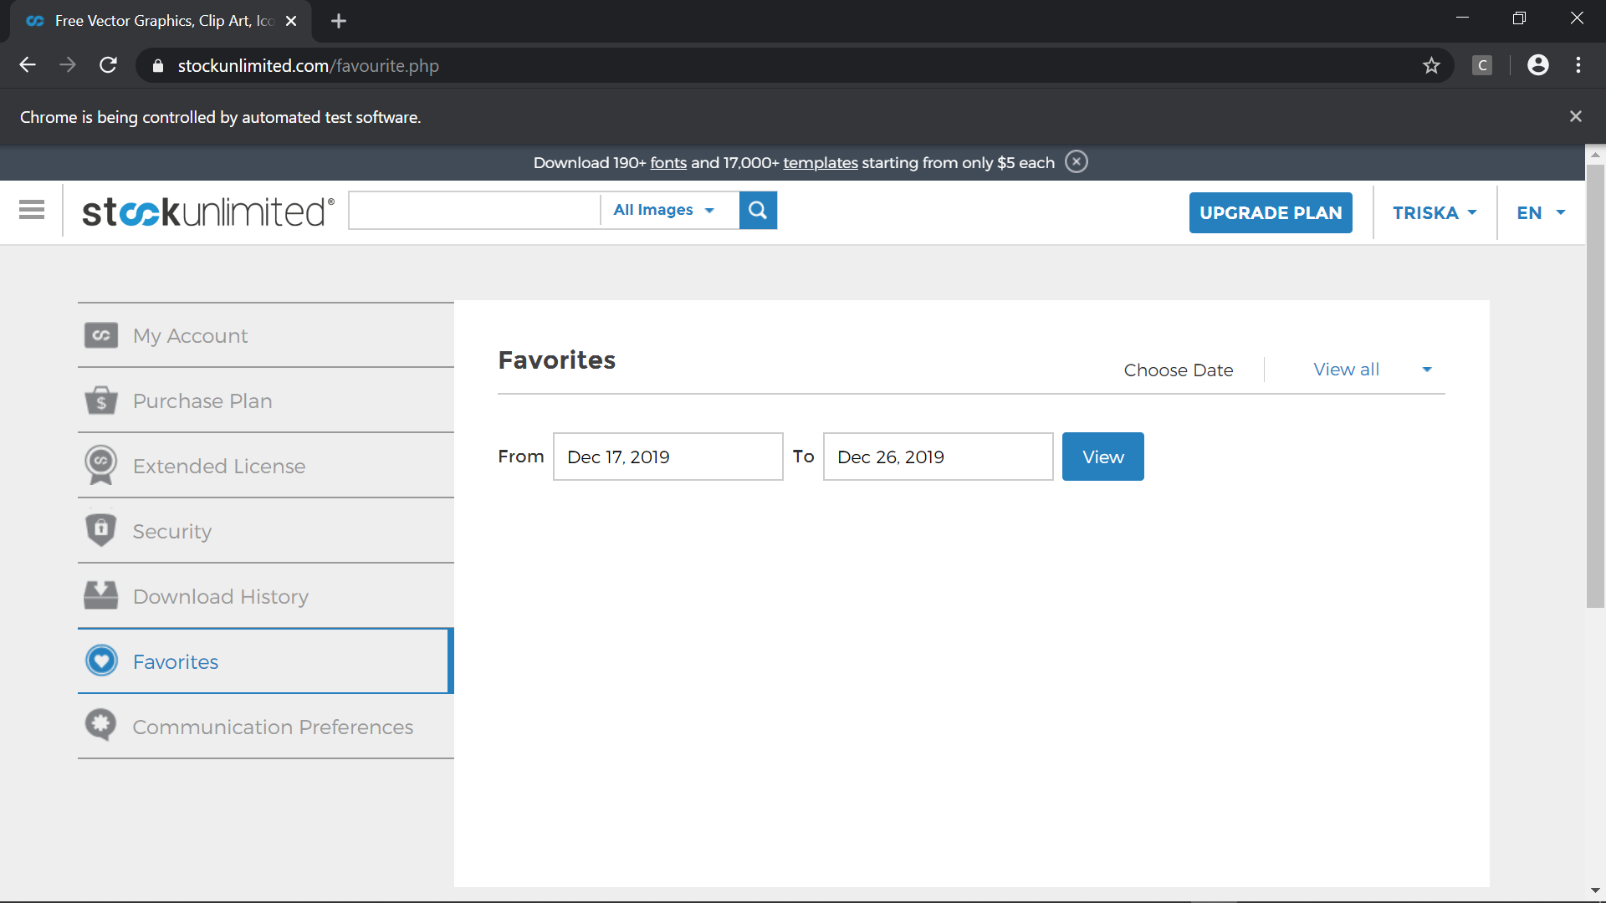

## **Pengujian Menggunakan RobotFramework**

### Fungsi Login

1. **FirstStockUnlimited.v1** (Email Valid, Password Valid)

* Scenario

**Open Browser** https://www.stockunlimited.com/ chrome

**Set Selenium Implicit Wait** 5

**Sleep** 2

**Click Element** xpath=//*[@id="su-login"]/a

**Sleep** 2

**Input Text** xpath=/html/body/div[2]/div[2]/form/span[2]/input

trispangrib@gmail.com

**Input Password** xpath=/html/body/div[2]/div[2]/form/span[3]/input Pangaribuan99

**Click Element** xpath=/html/body/div[2]/div[2]/form/input[4]

**Sleep** 3

**Close Browser**

**Log** Test Completed

* Snippet Browser saat Testing

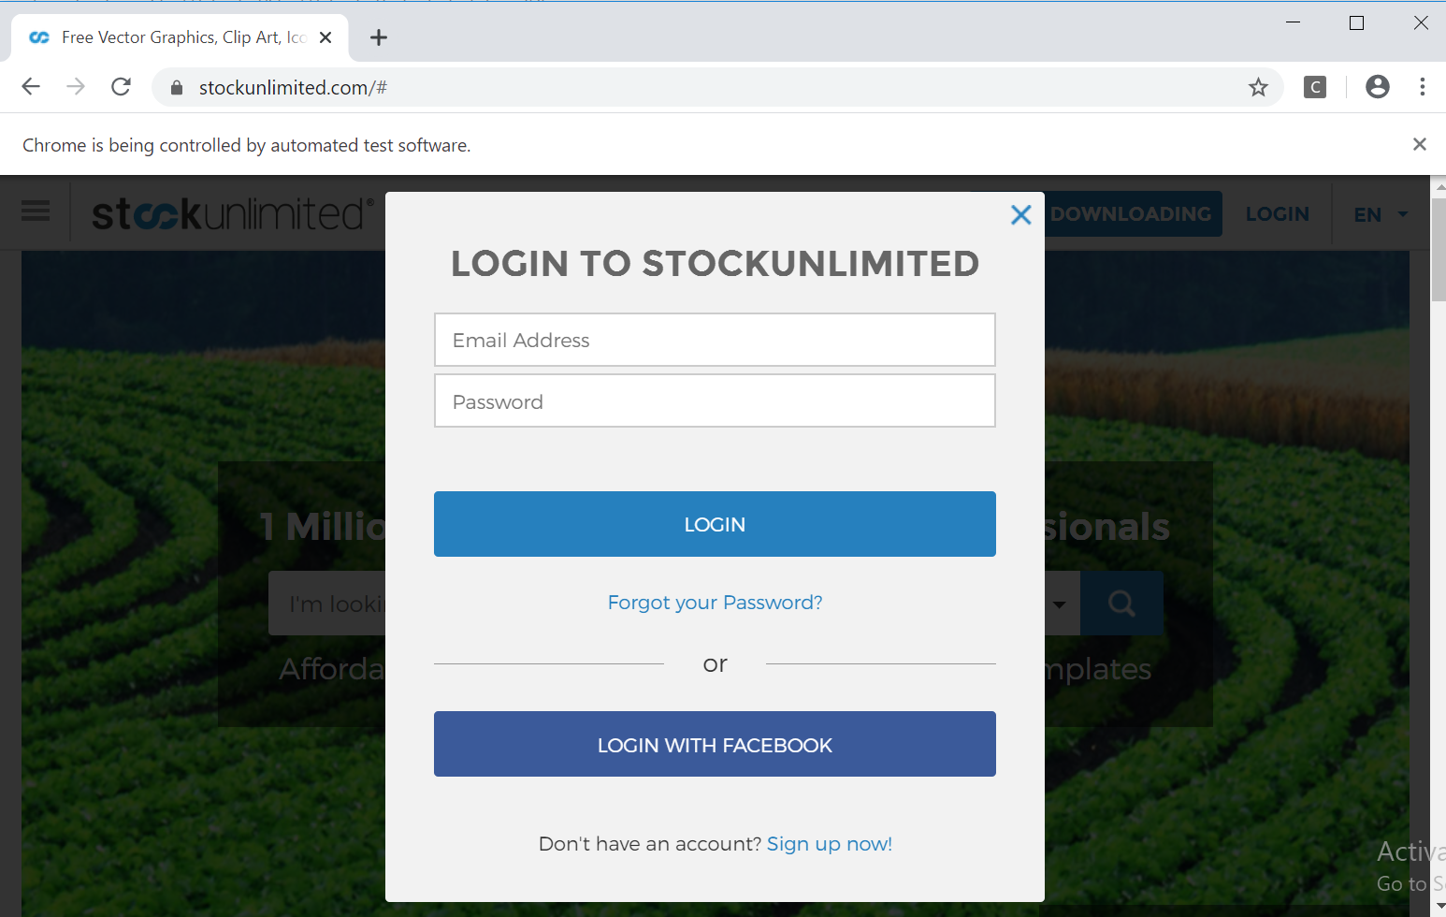

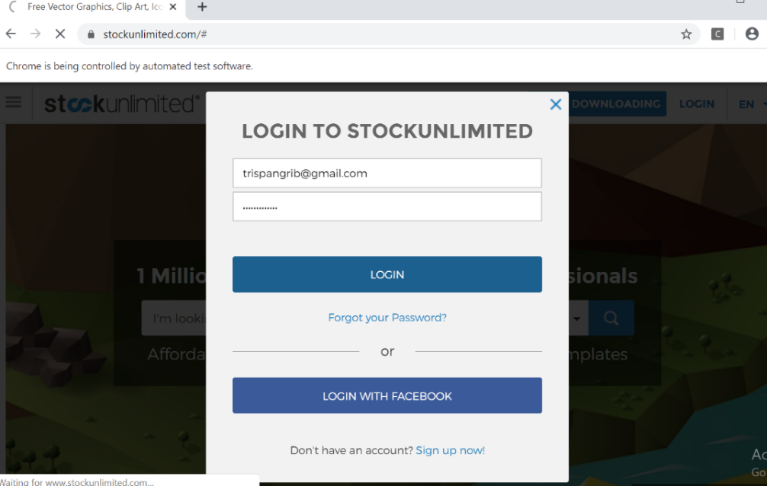

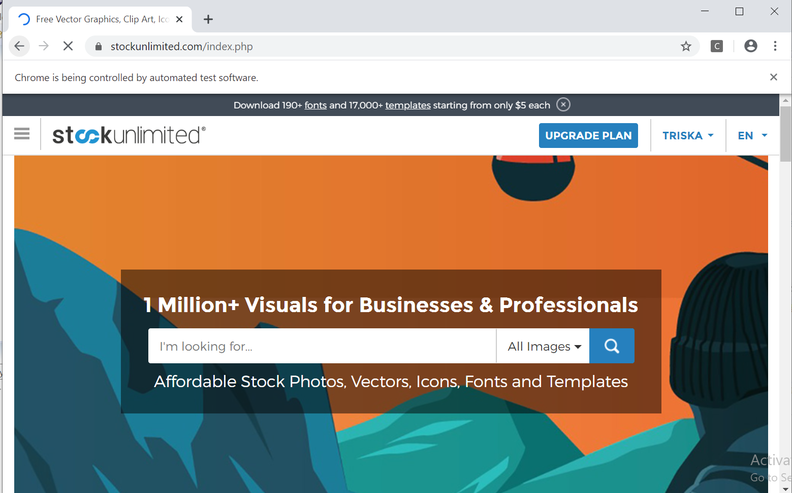

* Test Report

**Fungsi Login**

**Scenario**

|  |  |
| --- | --- |
| **Scenario** | **Description** |
| Open Browser | Alamat yang dituju adalah:  https://www.stockunlimited.com/ |
| Click Element | User mengklik elemen *link* “Login” |
| Input Text | User memasukkan *username* pada *text field* |
| Input Password | User memasukkan password pada *text field* |
| Click Element | User mengklik *button* Login |

**Test Frame**

| **No** | **Username** | **Password** |
| --- | --- | --- |
| 1 | Email Valid | Password Valid |
| 2 | Email Valid | Password Invalid |
| 3 | Email Invalid | Password Valid |
| 4 | Email Invalid | Password Invalid |

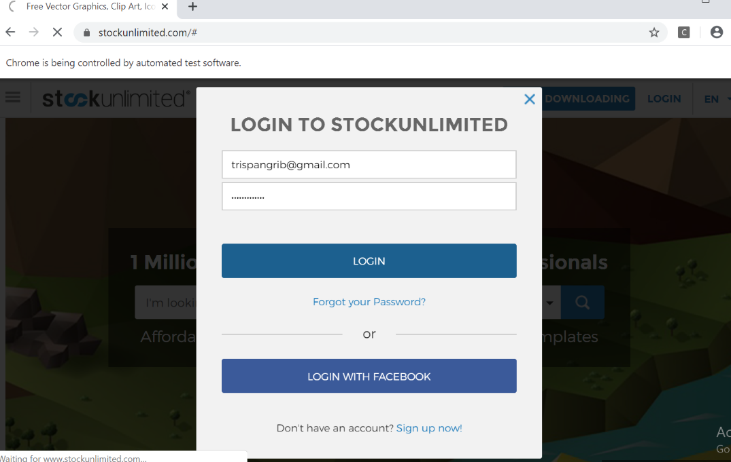**Test Fungsi FirstStockUnlimited.v1**

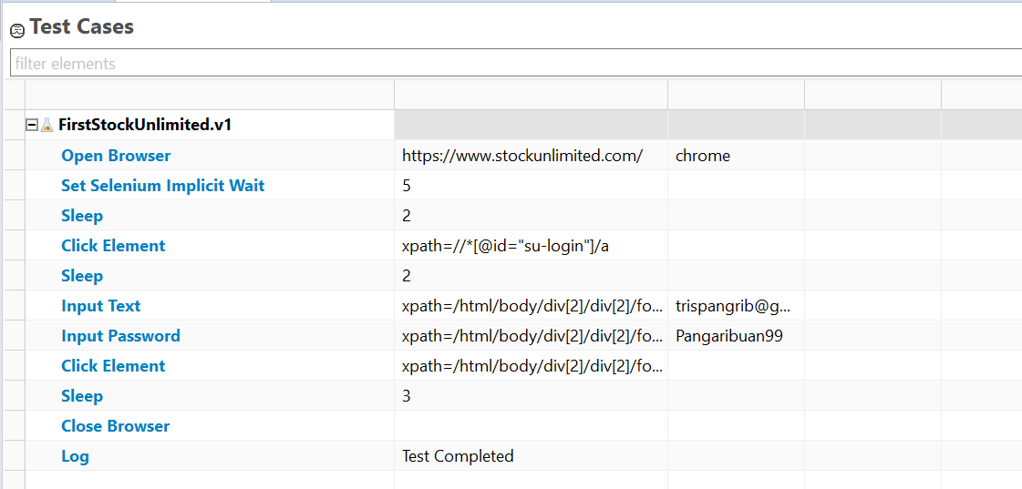

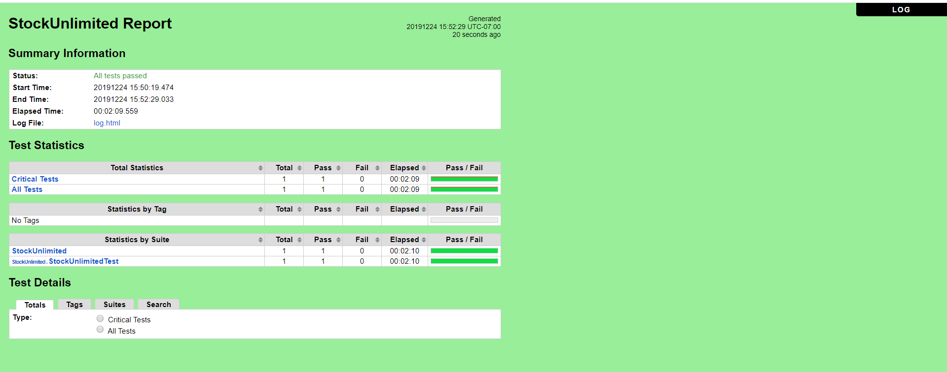

1. **FirstStockUnlimited.v2** (Email Valid, Password Invalid)

* Scenario

**Open Browser** https://www.stockunlimited.com/ chrome

**Set Selenium Implicit Wait** 5

**Sleep** 2

**Click Element** xpath=//*[@id="su-login"]/a

**Sleep** 2

**Input Text** xpath=/html/body/div[2]/div[2]/form/span[2]/input trispangrib@gmail.com

**Input Password** xpath=/html/body/div[2]/div[2]/form/span[3]/input ABCDA

**Click Element** xpath=/html/body/div[2]/div[2]/form/input[4]

**Sleep** 3

**Close Browser**

**Log** Test Completed

* Snippet Browser saat Testing



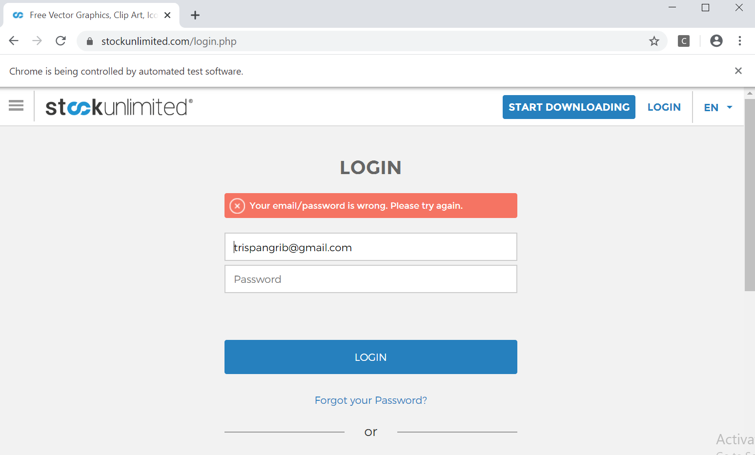

* Test Report

**Fungsi Login**

* **Scenario**

|  |  |
| --- | --- |
| **Scenario** | **Description** |
| Open Browser | Alamat yang dituju adalah:  https://www.stockunlimited.com/ |
| Click Element | User mengklik elemen *link* “Login” |
| Input Text | User memasukkan *username* pada *text field* |
| Input Password | User memasukkan password pada *text field* |
| Click Element | User mengklik *button* Login |

* **Test Frame**

| **No** | **Username** | **Password** |
| --- | --- | --- |
| 1 | Email Valid | Password Valid |
| 2 | Email Valid | Password Invalid |
| 3 | Email Invalid | Password Valid |
| 4 | Email Invalid | Password Invalid |

* **Test Fungsi FirstStockUnlimited.v2**



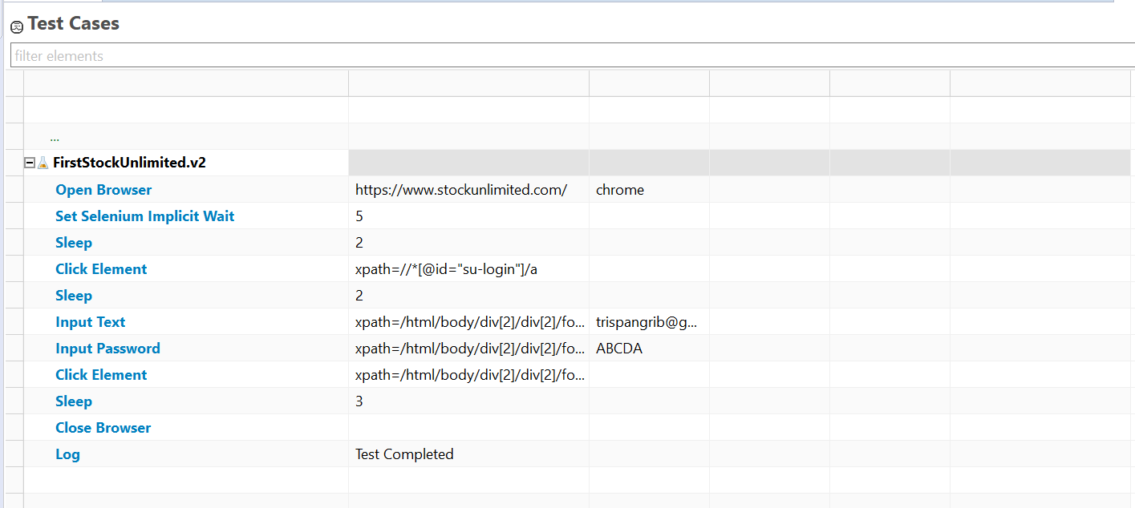

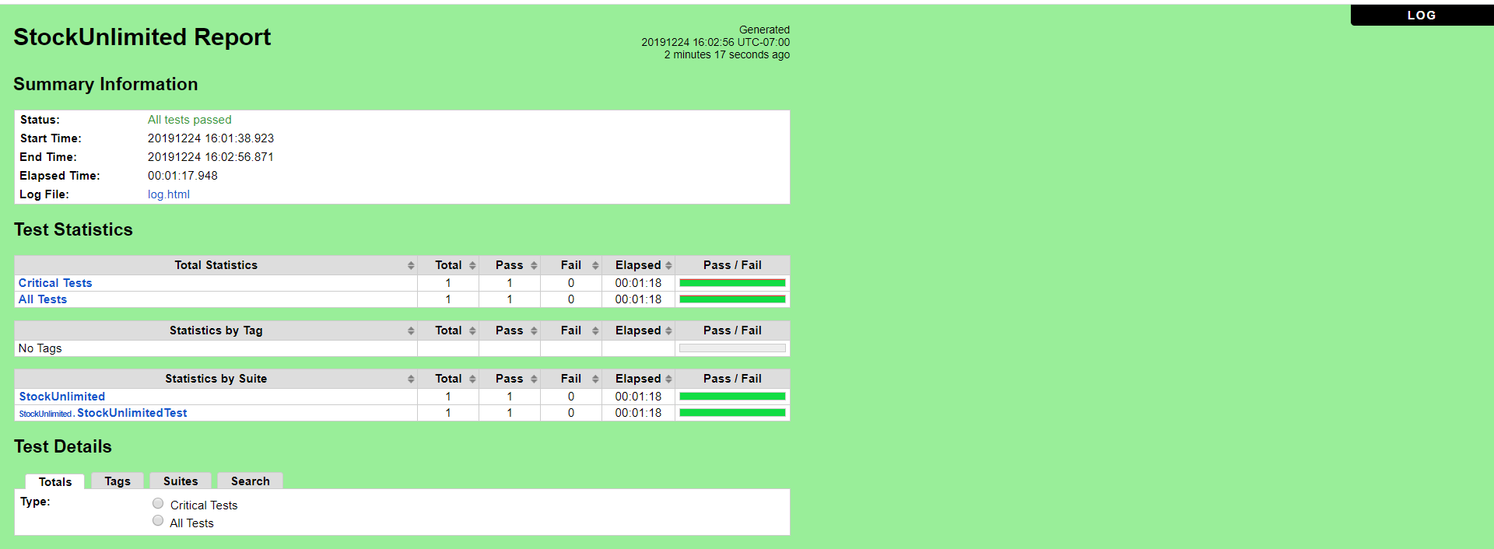

1. **FirstStockUnlimited.v3** (Email Invalid, Password Valid)

* Scenario

**Open Browser** https://www.stockunlimited.com/ chrome

**Set Selenium Implicit Wait** 5

**Sleep** 2

**Click Element** xpath=//*[@id="su-login"]/a

**Sleep** 2

**Input Text** xpath=/html/body/div[2]/div[2]/form/span[2]/input trisp@gmail.com

**Input Password** xpath=/html/body/div[2]/div[2]/form/span[3]/input Pangaribuan99

**Click Element** xpath=/html/body/div[2]/div[2]/form/input[4]

**Sleep** 3

**Close Browser**

**Log** Test Completed

* Snippet Browser saat Testing



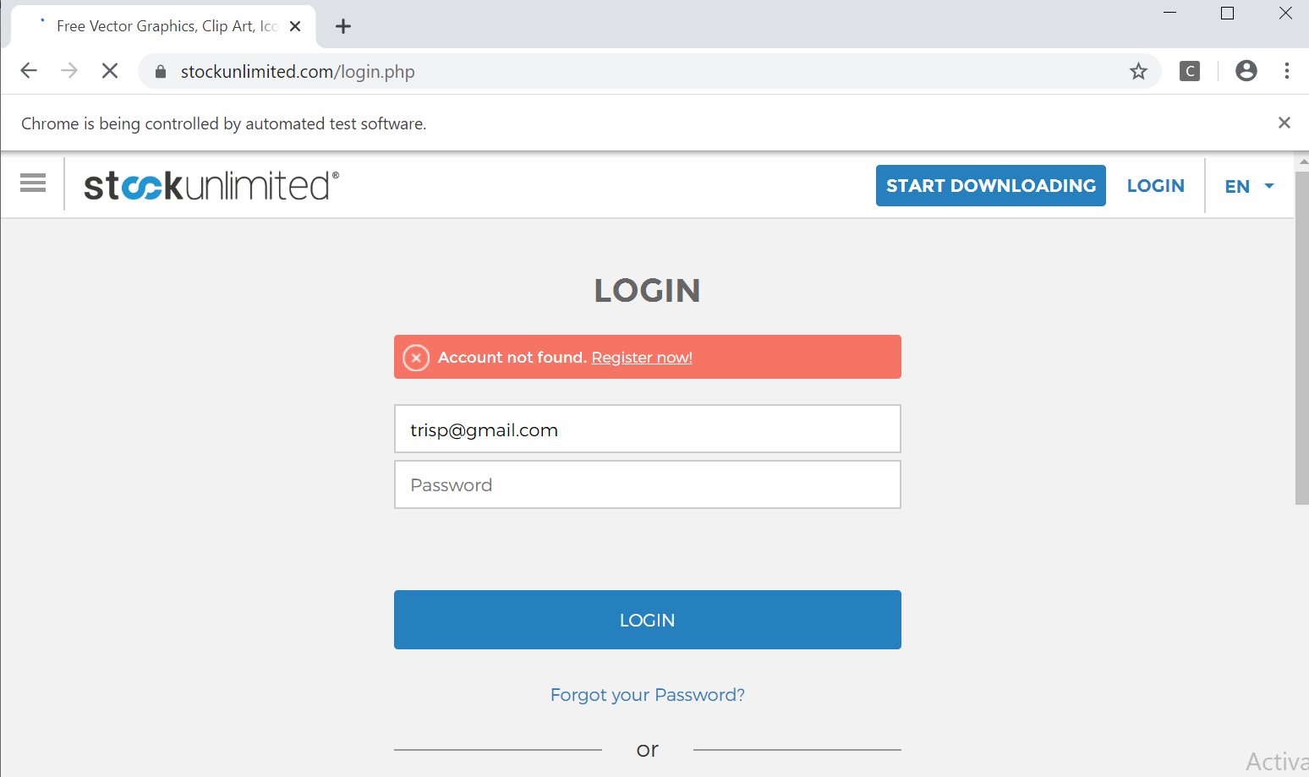

* Test Report

**Fungsi Login**

* **Scenario**

|  |  |
| --- | --- |
| **Scenario** | **Description** |
| Open Browser | Alamat yang dituju adalah:  https://www.stockunlimited.com/ |
| Click Element | User mengklik elemen *link* “Login” |
| Input Text | User memasukkan *username* pada *text field* |
| Input Password | User memasukkan password pada *text field* |
| Click Element | User mengklik *button* Login |

* **Test Frame**

| **No** | **Username** | **Password** |
| --- | --- | --- |
| 1 | Email Valid | Password Valid |
| 2 | Email Valid | Password Invalid |
| 3 | Email Invalid | Password Valid |
| 4 | Email Invalid | Password Invalid |

* **Test Fungsi FirstStockUnlimited.v3**



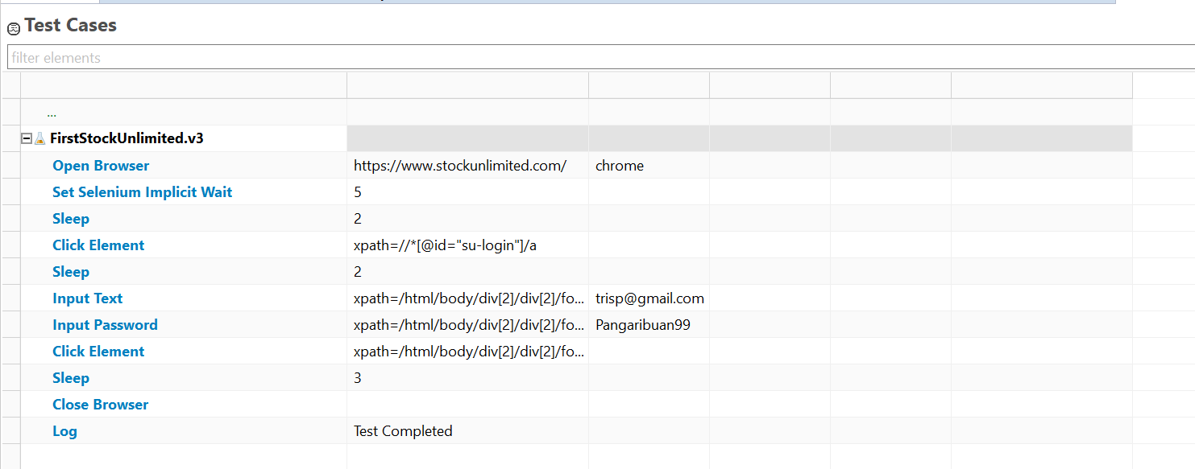

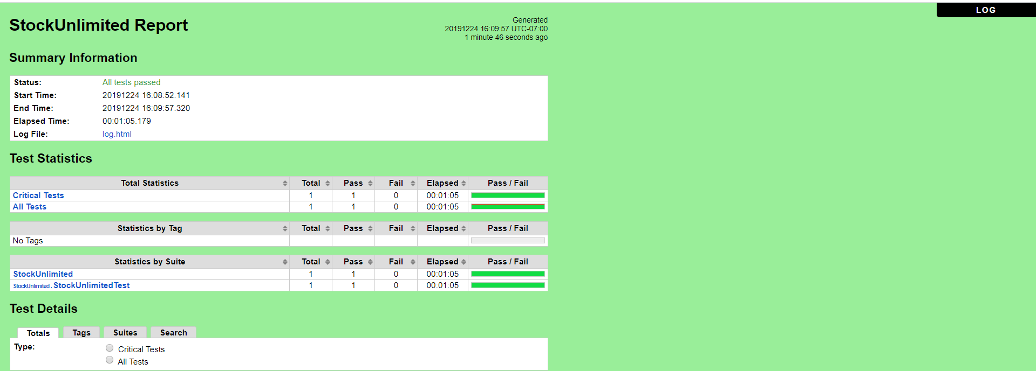

1. **FirstStockUnlimited.v4** (Email Invalid,Password Invalid)

* Scenario

**Open Browser** https://www.stockunlimited.com/ chrome

**Set Selenium Implicit Wait** 5

**Sleep** 2

**Click Element** xpath=//*[@id="su-login"]/a

**Sleep** 2

**Input Text** xpath=/html/body/div[2]/div[2]/form/span[2]/input trisp@gmail.com

**Input Password** xpath=/html/body/div[2]/div[2]/form/span[3]/input ABCDA

**Click Element** xpath=/html/body/div[2]/div[2]/form/input[4]

**Sleep** 3

**Close Browser**

**Log** Test Completed

* Snippet Browser saat Testing



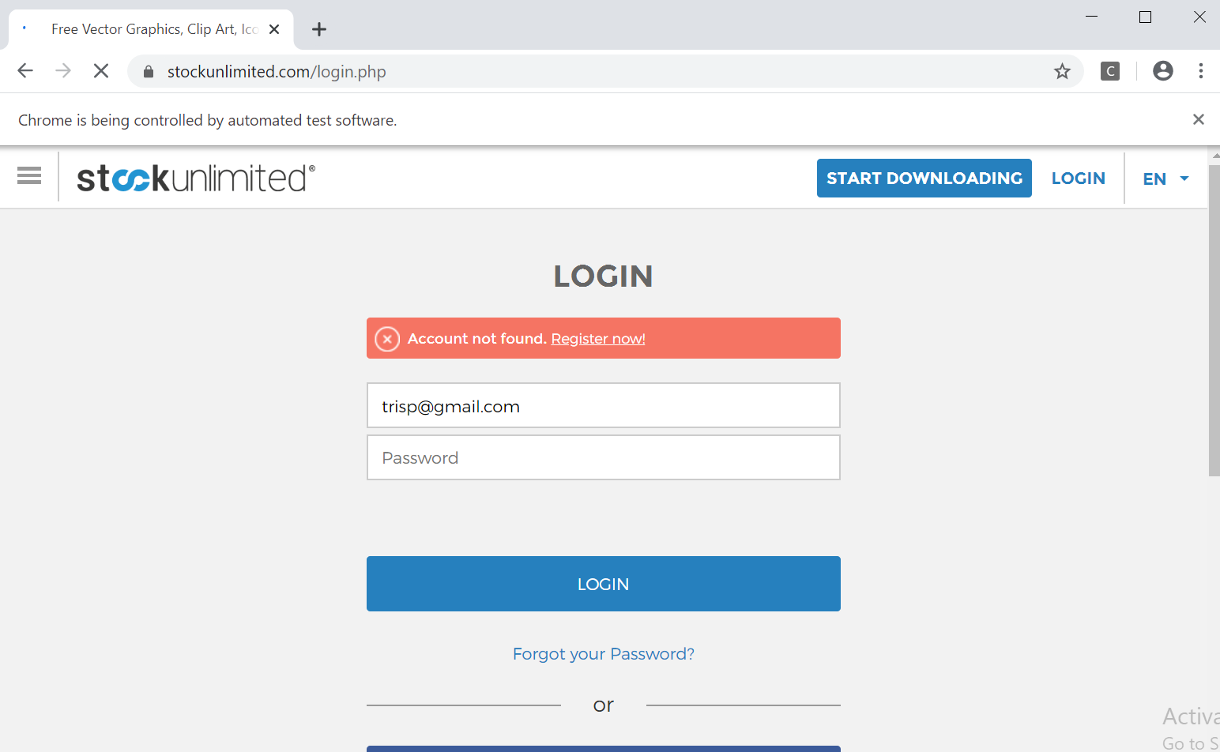

* Test Report

**Fungsi Login**

* **Scenario**

|  |  |
| --- | --- |
| **Scenario** | **Description** |
| Open Browser | Alamat yang dituju adalah:  https://www.stockunlimited.com/ |
| Click Element | User mengklik elemen *link* “Login” |
| Input Text | User memasukkan *username* pada *text field* |
| Input Password | User memasukkan password pada *text field* |
| Click Element | User mengklik *button* Login |

* **Test Frame**

| **No** | **Username** | **Password** |
| --- | --- | --- |
| 1 | Email Valid | Password Valid |
| 2 | Email Valid | Password Invalid |
| 3 | Email Invalid | Password Valid |
| 4 | Email Invalid | Password Invalid |

* **Test Fungsi FirstStockUnlimited.v4**



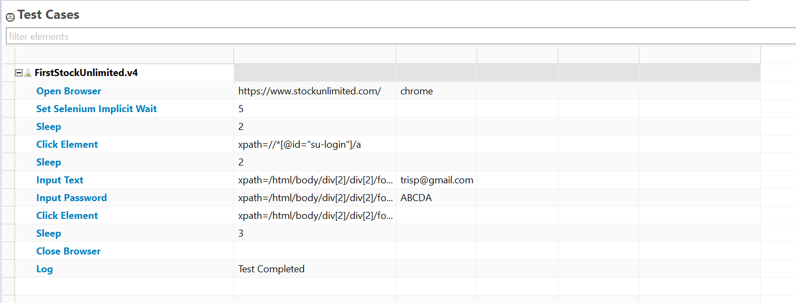

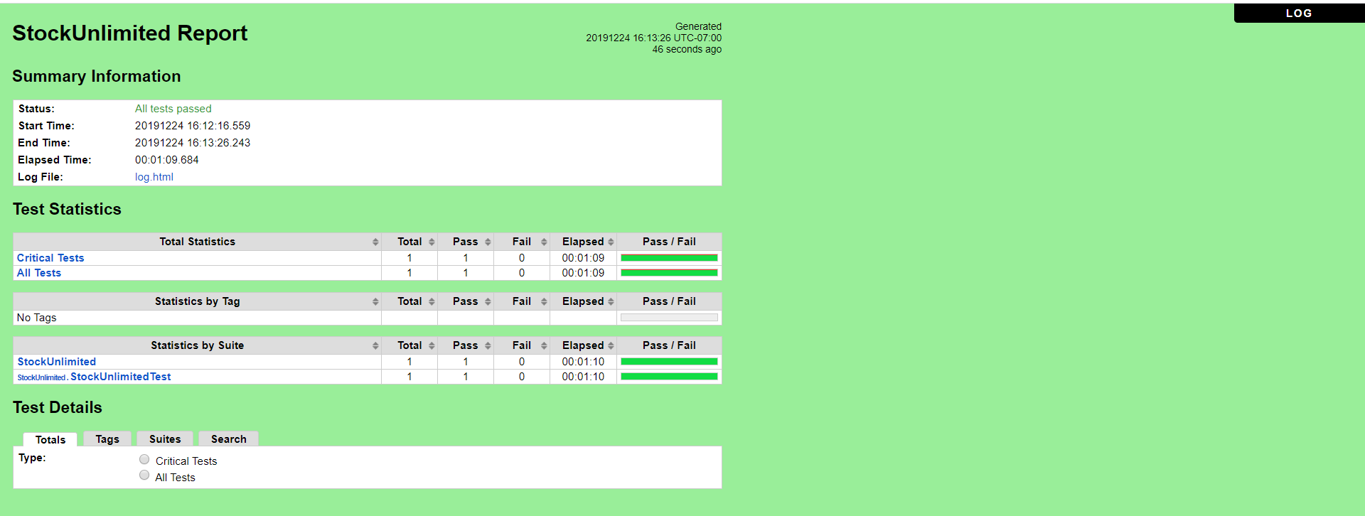

### Fungsi Searching (Vectors)

a. **SecondStockUnlimited.v1** (Vectors Valid)

* Scenario

**Open Browser** https://www.stockunlimited.com/ chrome

**Set Selenium Implicit Wait** 5

**Sleep** 2

**Click Element** xpath=//*[@id="su-login"]/a

**Sleep** 2

**Input Text** xpath=/html/body/div[2]/div[2]/form/span[2]/input trispangrib@gmail.com

**Input Password** xpath=/html/body/div[2]/div[2]/form/span[3]/input Pangaribuan99

**Click Element** xpath=/html/body/div[2]/div[2]/form/input[4]

**Sleep** 3

**Input Text** xpath=//*[@id="search_word"] workbook

**Click Element** xpath=//*[@id="search_box"]/div/div[1]

**Click Element** xpath=//*[@id="search_box"]/div/div[2]/span[1]/input

**Click Element** xpath=//*[@id="search_box"]/input[3]

**Sleep** 3

**Close Browser**

**Log** Test Completed

* Snippet Browser saat Testing







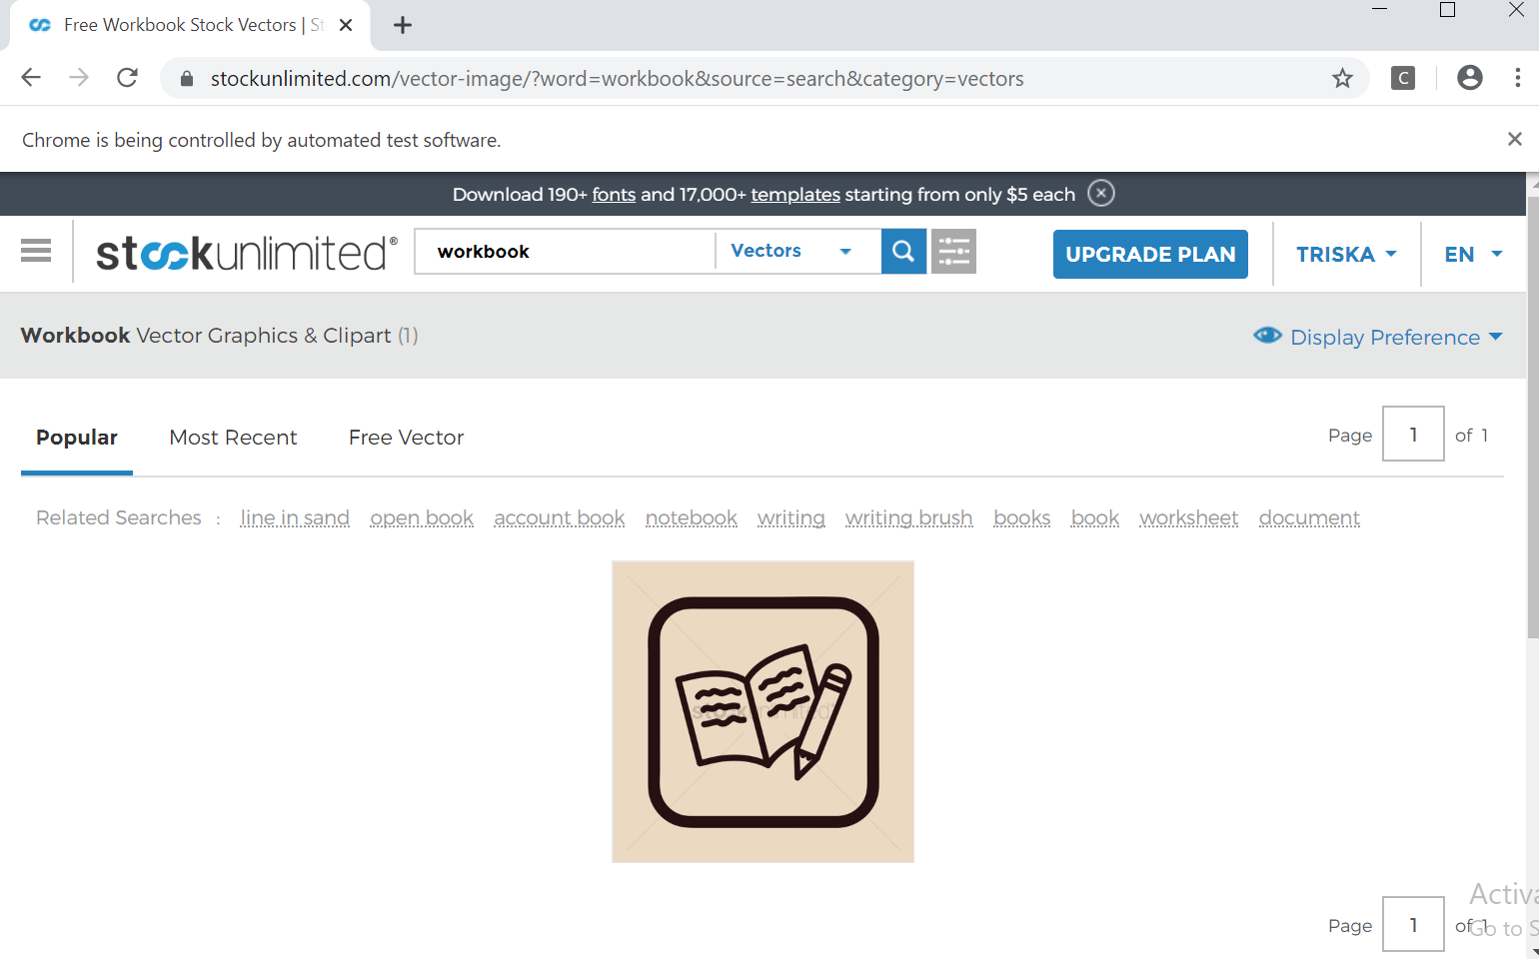

* Test Report

### **Fungsi Searching (Vectors)**

**Scenario**

|  |  |
| --- | --- |
| **Scenario** | **Description** |
| Open Browser | Alamat yang dituju adalah:  https://www.stockunlimited.com/ |
| Click Element | User mengklik elemen *link* “Login” |
| Input Text | User memasukkan *username* pada *text field* |
| Input Password | User memasukkan password pada *text field* |
| Click Element | User mengklik *button* Login |
| Input Text | User memasukkan *inputan* yang diinginkan |
| Click Element | Untuk mengklik *button* Select “Vectors” |
| Click Element | Untuk mengklik *button* Pencarian |

**Test Frame**

| **No** | **Searching** |
| --- | --- |
| 1 | Vectors Valid |
| 2 | Vectors Invalid |

**Test Fungsi SecondStockUnlimited.v2**



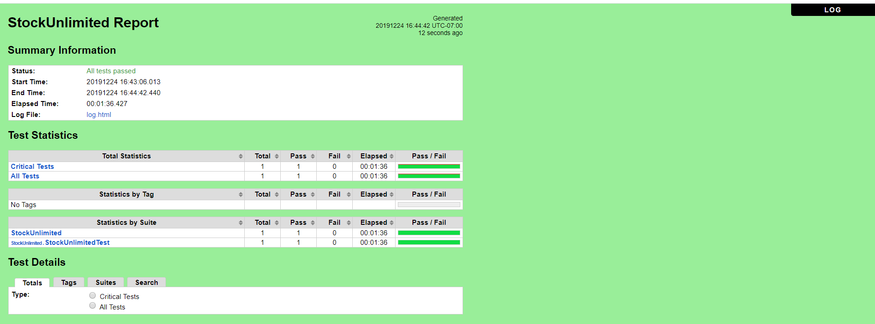

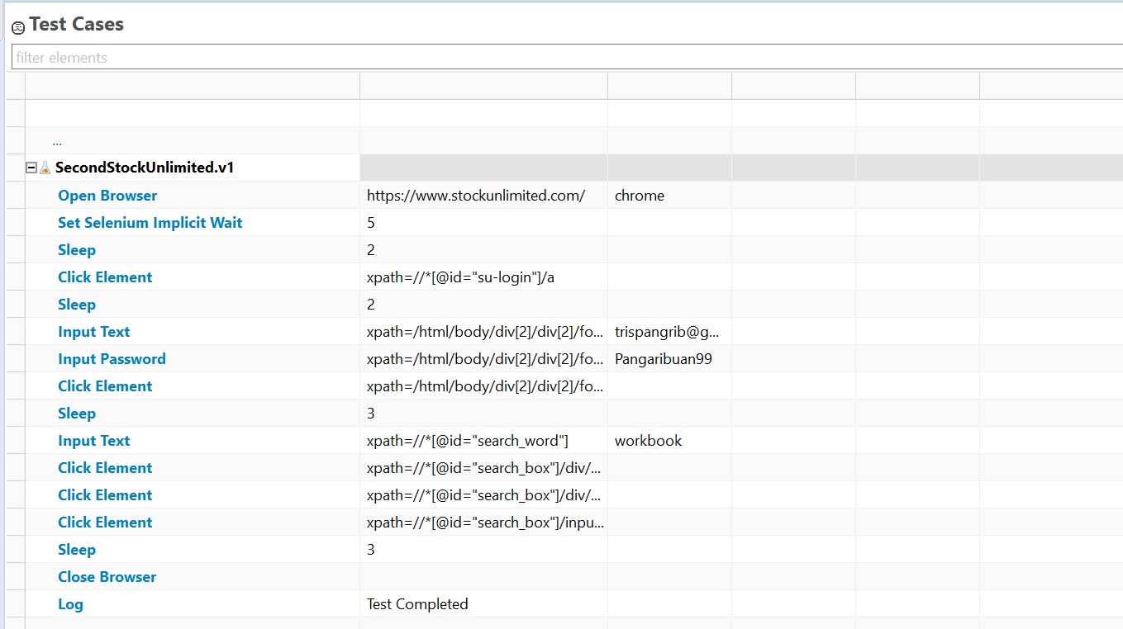

b. **SecondStockUnlimited.v2** (Vectors Invalid)

* Scenario

**Open Browser** https://www.stockunlimited.com/ chrome

**Set Selenium Implicit Wait** 5

**Sleep** 2

**Click Element** xpath=//*[@id="su-login"]/a

**Sleep** 2

**Input Text** xpath=/html/body/div[2]/div[2]/form/span[2]/input trispangrib@gmail.com

**Input Password** xpath=/html/body/div[2]/div[2]/form/span[3]/input Pangaribuan99

**Click Element** xpath=/html/body/div[2]/div[2]/form/input[4]

**Sleep** 3

**Input Text** xpath=//*[@id="search_word"] forte

**Click Element** xpath=//*[@id="search_box"]/div/div[1]

**Sleep** 2

**Click Element** xpath=//*[@id="search_box"]/div/div[2]/span[1]/input

**Sleep** 2

**Click Element** xpath=//*[@id="search_box"]/input[3]

**Sleep** 2

**Close Browser**

**Log** Test Completed

* Snippet Browser saat Testing







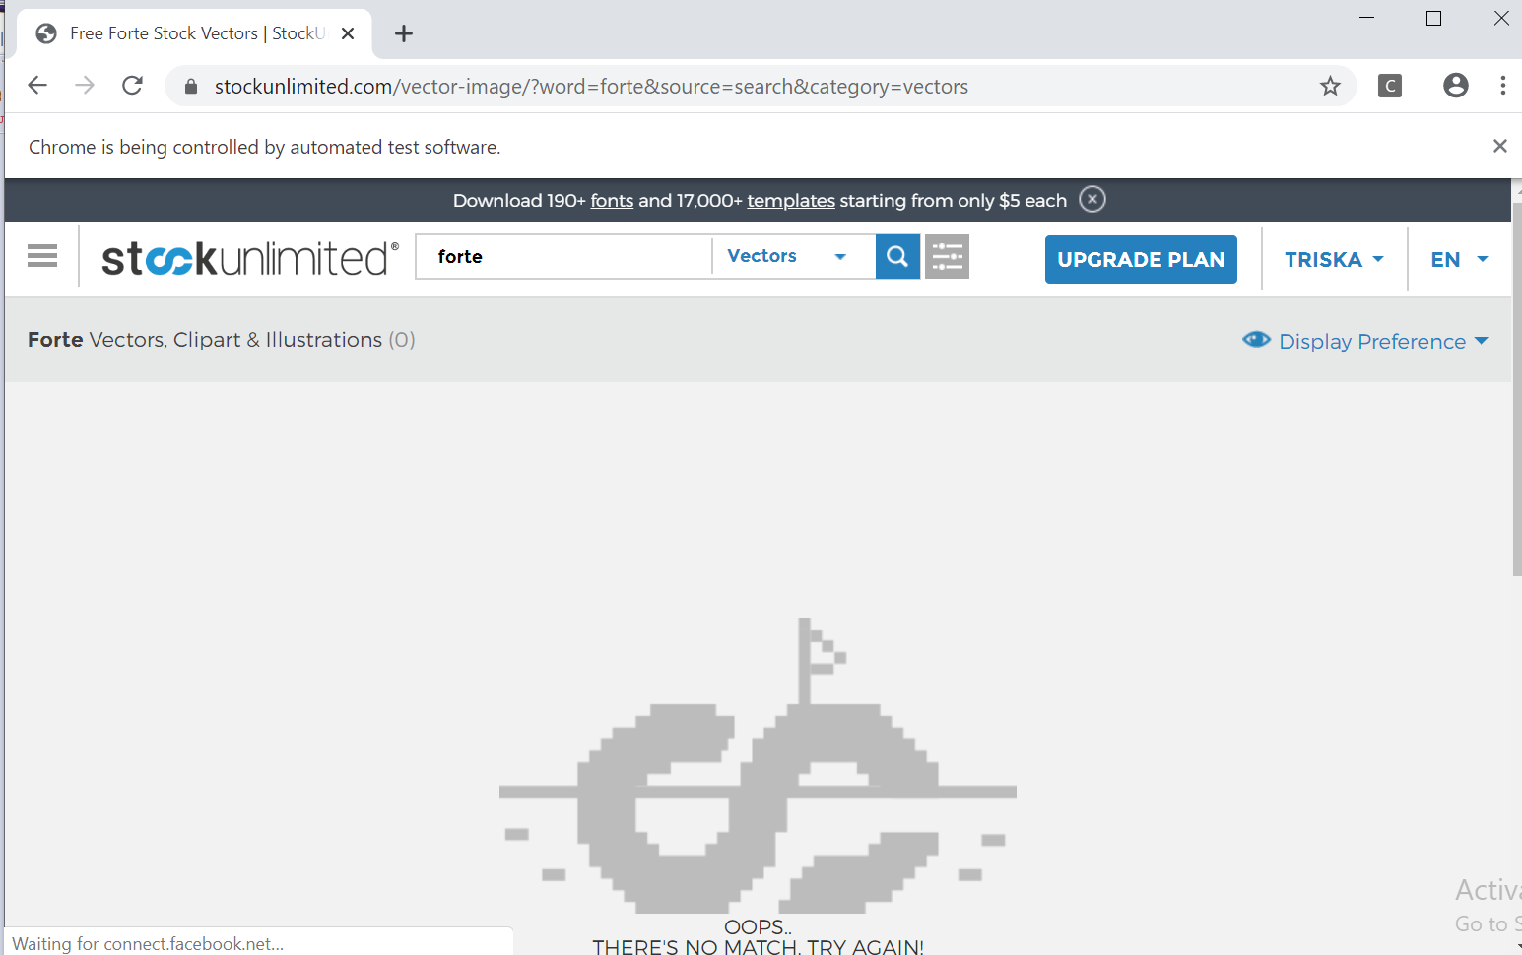

* Test Report

### **Fungsi Searching (Vectors)**

**Scenario**

|  |  |
| --- | --- |
| **Scenario** | **Description** |
| Open Browser | Alamat yang dituju adalah:  https://www.stockunlimited.com/ |
| Click Element | User mengklik elemen *link* “Login” |
| Input Text | User memasukkan *username* pada *text field* |
| Input Password | User memasukkan password pada *text field* |
| Click Element | User mengklik *button* Login |
| Input Text | User memasukkan *inputan* yang diinginkan |
| Click Element | Untuk mengklik *button* Select “Vectors” |
| Click Element | Untuk mengklik *button* Pencarian |

* **Test Frame**

| **No** | **Searching** |
| --- | --- |
| 1 | Vectors Valid |
| 2 | Vectors Invalid |

**Test Fungsi SecondStockUnlimited.v2**



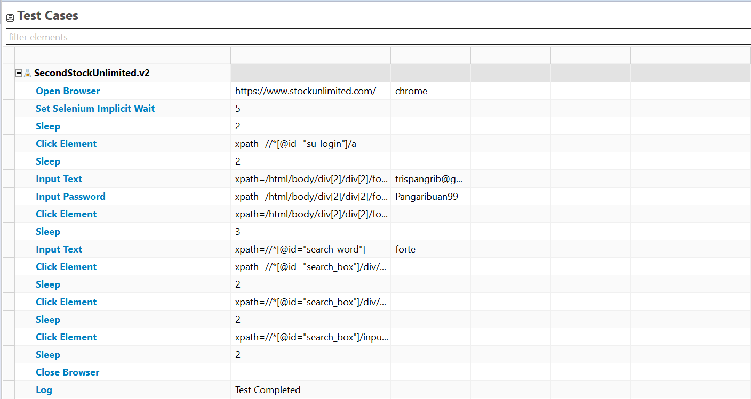

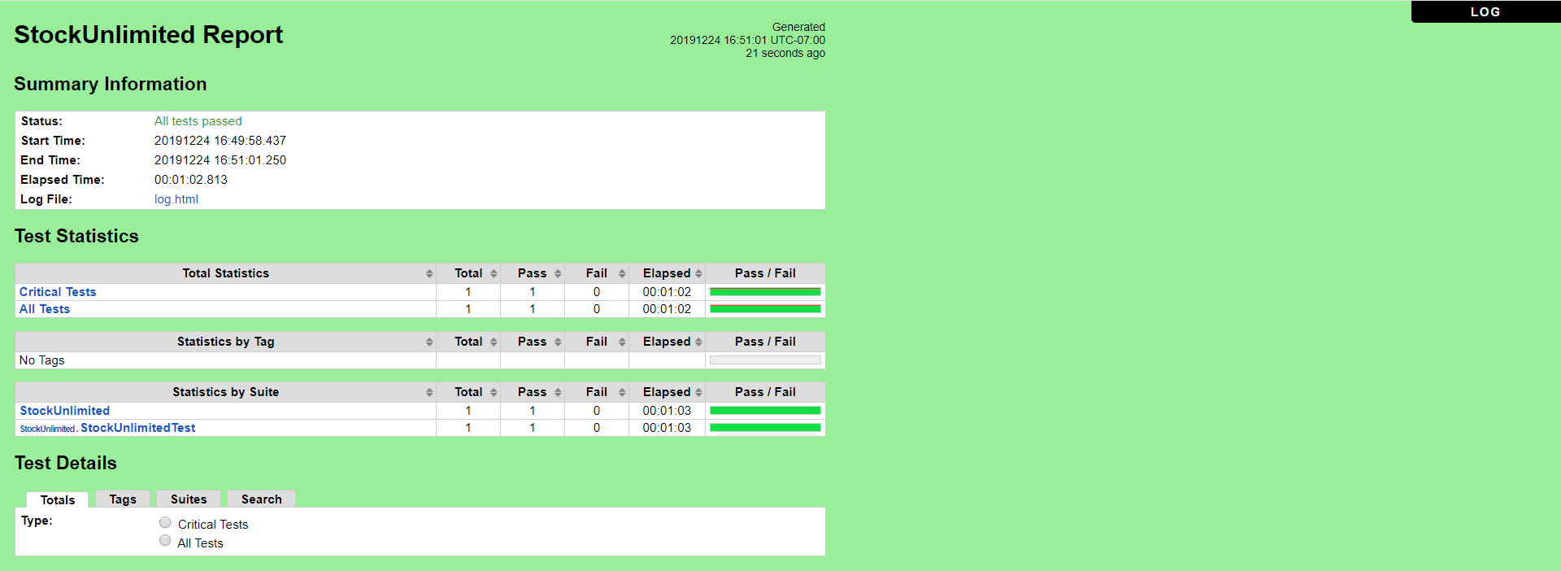

### Fungsi Searching (Audio)

a. **ThirdStockUnlimited.v1** (Audio Valid)

* Scenario

**Open Browser** https://www.stockunlimited.com/ chrome

**Set Selenium Implicit Wait** 5

**Sleep** 2

**Click Element** xpath=//*[@id="su-login"]/a

**Sleep** 2

**Input Text** xpath=/html/body/div[2]/div[2]/form/span[2]/input trispangrib@gmail.com

**Input Password** xpath=/html/body/div[2]/div[2]/form/span[3]/input Pangaribuan99

**Click Element** xpath=/html/body/div[2]/div[2]/form/input[4]

**Sleep** 3

**Input Text** xpath=//*[@id="search_word"] ariana music

**Click Element** xpath=//*[@id="search_box"]/div/div[1]

**Sleep** 2

**Click Element** xpath=//*[@id="search_box"]/div/div[2]/span[4]/input

**Sleep** 2

**Click Element** xpath=//*[@id="search_box"]/input[3]

**Sleep** 2

**Close Browser**

**Log** Test Completed

* Snippet Browser saat Testing
* 





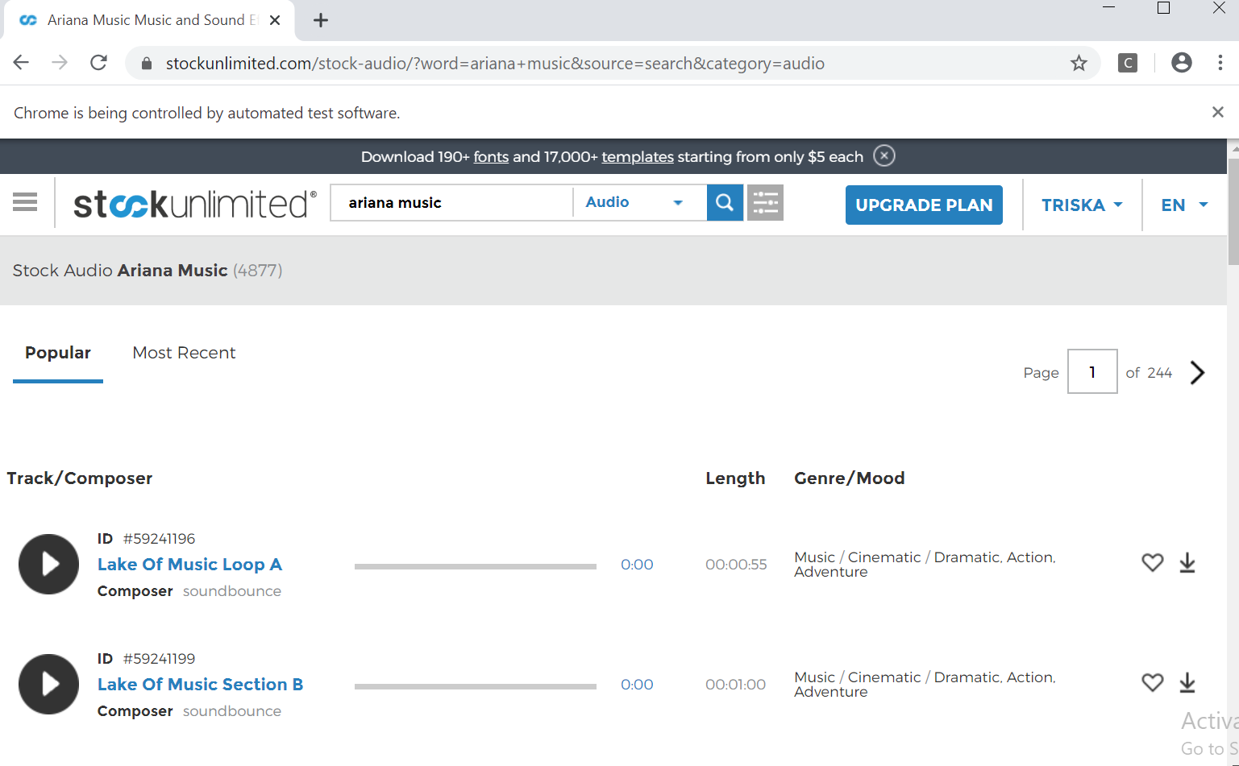

* Test Report

### **Fungsi Searching (Audio)**

**Scenario**

|  |  |
| --- | --- |
| **Scenario** | **Description** |
| Open Browser | Alamat yang dituju adalah:  https://www.stockunlimited.com/ |
| Click Element | User mengklik elemen *link* “Login” |
| Input Text | User memasukkan *username* pada *text field* |
| Input Password | User memasukkan password pada *text field* |
| Click Element | User mengklik *button* Login |
| Input Text | User memasukkan *inputan* yang diinginkan |
| Click Element | Untuk mengklik *button* Select “Audio” |
| Click Element | Untuk mengklik *button* Pencarian |

* **Test Frame**

| **No** | **Searching** |
| --- | --- |
| 1 | Audio Valid |
| 2 | Audio Invalid |

**Test Fungsi ThirdStockUnlimited.v1**



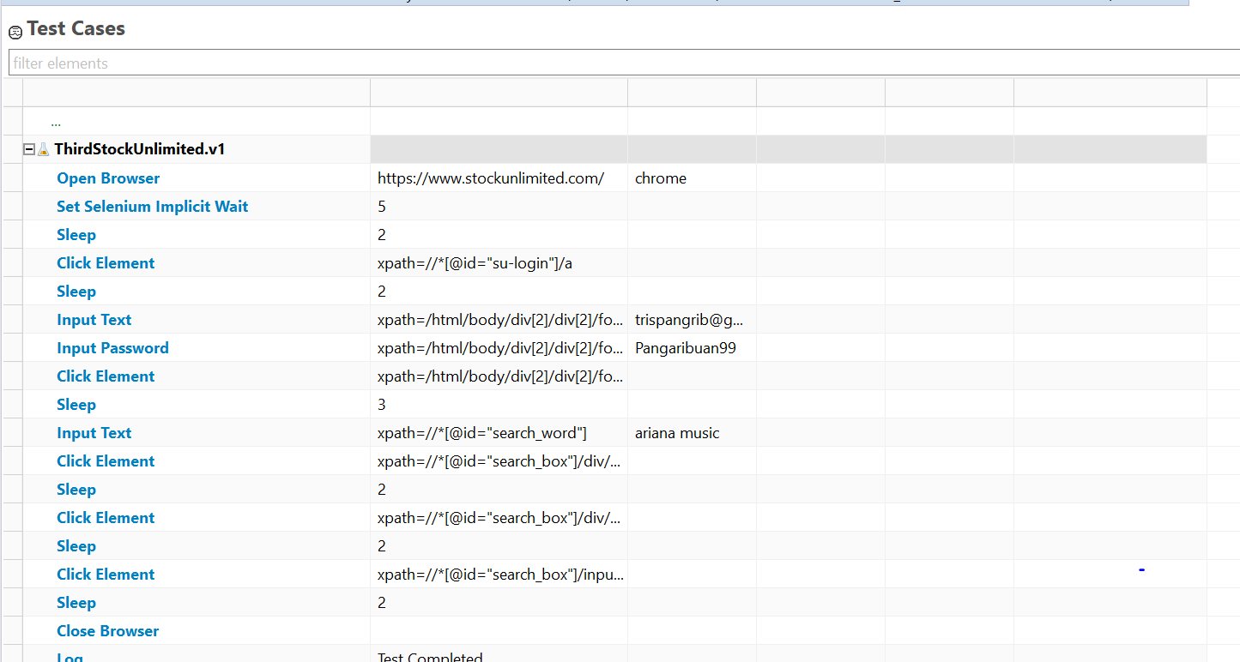

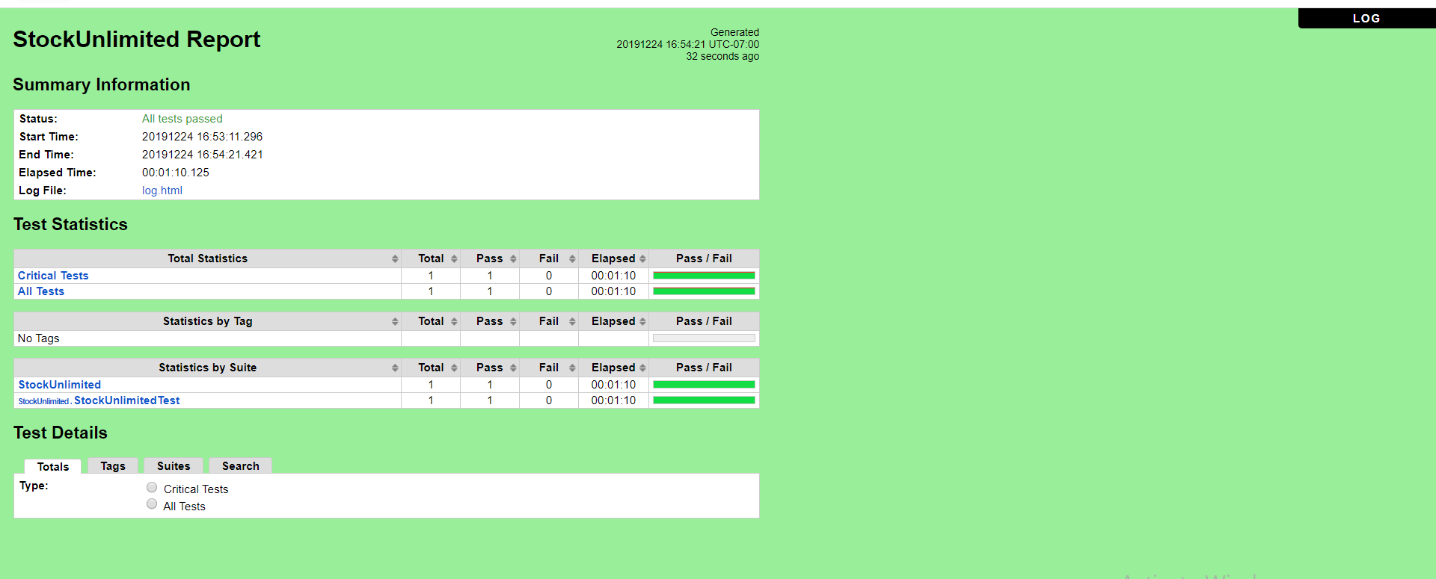

b. **ThirdStockUnlimited.v2** (Audio Invalid)

* Scenario

**Open Browser** https://www.stockunlimited.com/ chrome

**Set Selenium Implicit Wait** 5

**Sleep** 2

**Click Element** xpath=//*[@id="su-login"]/a

**Sleep** 2

**Input Text** xpath=/html/body/div[2]/div[2]/form/span[2]/input trispangrib@gmail.com

**Input Password** xpath=/html/body/div[2]/div[2]/form/span[3]/input Pangaribuan99

**Click Element** xpath=/html/body/div[2]/div[2]/form/input[4]

**Sleep** 3

**Input Text** xpath=//*[@id="search_word"] ariana grande

**Click Element** xpath=//*[@id="search_box"]/div/div[1]

**Sleep** 2

**Click Element** xpath=//*[@id="search_box"]/div/div[2]/span[4]/input

**Sleep** 2

**Click Element** xpath=//*[@id="search_box"]/input[3]

**Sleep** 2

**Close Browser**

**Log** Test Completed

* Snippet Browser saat Testing
* 





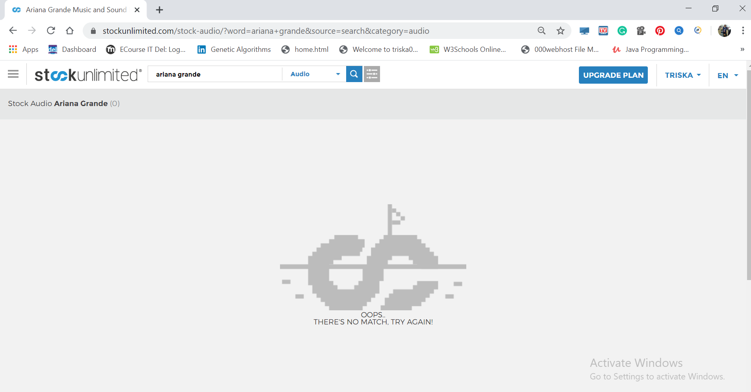

* Test Report

### **Fungsi Searching (Audio)**

**Scenario**

|  |  |
| --- | --- |
| **Scenario** | **Description** |
| Open Browser | Alamat yang dituju adalah:  https://www.stockunlimited.com/ |
| Click Element | User mengklik elemen *link* “Login” |
| Input Text | User memasukkan *username* pada *text field* |
| Input Password | User memasukkan password pada *text field* |
| Click Element | User mengklik *button* Login |
| Input Text | User memasukkan *inputan* yang diinginkan |
| Click Element | Untuk mengklik *button* Select “Audio” |
| ‘Click Element | Untuk mengklik *button* Pencarian |

* **Test Frame**

| **No** | **Searching** |
| --- | --- |
| 1 | Audio Valid |
| 2 | Audio Invalid |

**Test Fungsi ThirdStockUnlimited.v1**



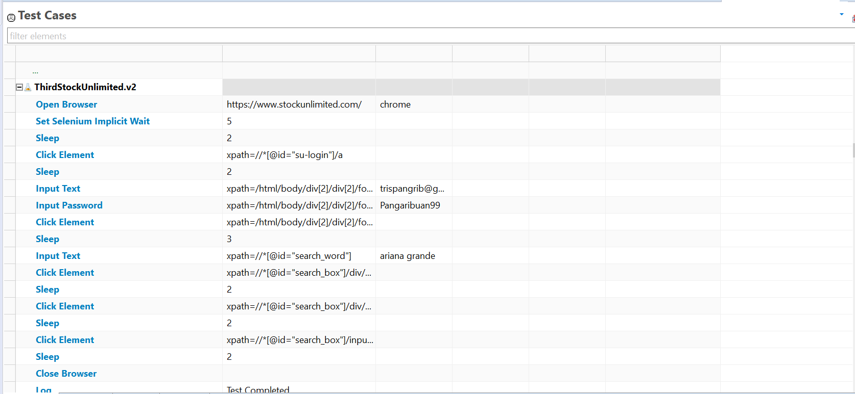

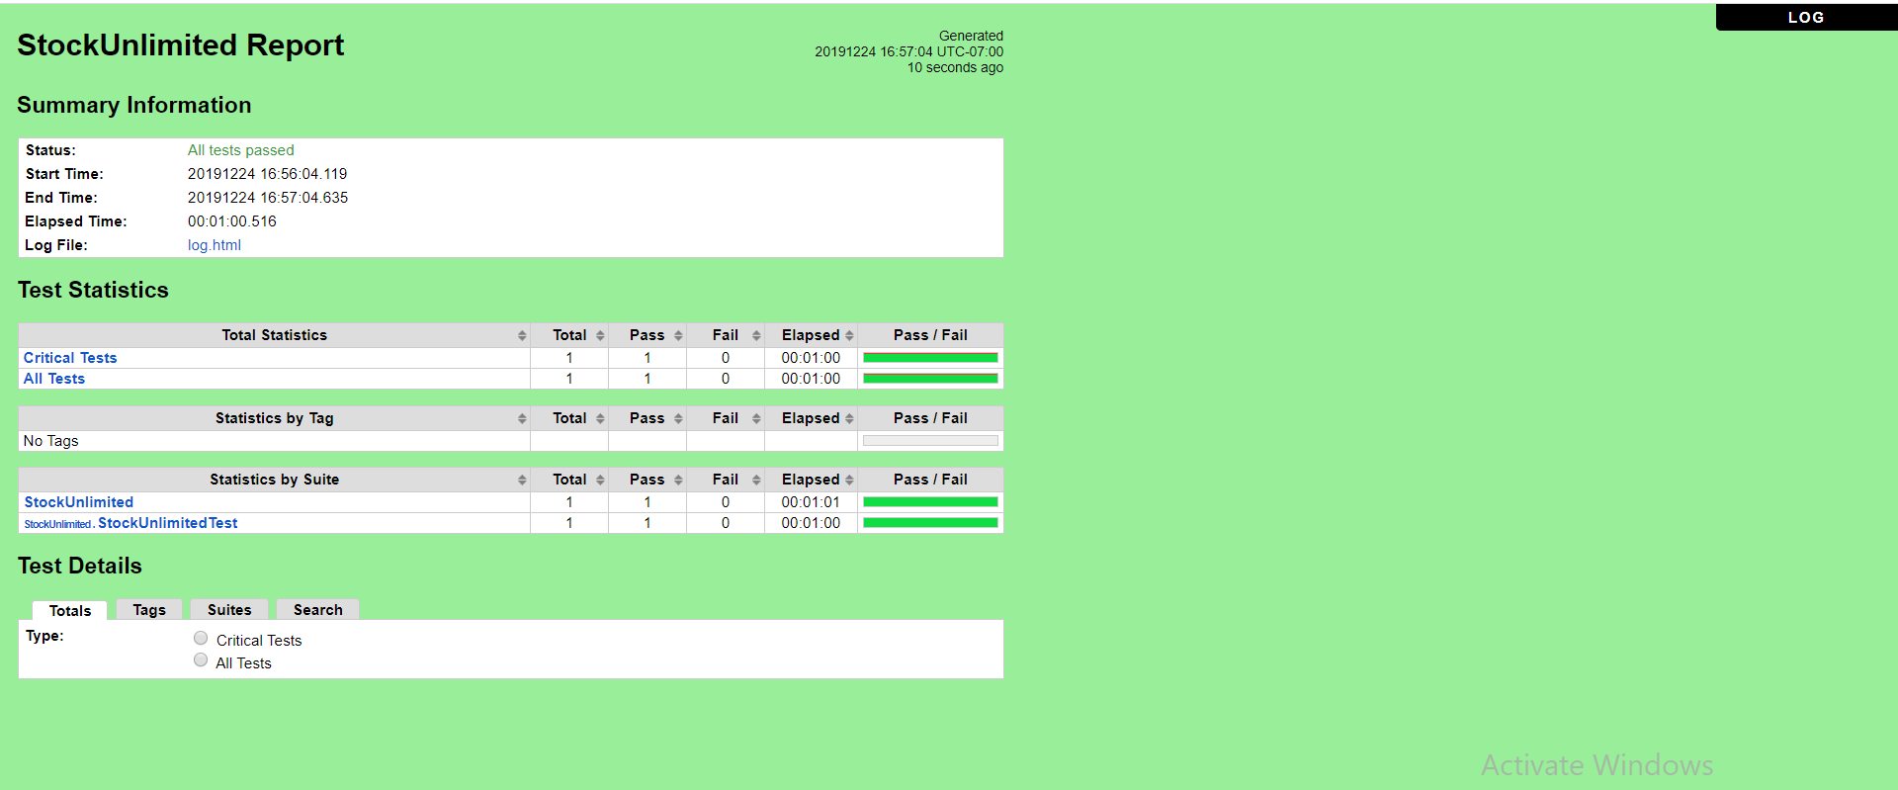

### Fungsi Searching (Fonts)

a. **FourthStockUnlimited.v1** (Fonts Valid)

* Scenario

**Open Browser** https://www.stockunlimited.com/ chrome

**Set Selenium Implicit Wait** 5

**Sleep** 2

**Click Element** xpath=//*[@id="su-login"]/a

**Sleep** 2

**Input Text** xpath=/html/body/div[2]/div[2]/form/span[2]/input trispangrib@gmail.com

**Input Password** xpath=/html/body/div[2]/div[2]/form/span[3]/input Pangaribuan99

**Click Element** xpath=/html/body/div[2]/div[2]/form/input[4]

**Sleep** 3

**Input Text** xpath=//*[@id="search_word"] sans serif

**Click Element** xpath=//*[@id="search_box"]/div/div[1]

**Sleep** 2

**Click Element** xpath=//*[@id="search_box"]/div/div[2]/span[6]/input

**Sleep** 2

**Click Element** xpath=//*[@id="search_box"]/input[3]

**Sleep** 2

**Close Browser**

**Log** Test Completed

* Snippet Browser saat Testing
* 



* 

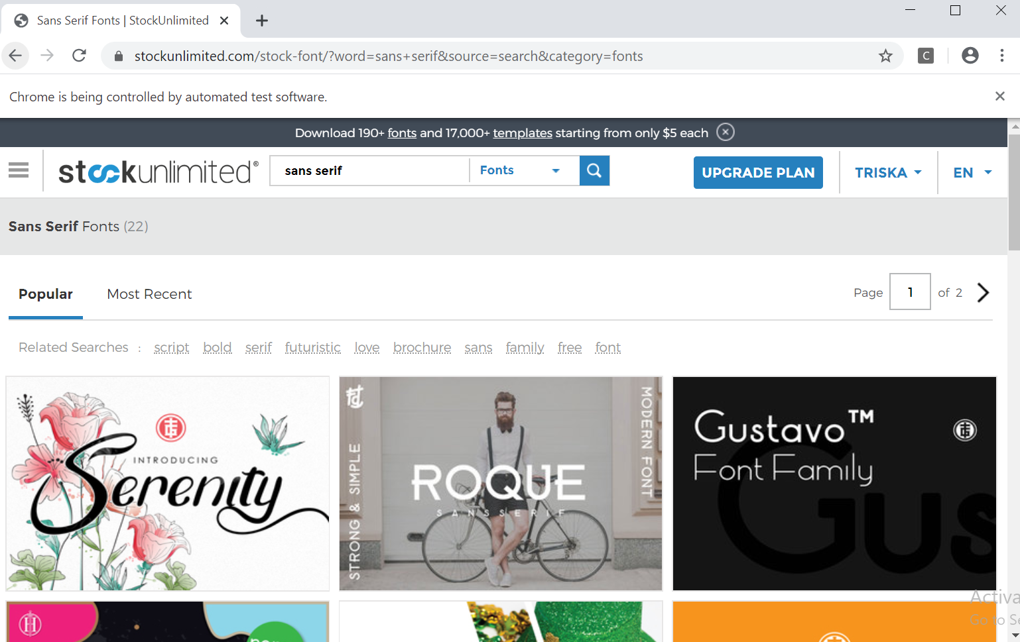

* Test Report

### **Fungsi Searching (Fonts)**

**Scenario**

|  |  |
| --- | --- |
| **Scenario** | **Description** |
| Open Browser | Alamat yang dituju adalah:  https://www.stockunlimited.com/ |
| Click Element | User mengklik elemen *link* “Login” |
| Input Text | User memasukkan *username* pada *text field* |
| Input Password | User memasukkan password pada *text field* |
| Click Element | User mengklik *button* Login |
| Input Text | User memasukkan *inputan* yang diinginkan |
| Click Element | Untuk mengklik *button* Select “Fonts” |
| ‘Click Element | Untuk mengklik *button* Pencarian |

* **Test Frame**

| **No** | **Searching** |
| --- | --- |
| 1 | Fonts Valid |
| 2 | Fonts Invalid |

**Test Fungsi FourthStockUnlimited.v1**



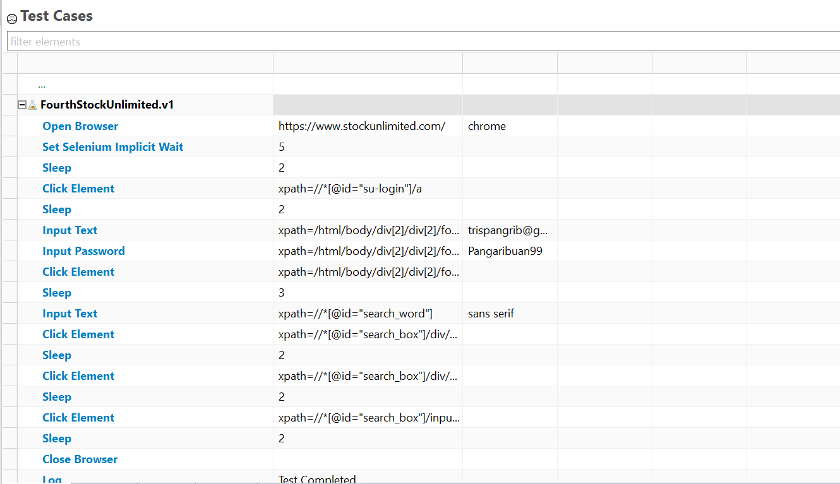

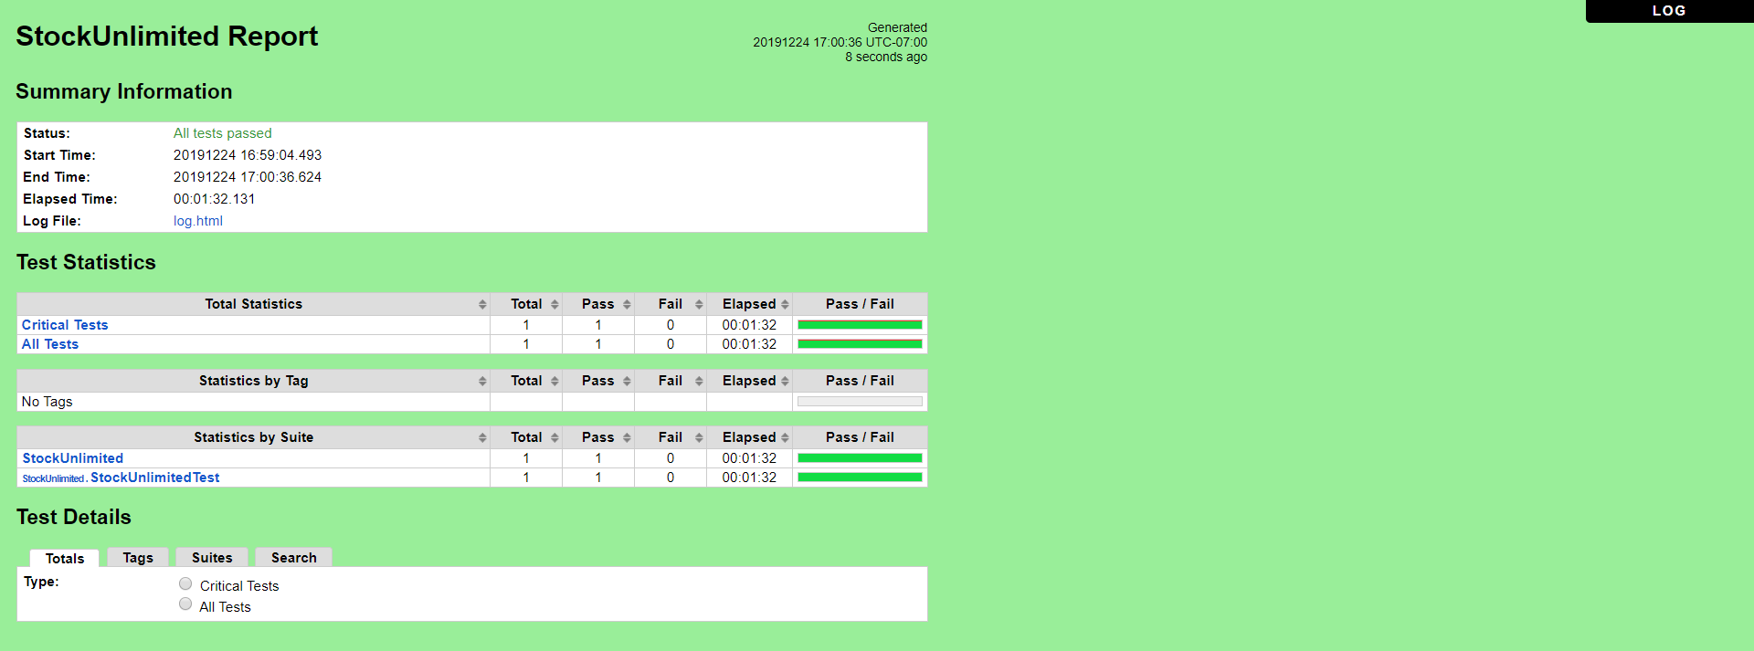

b. **FourthStockUnlimited.v2**(Fonts Invalid)

* Scenario

**Open Browser** https://www.stockunlimited.com/ chrome

**Set Selenium Implicit Wait** 5

**Sleep** 2

**Click Element** xpath=//*[@id="su-login"]/a

**Sleep** 2

**Input Text** xpath=/html/body/div[2]/div[2]/form/span[2]/input trispangrib@gmail.com

**Input Password** xpath=/html/body/div[2]/div[2]/form/span[3]/input Pangaribuan99

**Click Element** xpath=/html/body/div[2]/div[2]/form/input[4]

**Sleep** 3

**Input Text** xpath=//*[@id="search_word"] Times New

**Click Element** xpath=//*[@id="search_box"]/div/div[1]

**Sleep** 2

**Click Element** xpath=//*[@id="search_box"]/div/div[2]/span[6]/input

**Sleep** 2

**Click Element** xpath=//*[@id="search_box"]/input[3]

**Sleep** 2

**Close Browser**

**Log** Test Completed

* Snippet Browser saat Testing
* 





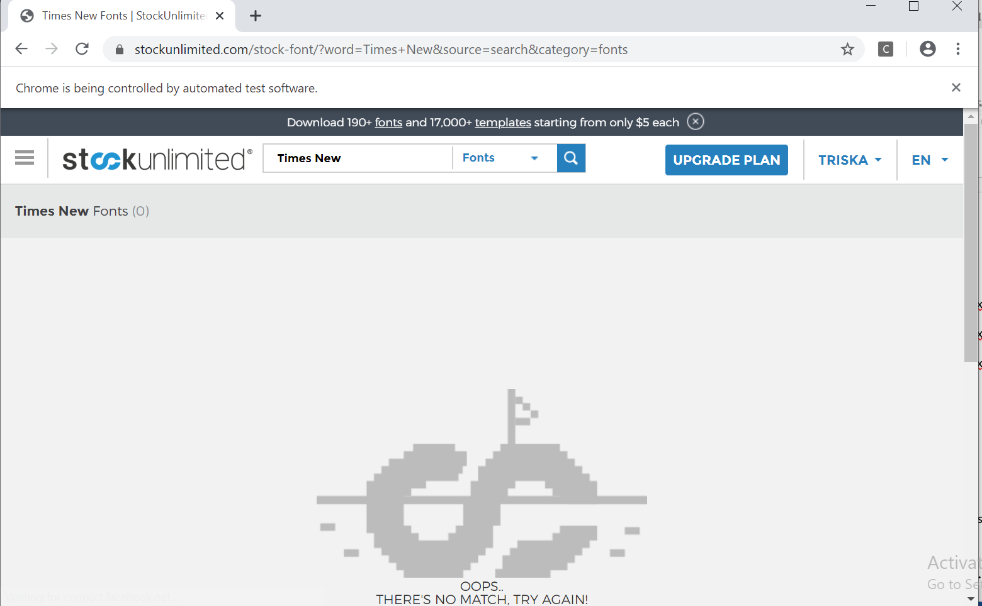

* Test Report

### **Fungsi Searching (Fonts)**

**Scenario**

|  |  |
| --- | --- |
| **Scenario** | **Description** |
| Open Browser | Alamat yang dituju adalah:  https://www.stockunlimited.com/ |
| Click Element | User mengklik elemen *link* “Login” |
| Input Text | User memasukkan *username* pada *text field* |
| Input Password | User memasukkan password pada *text field* |
| Click Element | User mengklik *button* Login |
| Input Text | User memasukkan *inputan* yang diinginkan |
| Click Element | Untuk mengklik *button* Select “Fonts” |
| ‘Click Element | Untuk mengklik *button* Pencarian |

* **Test Frame**

| **No** | **Searching** |
| --- | --- |
| 1 | Fonts Valid |
| 2 | Fonts Invalid |

**Test Fungsi FourthStockUnlimited.v2**



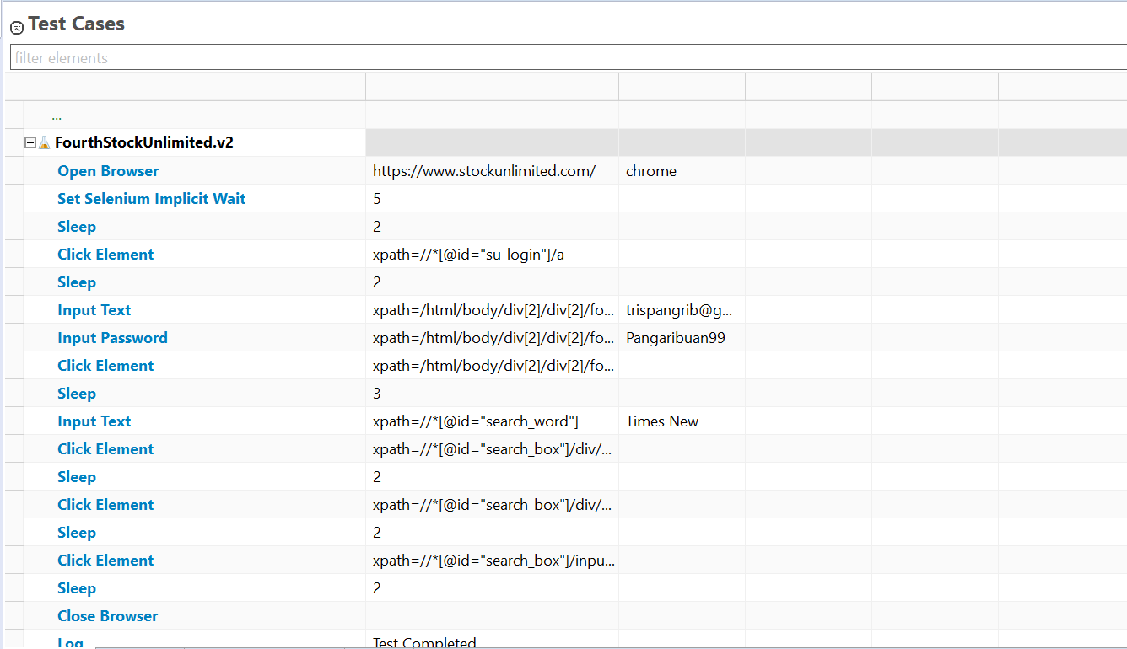

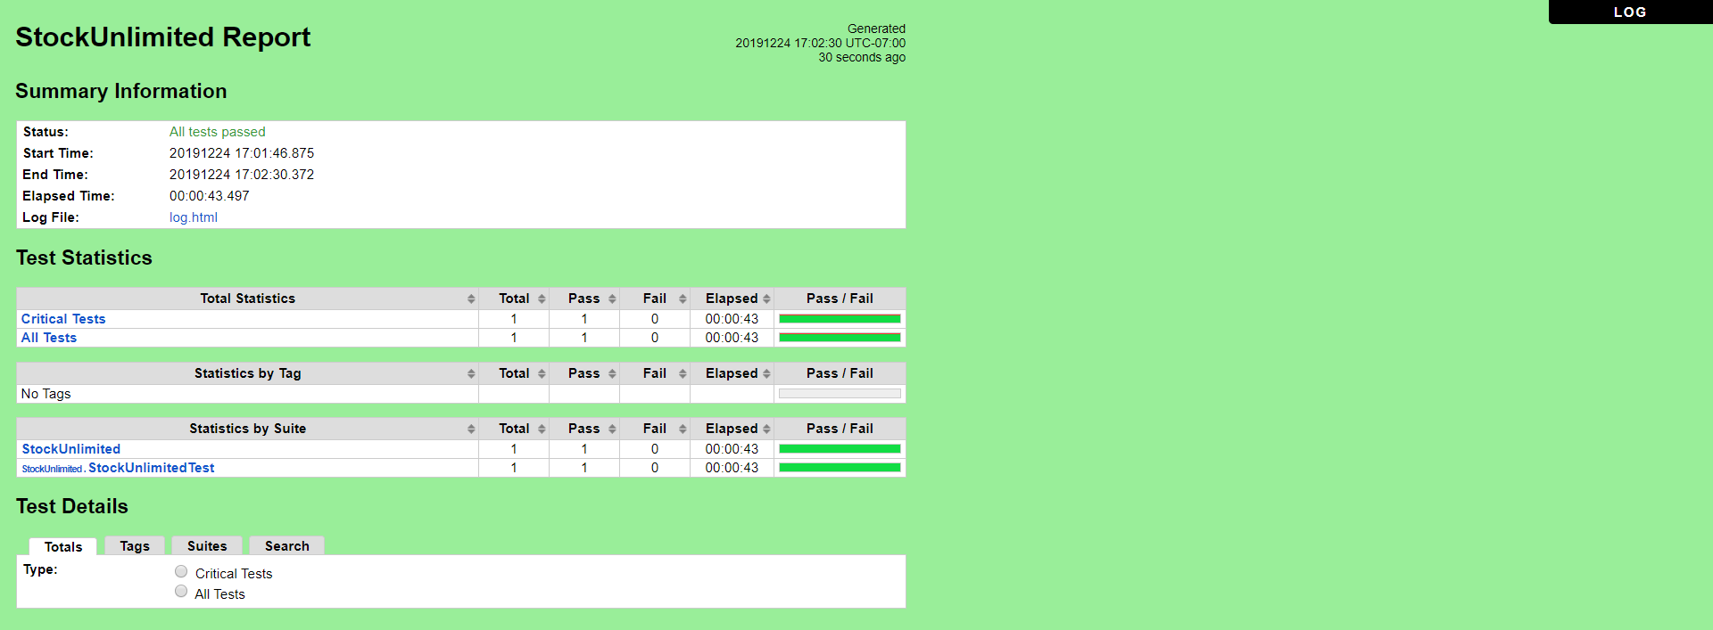

### Fungsi Security

a. **FifthStockUnlimited.v1** (Old Password Valid, New Password Valid, Confirm Password Valid)

* Scenario

**Open Browser** https://www.stockunlimited.com/ chrome

**Set Selenium Implicit Wait** 5

**Sleep** 2

**Click Element** xpath=//*[@id="su-login"]/a

**Sleep** 2

**Input Text** xpath=/html/body/div[2]/div[2]/form/span[2]/input trispangrib@gmail.com

**Input Password** xpath=/html/body/div[2]/div[2]/form/span[3]/input Pangaribuan99

**Click Element** xpath=/html/body/div[2]/div[2]/form/input[4]

**Sleep** 3

**Click Element** xpath=//*[@id="sui-user-menu"]/a

**Sleep** 2

**Click Element** xpath=//*[@id="sui-user-menu"]/div/a[4]

**Sleep** 2

**Input Password** xpath=//*[@id="form"]/span[3]/input Pangaribuan99

**Input Password** xpath=//*[@id="newpassword"] Triska4499

**Input Password** xpath=//*[@id="confirmpassword"] Triska4499

**Click Element** xpath=//*[@id="form"]/input[3]

**Sleep** 4

**Close Browser**

**Log** Test Completed

* Snippet Browser saat Testing
* 





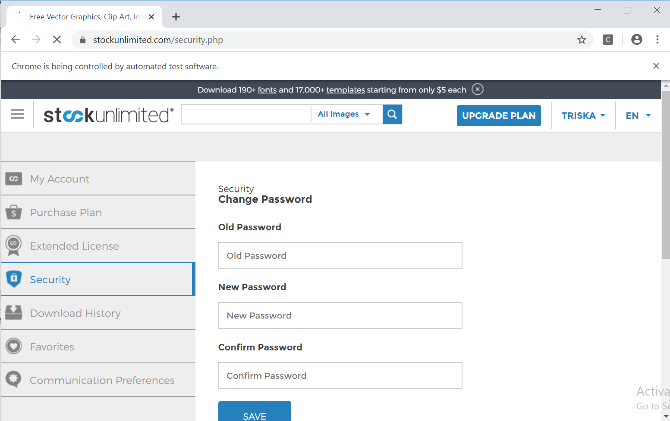

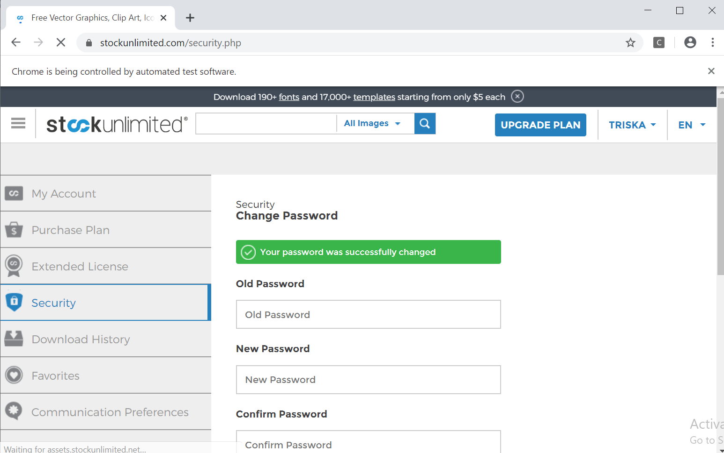

* Test Report

### **Fungsi Security**

### **Scenario**

|  |  |
| --- | --- |
| **Scenario** | **Description** |
| Open Browser | Alamat yang dituju adalah:  https://www.stockunlimited.com/ |
| Click Element | User mengklik elemen *link* “Login” |
| Input Text | User memasukkan *username* pada *text field* |
| Input Password | User memasukkan password pada *text field* |
| Click Element | User mengklik *button* Login |
| Click Element | User mengklik *button* nama account |
| Click Element | User mengklik *button* Select “Security” |
| Input Password | User memasukkan old password pada *text field* |
| Input Password | User memasukkan new password pada *text field* |
| Input Password | User memasukkan confirm password pada *text field* |
| Click Element | User mengklik *button* “Save” |

* **Test Frame**

|  |  |  |  |
| --- | --- | --- | --- |
| **No.** | **Old Password** | **New Password** | **Confirm Password** |
| 1 | Password Valid | Password Valid | Password Valid |
| 2 | Password Valid | Password Invalid | Password Invalid |
| 3 | Password Valid | Password Valid | Password Invalid |
| 4 | Password Invalid | Password Invalid | Password Invalid |
| 5 | Password Valid | Password Invalid | Password Valid |
| 6 | Password Invalid | Password Valid | Password Valid |
| 7 | Password Invalid | Password Invalid | Password Valid |
| 8 | Password Invalid | Password Valid | Password Invalid |

**Test Fungsi FifthStockUnlimited.v1**



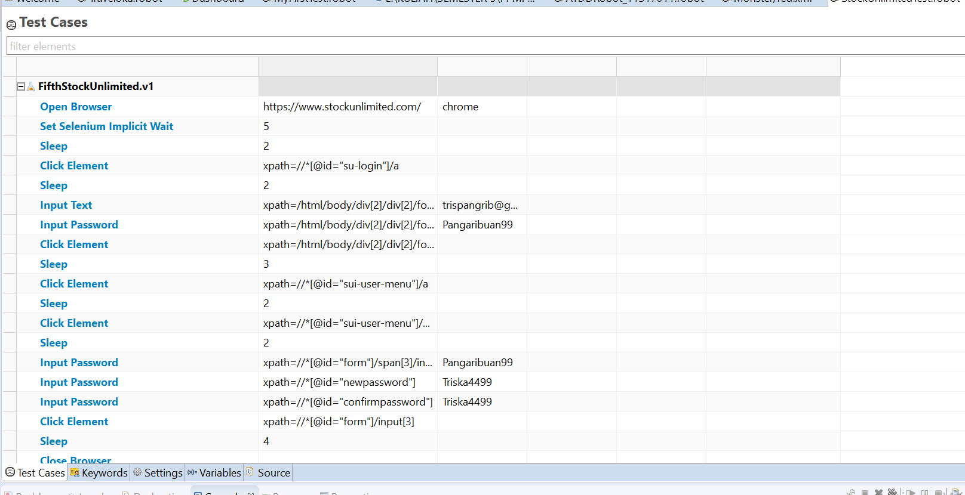

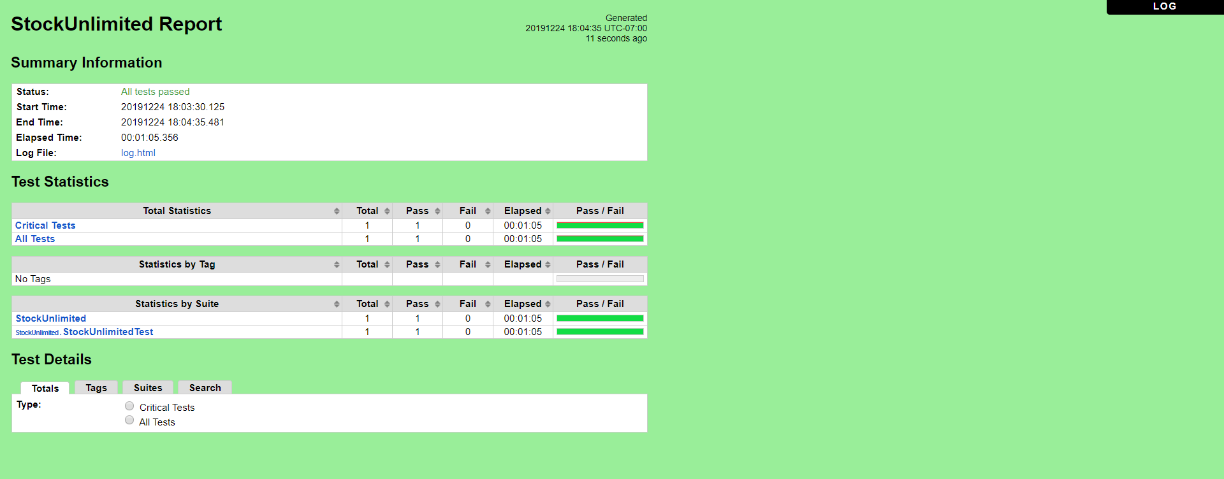

b. **FifthStockUnlimited.v2** (Old Password Valid , New Password Invalid, Confirm Password Invalid)

* Scenario

**Open Browser** https://www.stockunlimited.com/ chrome

**Set Selenium Implicit Wait** 5

**Sleep** 2

**Click Element** xpath=//*[@id="su-login"]/a

**Sleep** 2

**Input Text** xpath=/html/body/div[2]/div[2]/form/span[2]/input trispangrib@gmail.com

**Input Password** xpath=/html/body/div[2]/div[2]/form/span[3]/input Triska4499

**Click Element** xpath=/html/body/div[2]/div[2]/form/input[4]

**Sleep** 3

**Click Element** xpath=//*[@id="sui-user-menu"]/a

**Sleep** 2

**Click Element** xpath=//*[@id="sui-user-menu"]/div/a[4]

**Sleep** 2

**Input Password** xpath=//*[@id="form"]/span[3]/input Triska4499

**Input Password** xpath=//*[@id="newpassword"] Tri

**Input Password** xpath=//*[@id="confirmpassword"] Tri

**Click Element** xpath=//*[@id="form"]/input[3]

**Sleep** 4

**Close Browser**

**Log** Test Completed

* Snippet Browser saat Testing
* 

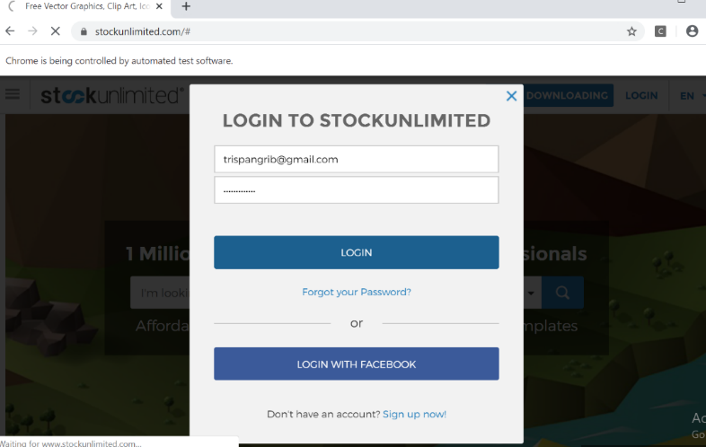





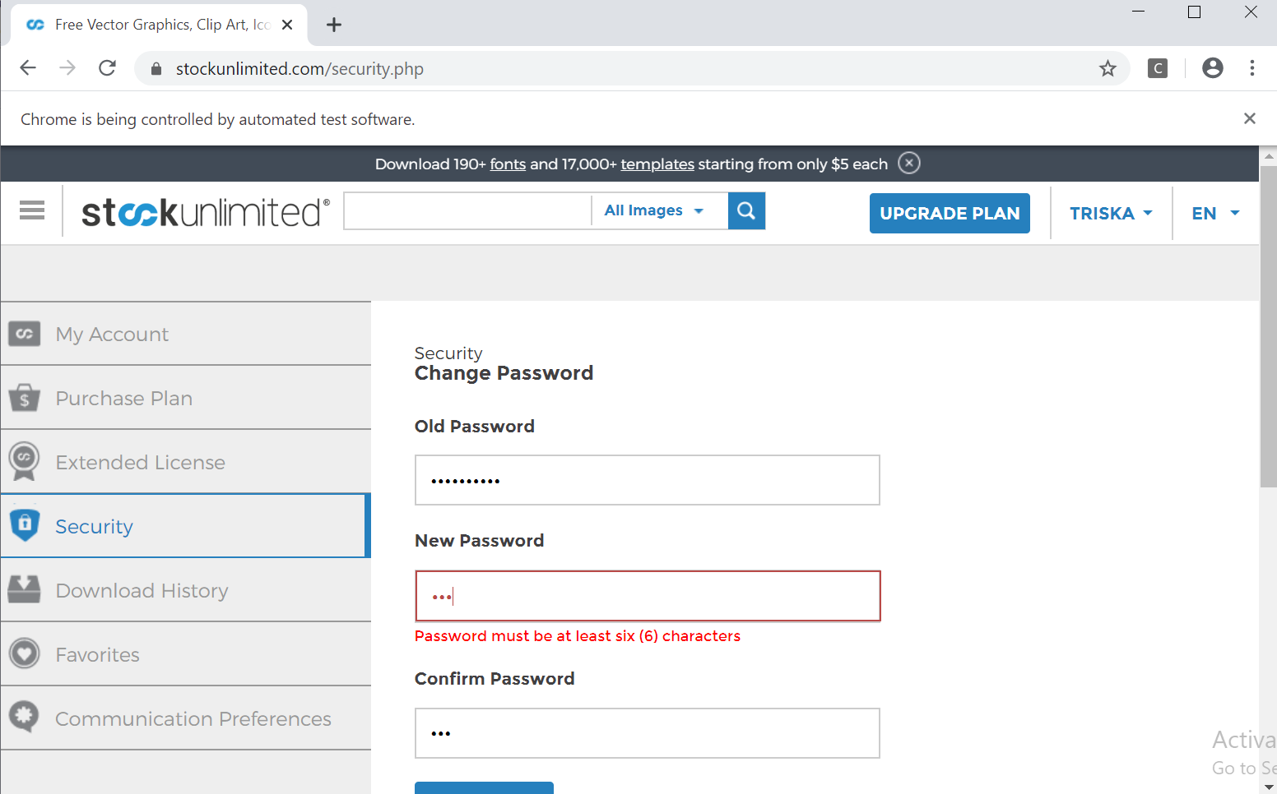

* Test Report

### **Fungsi Security**

### **Scenario**

|  |  |
| --- | --- |
| **Scenario** | **Description** |
| Open Browser | Alamat yang dituju adalah:  https://www.stockunlimited.com/ |
| Click Element | User mengklik elemen *link* “Login” |
| Input Text | User memasukkan *username* pada *text field* |
| Input Password | User memasukkan password pada *text field* |
| Click Element | User mengklik *button* Login |
| Click Element | User mengklik *button* nama account |
| Click Element | User mengklik *button* Select “Security” |
| Input Password | User memasukkan old password pada *text field* |
| Input Password | User memasukkan new password pada *text field* |
| Input Password | User memasukkan confirm password pada *text field* |
| Click Element | User mengklik *button* “Save” |

* **Test Frame**

|  |  |  |  |
| --- | --- | --- | --- |
| **No.** | **Old Password** | **New Password** | **Confirm Password** |
| 1 | Password Valid | Password Valid | Password Valid |
| 2 | Password Valid | Password Invalid | Password Invalid |
| 3 | Password Valid | Password Valid | Password Invalid |
| 4 | Password Invalid | Password Invalid | Password Invalid |
| 5 | Password Valid | Password Invalid | Password Valid |
| 6 | Password Invalid | Password Valid | Password Valid |
| 7 | Password Invalid | Password Invalid | Password Valid |
| 8 | Password Invalid | Password Valid | Password Invalid |

**Test Fungsi FifthStockUnlimited.v2**



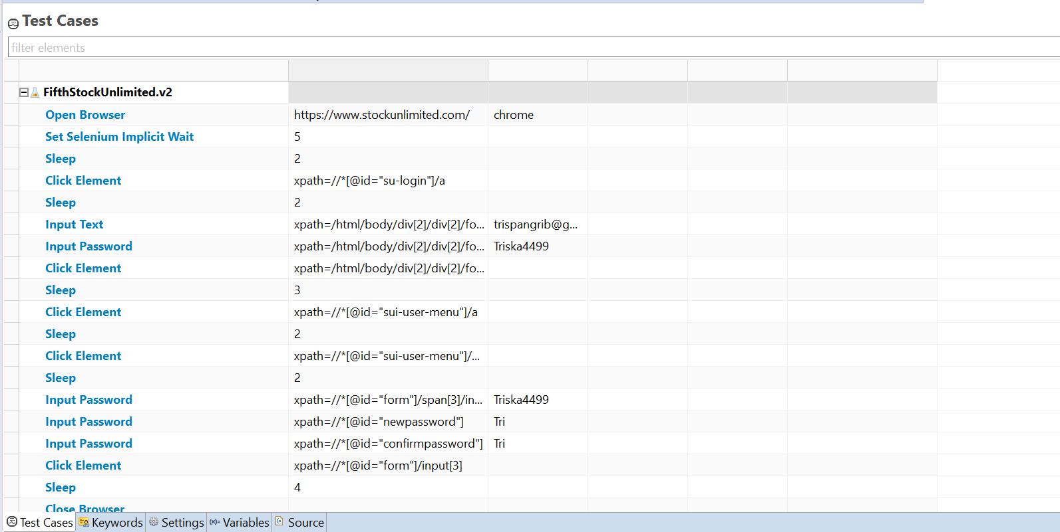

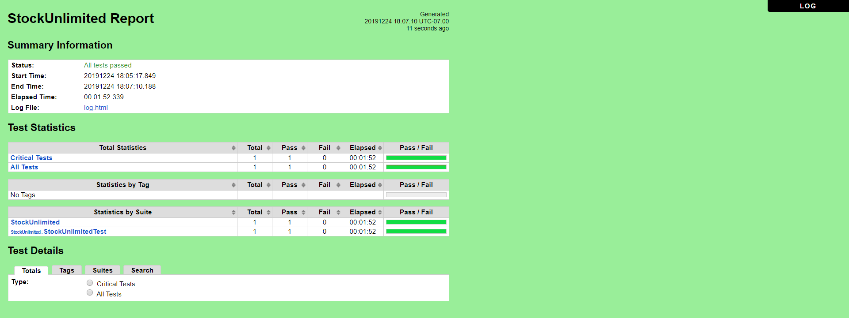

c. **FifthStockUnlimited.v3**(Old Password Valid , New Password Valid, Confirm Password Invalid)

* Scenario

**Open Browser** https://www.stockunlimited.com/ chrome

**Set Selenium Implicit Wait** 5

**Sleep** 2

**Click Element** xpath=//*[@id="su-login"]/a

**Sleep** 2

**Input Text** xpath=/html/body/div[2]/div[2]/form/span[2]/input trispangrib@gmail.com

**Input Password** xpath=/html/body/div[2]/div[2]/form/span[3]/input Triska4499

**Click Element** xpath=/html/body/div[2]/div[2]/form/input[4]

**Sleep** 3

**Click Element** xpath=//*[@id="sui-user-menu"]/a

**Sleep** 2

**Click Element** xpath=//*[@id="sui-user-menu"]/div/a[4]

**Sleep** 2

**Input Password** xpath=//*[@id="form"]/span[3]/input Triska4499

**Input Password** xpath=//*[@id="newpassword"] Pangaribuan99

**Input Password** xpath=//*[@id="confirmpassword"] Tri

**Click Element** xpath=//*[@id="form"]/input[3]

**Sleep** 4

**Close Browser**

**Log** Test Completed

* Snippet Browser saat Testing
* 







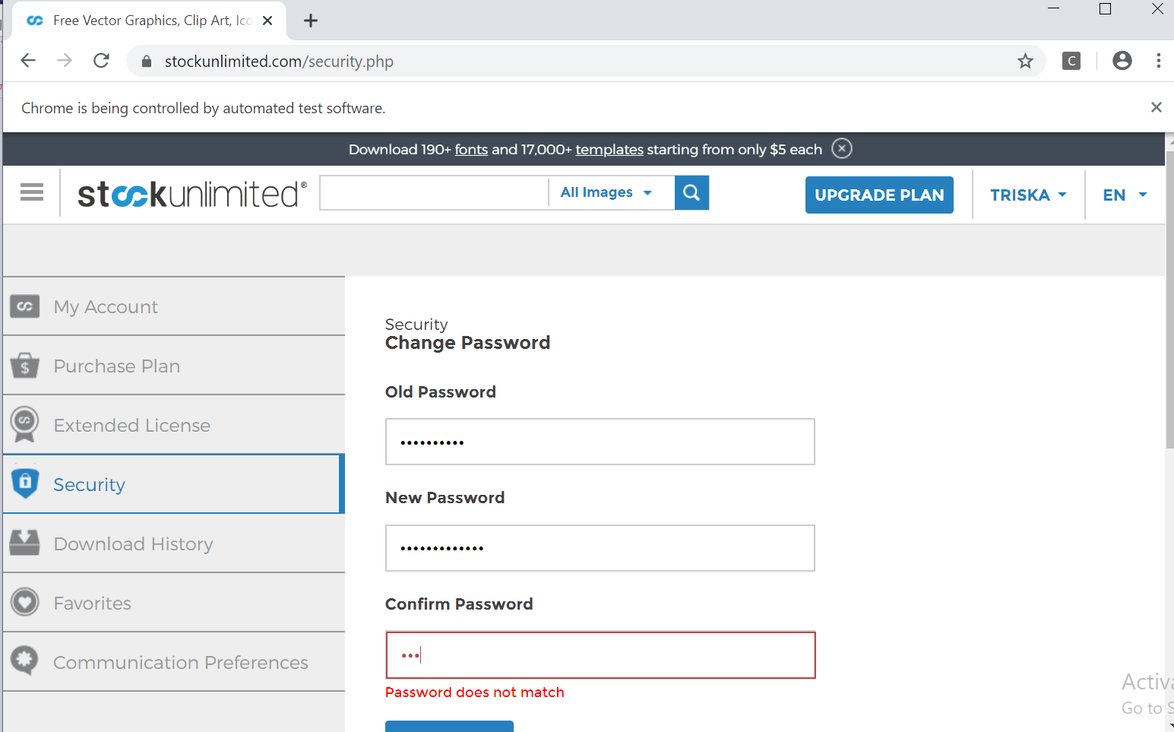

* Test Report

### **Fungsi Security**

### **Scenario**

|  |  |
| --- | --- |
| **Scenario** | **Description** |
| Open Browser | Alamat yang dituju adalah:  https://www.stockunlimited.com/ |
| Click Element | User mengklik elemen *link* “Login” |
| Input Text | User memasukkan *username* pada *text field* |
| Input Password | User memasukkan password pada *text field* |
| Click Element | User mengklik *button* Login |
| Click Element | User mengklik *button* nama account |
| Click Element | User mengklik *button* Select “Security” |
| Input Password | User memasukkan old password pada *text field* |
| Input Password | User memasukkan new password pada *text field* |
| Input Password | User memasukkan confirm password pada *text field* |
| Click Element | User mengklik *button* “Save” |

* **Test Frame**

|  |  |  |  |
| --- | --- | --- | --- |
| **No.** | **Old Password** | **New Password** | **Confirm Password** |
| 1 | Password Valid | Password Valid | Password Valid |
| 2 | Password Valid | Password Invalid | Password Invalid |
| 3 | Password Valid | Password Valid | Password Invalid |
| 4 | Password Invalid | Password Invalid | Password Invalid |
| 5 | Password Valid | Password Invalid | Password Valid |
| 6 | Password Invalid | Password Valid | Password Valid |
| 7 | Password Invalid | Password Invalid | Password Valid |
| 8 | Password Invalid | Password Valid | Password Invalid |

**Test Fungsi FifthStockUnlimited.v3**



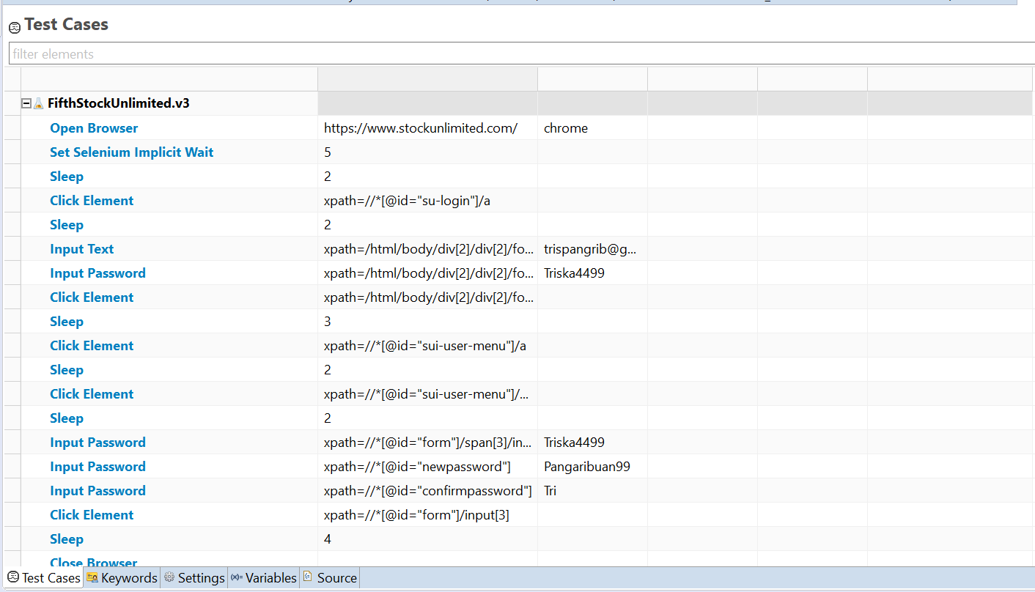

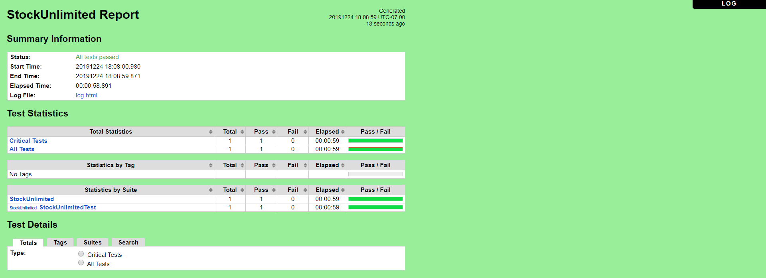

d. **FifthStockUnlimited.v4** (Old Password Invalid, New Password Invalid, Confirm Password Invalid)

* Scenario

**Open Browser** https://www.stockunlimited.com/ chrome

**Set Selenium Implicit Wait** 5

**Sleep** 2

**Click Element** xpath=//*[@id="su-login"]/a

**Sleep** 2

**Input Text** xpath=/html/body/div[2]/div[2]/form/span[2]/input trispangrib@gmail.com

**Input Password** xpath=/html/body/div[2]/div[2]/form/span[3]/input Triska4499

**Click Element** xpath=/html/body/div[2]/div[2]/form/input[4]

**Sleep** 3

**Click Element** xpath=//*[@id="sui-user-menu"]/a

**Sleep** 2

**Click Element** xpath=//*[@id="sui-user-menu"]/div/a[4]

**Sleep** 2

**Input Password** xpath=//*[@id="form"]/span[3]/input 123

**Input Password** xpath=//*[@id="newpassword"] Tri

**Input Password** xpath=//*[@id="confirmpassword"] Tri

**Click Element** xpath=//*[@id="form"]/input[3]

**Sleep** 4

**Close Browser**

**Log** Test Completed

* Snippet Browser saat Testing









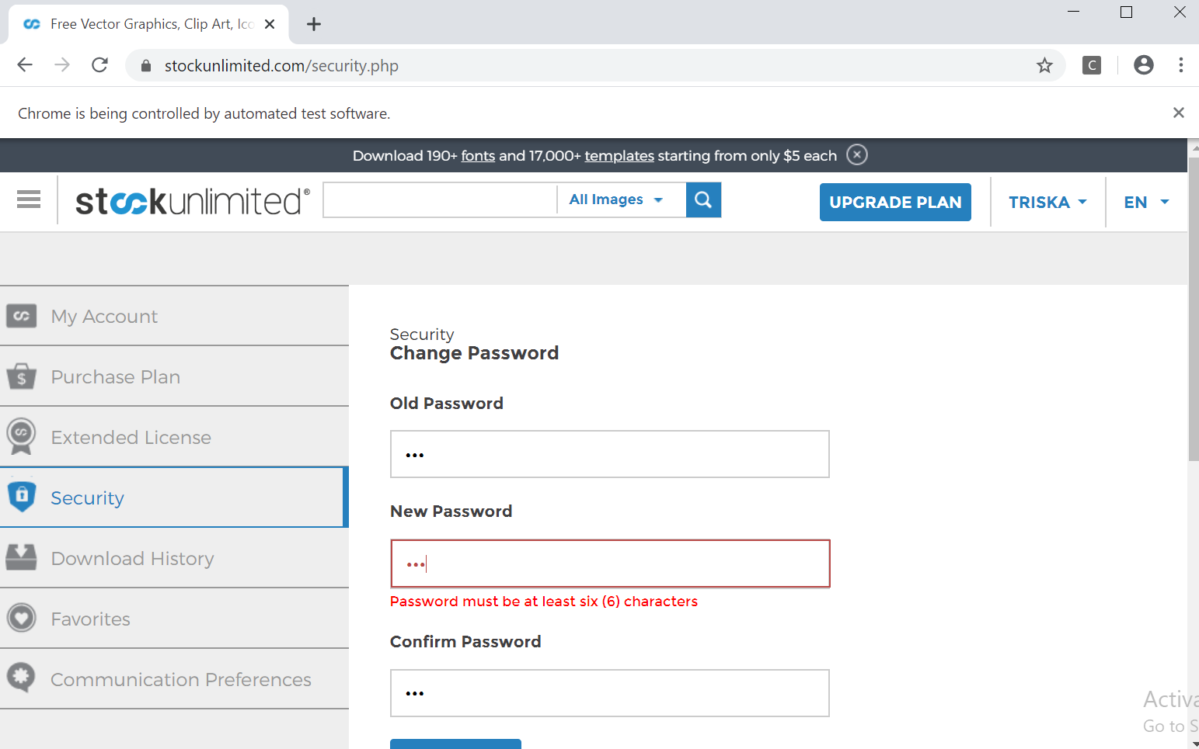

* Test Report

### **Fungsi Security**

### **Scenario**

|  |  |
| --- | --- |
| **Scenario** | **Description** |
| Open Browser | Alamat yang dituju adalah:  https://www.stockunlimited.com/ |
| Click Element | User mengklik elemen *link* “Login” |
| Input Text | User memasukkan *username* pada *text field* |
| Input Password | User memasukkan password pada *text field* |
| Click Element | User mengklik *button* Login |
| Click Element | User mengklik *button* nama account |
| Click Element | User mengklik *button* Select “Security” |
| Input Password | User memasukkan old password pada *text field* |
| Input Password | User memasukkan new password pada *text field* |
| Input Password | User memasukkan confirm password pada *text field* |
| Click Element | User mengklik *button* “Save” |

* **Test Frame**

|  |  |  |  |
| --- | --- | --- | --- |
| **No.** | **Old Password** | **New Password** | **Confirm Password** |
| 1 | Password Valid | Password Valid | Password Valid |
| 2 | Password Valid | Password Invalid | Password Invalid |
| 3 | Password Valid | Password Valid | Password Invalid |
| 4 | Password Invalid | Password Invalid | Password Invalid |
| 5 | Password Valid | Password Invalid | Password Valid |
| 6 | Password Invalid | Password Valid | Password Valid |
| 7 | Password Invalid | Password Invalid | Password Valid |
| 8 | Password Invalid | Password Valid | Password Invalid |

**Test Fungsi FifthStockUnlimited.v4**



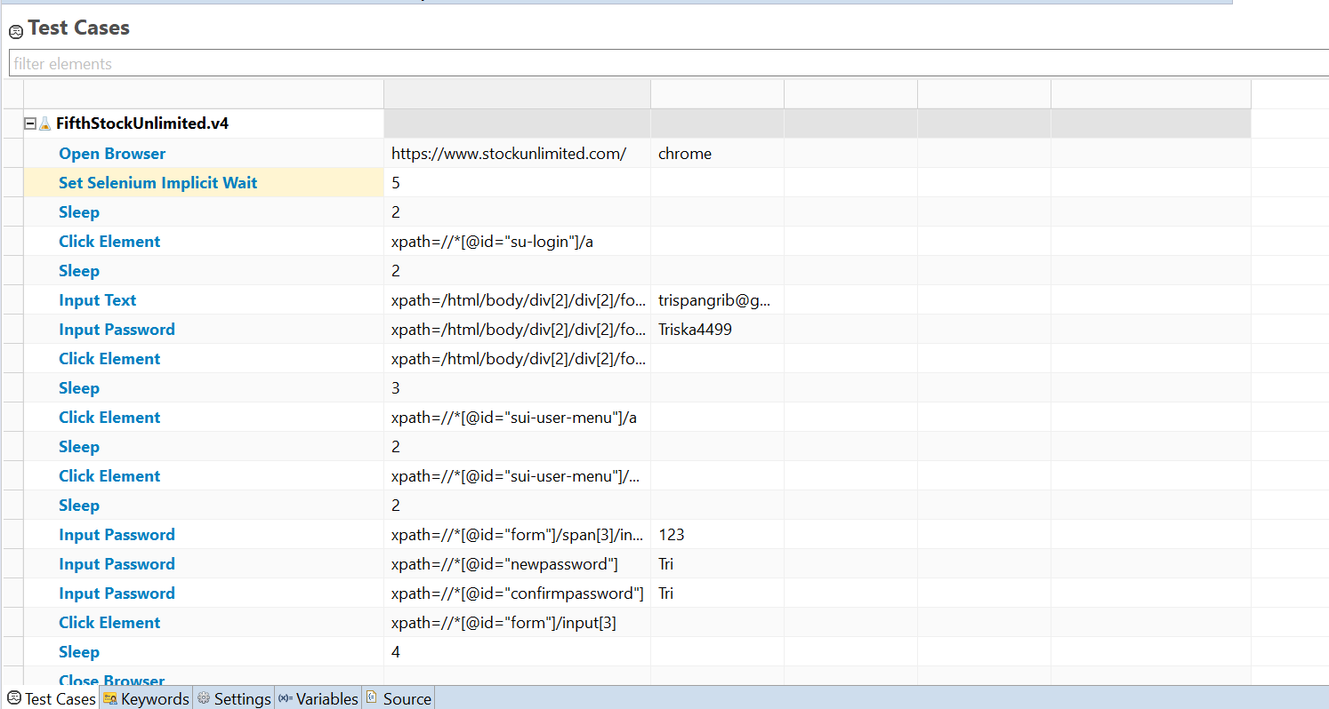

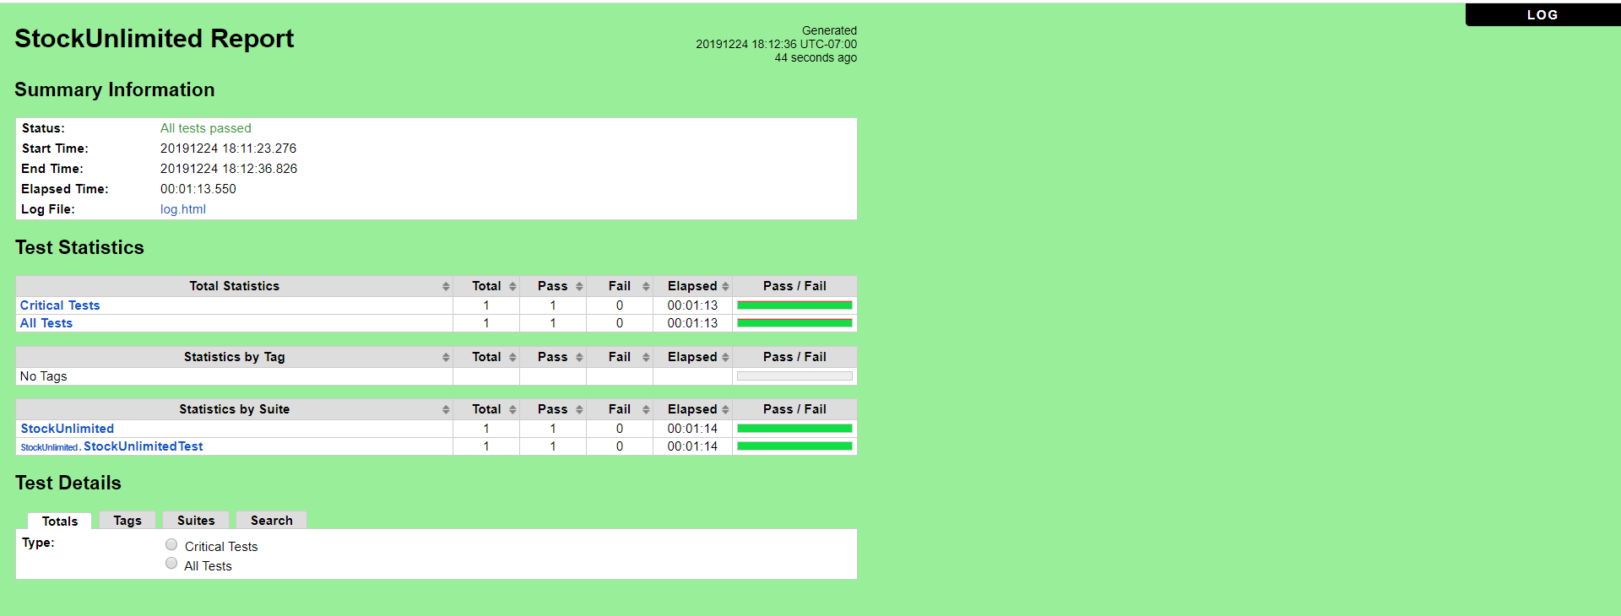

e. **FifthStockUnlimited.v5** (Old Password Valid, New Password Invalid, Confirm Password Valid)

* Scenario

**Open Browser** https://www.stockunlimited.com/ chrome

**Set Selenium Implicit Wait** 5

**Sleep** 2

**Click Element** xpath=//*[@id="su-login"]/a

**Sleep** 2

**Input Text** xpath=/html/body/div[2]/div[2]/form/span[2]/input trispangrib@gmail.com

**Input Password** xpath=/html/body/div[2]/div[2]/form/span[3]/input Triska4499

**Click Element** xpath=/html/body/div[2]/div[2]/form/input[4]

**Sleep** 3

**Click Element** xpath=//*[@id="sui-user-menu"]/a

**Sleep** 2

**Click Element** xpath=//*[@id="sui-user-menu"]/div/a[4]

**Sleep** 2

**Input Password** xpath=//*[@id="form"]/span[3]/input Triska4499

**Input Password** xpath=//*[@id="newpassword"] -

**Input Password** xpath=//*[@id="confirmpassword"] Pangaribuan99

**Click Element** xpath=//*[@id="form"]/input[3]

**Sleep** 4

**Close Browser**

**Log** Test Completed

* Snippet Browser saat Testing
* 







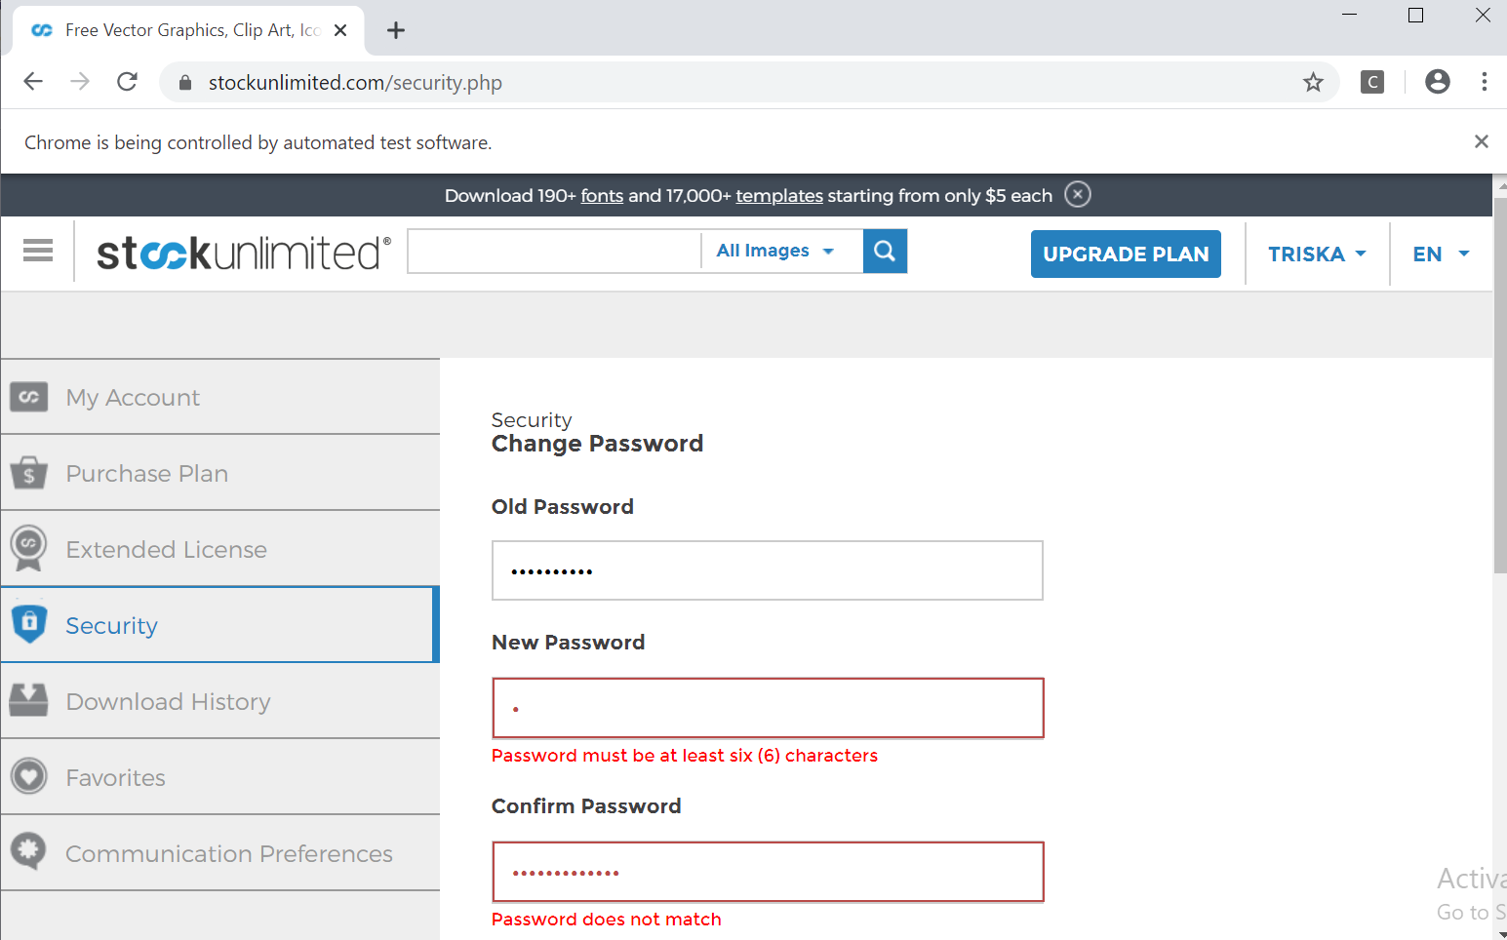

* Test Report

### **Fungsi Security**

### **Scenario**

|  |  |
| --- | --- |
| **Scenario** | **Description** |
| Open Browser | Alamat yang dituju adalah:  https://www.stockunlimited.com/ |
| Click Element | User mengklik elemen *link* “Login” |
| Input Text | User memasukkan *username* pada *text field* |
| Input Password | User memasukkan password pada *text field* |
| Click Element | User mengklik *button* Login |
| Click Element | User mengklik *button* nama account |
| Click Element | User mengklik *button* Select “Security” |
| Input Password | User memasukkan old password pada *text field* |
| Input Password | User memasukkan new password pada *text field* |
| Input Password | User memasukkan confirm password pada *text field* |
| Click Element | User mengklik *button* “Save” |

* **Test Frame**

|  |  |  |  |
| --- | --- | --- | --- |
| **No.** | **Old Password** | **New Password** | **Confirm Password** |
| 1 | Password Valid | Password Valid | Password Valid |
| 2 | Password Valid | Password Invalid | Password Invalid |
| 3 | Password Valid | Password Valid | Password Invalid |
| 4 | Password Invalid | Password Invalid | Password Invalid |
| 5 | Password Valid | Password Invalid | Password Valid |
| 6 | Password Invalid | Password Valid | Password Valid |
| 7 | Password Invalid | Password Invalid | Password Valid |
| 8 | Password Invalid | Password Valid | Password Invalid |

* **Test Fungsi FifthStockUnlimited.v5**



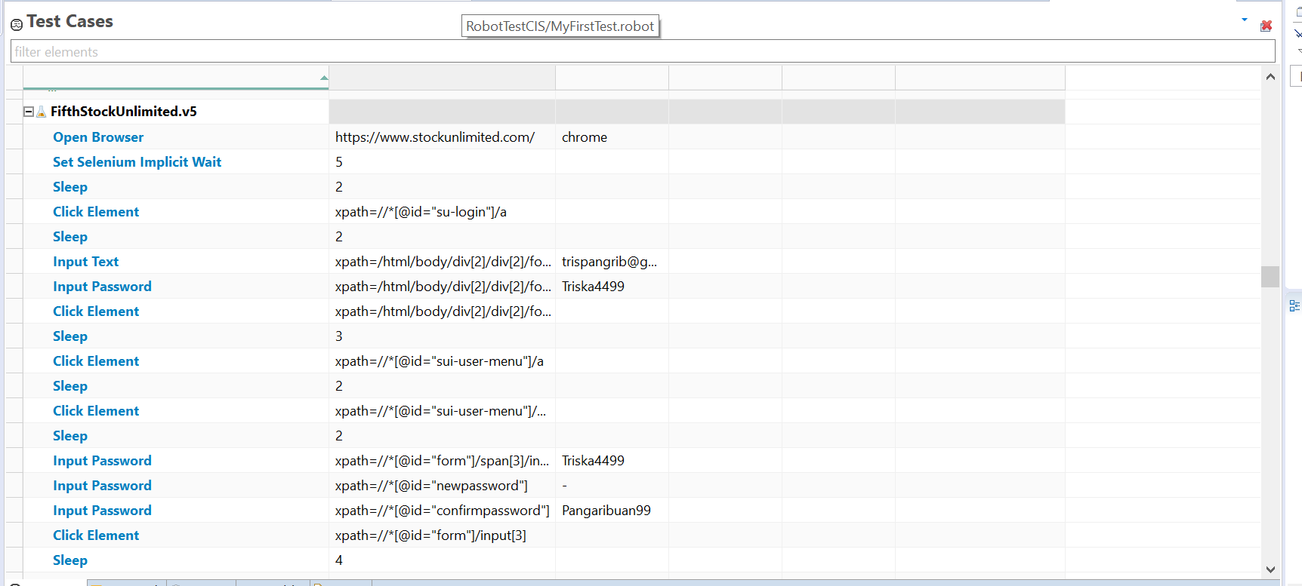

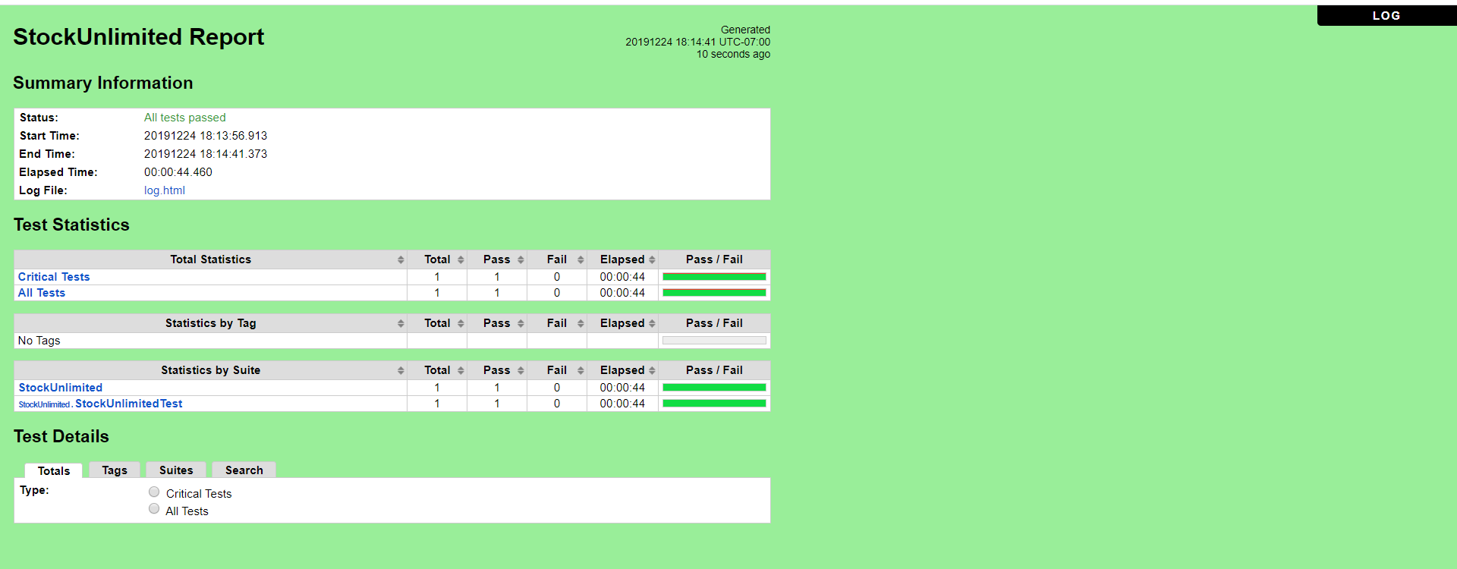

f. **FifthStockUnlimited.v6** (Old Password Invalid, New Password Valid, Confirm Password Valid)

* Scenario

**Open Browser** https://www.stockunlimited.com/ chrome

**Set Selenium Implicit Wait** 5

**Sleep** 2

**Click Element** xpath=//*[@id="su-login"]/a

**Sleep** 2

**Input Text** xpath=/html/body/div[2]/div[2]/form/span[2]/input trispangrib@gmail.com

**Input Password** xpath=/html/body/div[2]/div[2]/form/span[3]/input Triska4499

**Click Element** xpath=/html/body/div[2]/div[2]/form/input[4]

**Sleep** 3

**Click Element** xpath=//*[@id="sui-user-menu"]/a

**Sleep** 2

**Click Element** xpath=//*[@id="sui-user-menu"]/div/a[4]

**Sleep** 2

**Input Password** xpath=//*[@id="form"]/span[3]/input jika

**Input Password** xpath=//*[@id="newpassword"] Pangaribuan99

**Input Password** xpath=//*[@id="confirmpassword"] Pangaribuan99

**Click Element** xpath=//*[@id="form"]/input[3]

**Sleep** 4

**Close Browser**

**Log** Test Completed

* Snippet Browser saat Testing
* 







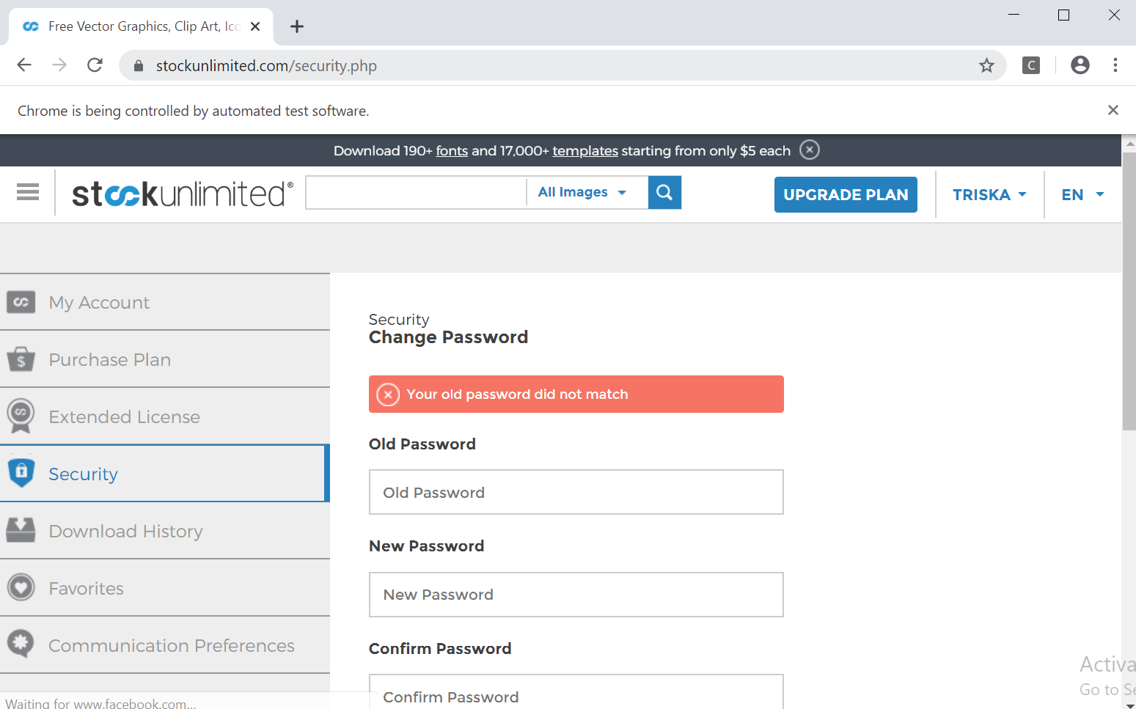

* Test Report

### **Fungsi Security**

### **Scenario**

|  |  |
| --- | --- |
| **Scenario** | **Description** |
| Open Browser | Alamat yang dituju adalah:  https://www.stockunlimited.com/ |
| Click Element | User mengklik elemen *link* “Login” |
| Input Text | User memasukkan *username* pada *text field* |
| Input Password | User memasukkan password pada *text field* |
| Click Element | User mengklik *button* Login |
| Click Element | User mengklik *button* nama account |
| Click Element | User mengklik *button* Select “Security” |
| Input Password | User memasukkan old password pada *text field* |
| Input Password | User memasukkan new password pada *text field* |
| Input Password | User memasukkan confirm password pada *text field* |
| Click Element | User mengklik *button* “Save” |

* **Test Frame**

|  |  |  |  |
| --- | --- | --- | --- |
| **No.** | **Old Password** | **New Password** | **Confirm Password** |
| 1 | Password Valid | Password Valid | Password Valid |
| 2 | Password Valid | Password Invalid | Password Invalid |
| 3 | Password Valid | Password Valid | Password Invalid |
| 4 | Password Invalid | Password Invalid | Password Invalid |
| 5 | Password Valid | Password Invalid | Password Valid |
| 6 | Password Invalid | Password Valid | Password Valid |
| 7 | Password Invalid | Password Invalid | Password Valid |
| 8 | Password Invalid | Password Valid | Password Invalid |

**Test Fungsi FifthStockUnlimited.v6**



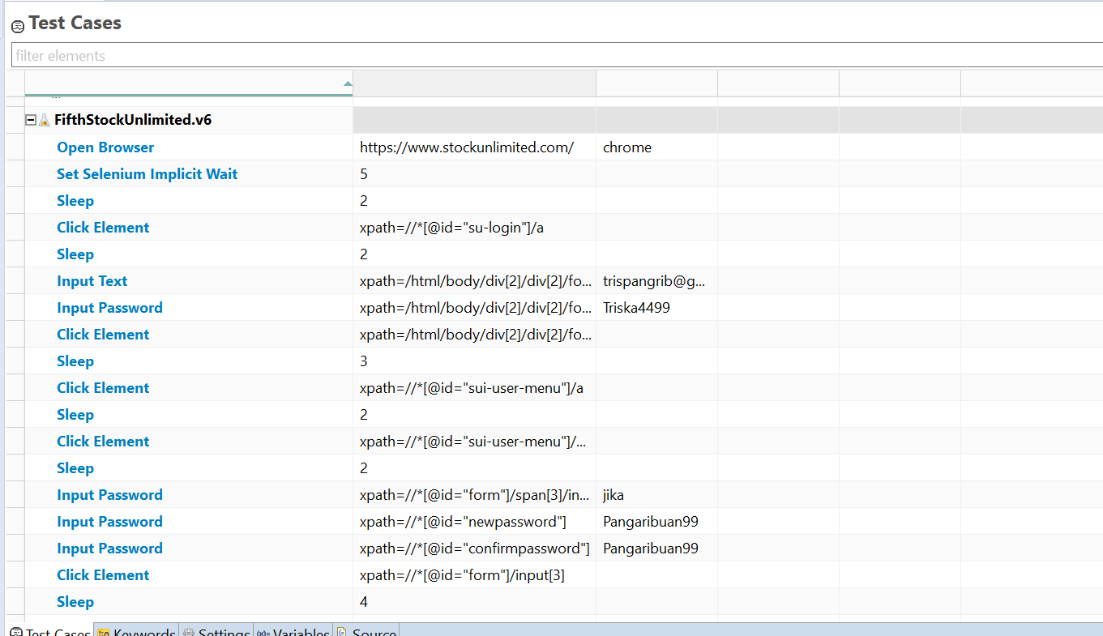

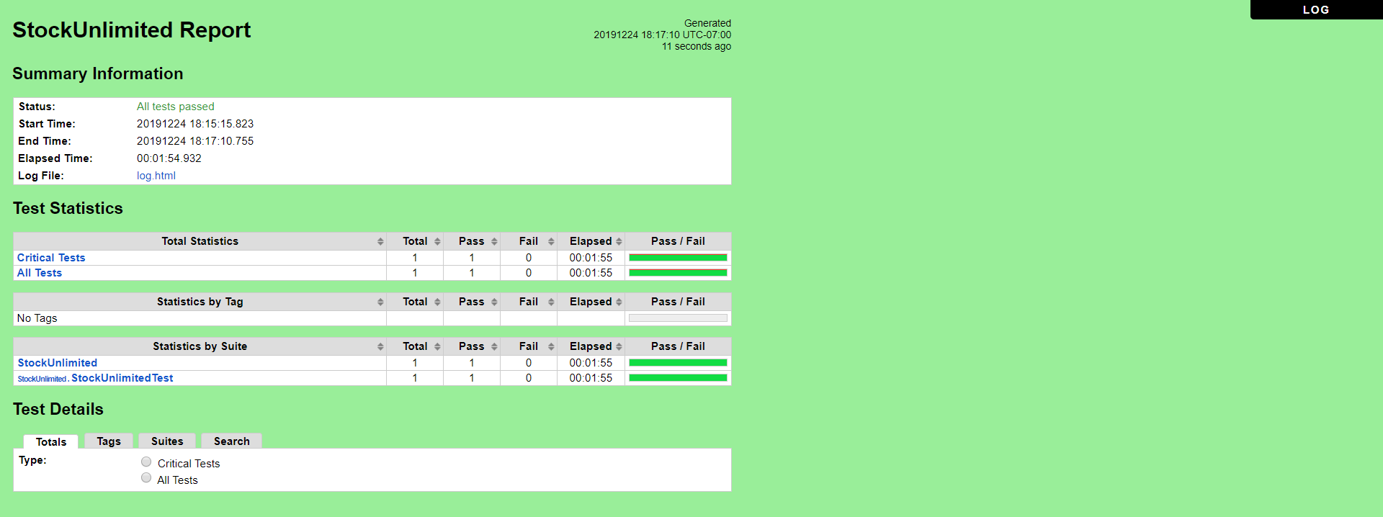

g. **FifthStockUnlimited.v7** (Old Password Invalid, New Password Invalid, Confirm Password Valid)

* Scenario

**Open Browser** https://www.stockunlimited.com/ chrome

**Set Selenium Implicit Wait** 5

**Sleep** 2

**Click Element** xpath=//*[@id="su-login"]/a

**Sleep** 2

**Input Text** xpath=/html/body/div[2]/div[2]/form/span[2]/input trispangrib@gmail.com

**Input Password** xpath=/html/body/div[2]/div[2]/form/span[3]/input Triska4499

**Click Element** xpath=/html/body/div[2]/div[2]/form/input[4]

**Sleep** 3

**Click Element** xpath=//*[@id="sui-user-menu"]/a

**Sleep** 2

**Click Element** xpath=//*[@id="sui-user-menu"]/div/a[4]

**Sleep** 2

**Input Password** xpath=//*[@id="form"]/span[3]/input jika

**Input Password** xpath=//*[@id="newpassword"] -

**Input Password** xpath=//*[@id="confirmpassword"] Pangaribuan99

**Click Element** xpath=//*[@id="form"]/input[3]

**Sleep** 4

**Close Browser**

**Log** Test Completed

* Snippet Browser saat Testing
* 







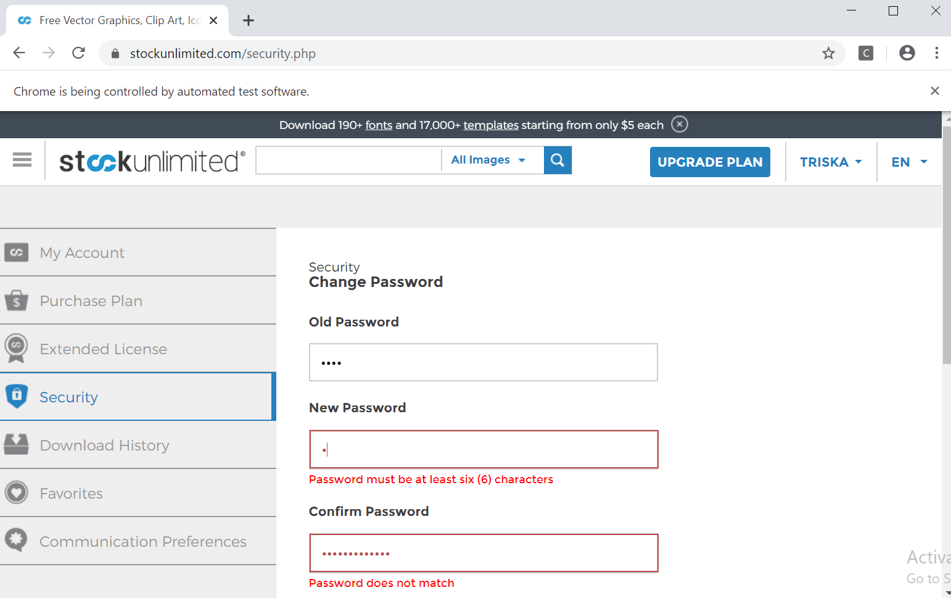

* Test Report

### **Fungsi Security**

### **Scenario**

|  |  |
| --- | --- |
| **Scenario** | **Description** |
| Open Browser | Alamat yang dituju adalah:  https://www.stockunlimited.com/ |
| Click Element | User mengklik elemen *link* “Login” |
| Input Text | User memasukkan *username* pada *text field* |
| Input Password | User memasukkan password pada *text field* |
| Click Element | User mengklik *button* Login |
| Click Element | User mengklik *button* nama account |
| Click Element | User mengklik *button* Select “Security” |
| Input Password | User memasukkan old password pada *text field* |
| Input Password | User memasukkan new password pada *text field* |
| Input Password | User memasukkan confirm password pada *text field* |
| Click Element | User mengklik *button* “Save” |

* **Test Frame**

|  |  |  |  |
| --- | --- | --- | --- |
| **No.** | **Old Password** | **New Password** | **Confirm Password** |
| 1 | Password Valid | Password Valid | Password Valid |
| 2 | Password Valid | Password Invalid | Password Invalid |
| 3 | Password Valid | Password Valid | Password Invalid |
| 4 | Password Invalid | Password Invalid | Password Invalid |
| 5 | Password Valid | Password Invalid | Password Valid |
| 6 | Password Invalid | Password Valid | Password Valid |
| 7 | Password Invalid | Password Invalid | Password Valid |
| 8 | Password Invalid | Password Valid | Password Invalid |

**Test Fungsi FifthStockUnlimited.v7**



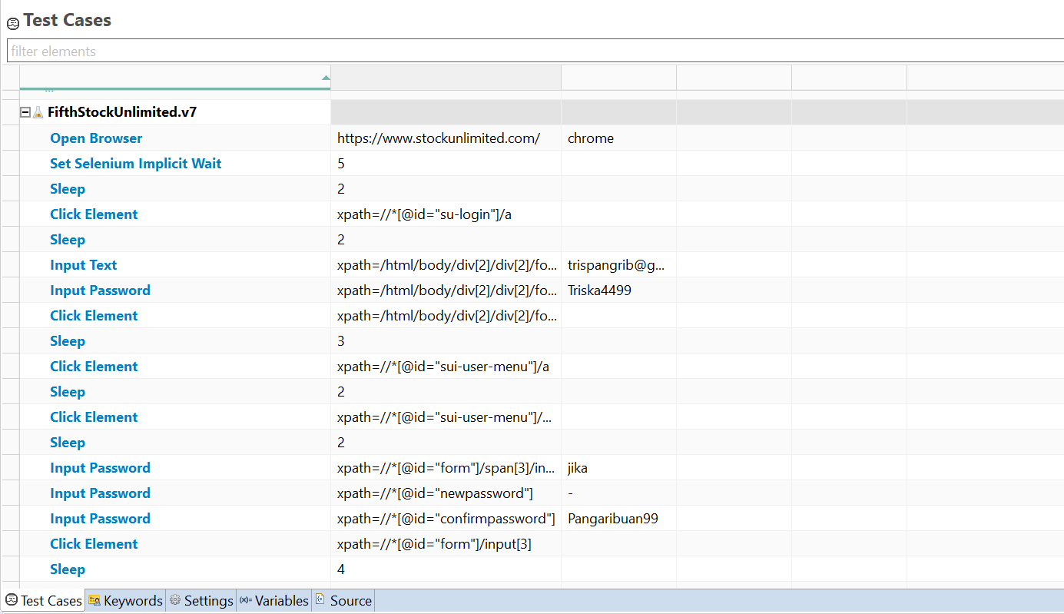

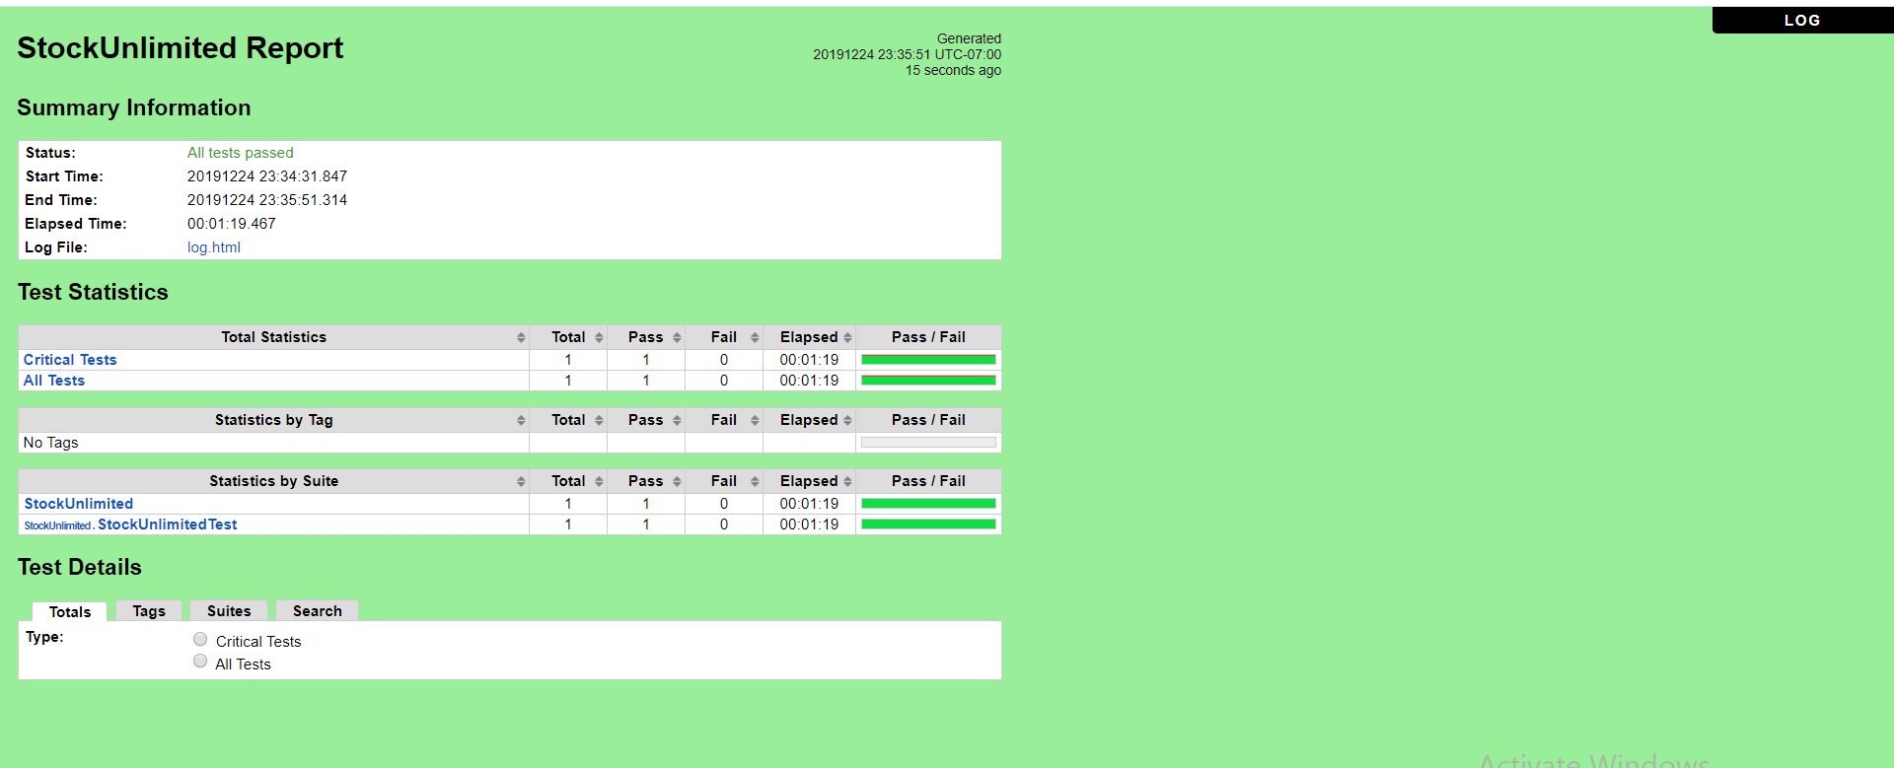

h. **FifthStockUnlimited.v8** (Old Password Invalid, New Password Valid , Confirm Password Invalid)

* Scenario

**Open Browser** https://www.stockunlimited.com/ chrome

**Set Selenium Implicit Wait** 5

**Sleep** 2

**Click Element** xpath=//*[@id="su-login"]/a

**Sleep** 2

**Input Text** xpath=/html/body/div[2]/div[2]/form/span[2]/input trispangrib@gmail.com

**Input Password** xpath=/html/body/div[2]/div[2]/form/span[3]/input Triska4499

**Click Element** xpath=/html/body/div[2]/div[2]/form/input[4]

**Sleep** 3

**Click Element** xpath=//*[@id="sui-user-menu"]/a

**Sleep** 2

**Click Element** xpath=//*[@id="sui-user-menu"]/div/a[4]

**Sleep** 2

**Input Password** xpath=//*[@id="form"]/span[3]/input -

**Input Password** xpath=//*[@id="newpassword"] Pangaribuan99

**Input Password** xpath=//*[@id="confirmpassword"] -

**Click Element** xpath=//*[@id="form"]/input[3]

**Sleep** 4

**Close Browser**

**Log** Test Completed

* Snippet Browser saat Testing
* 







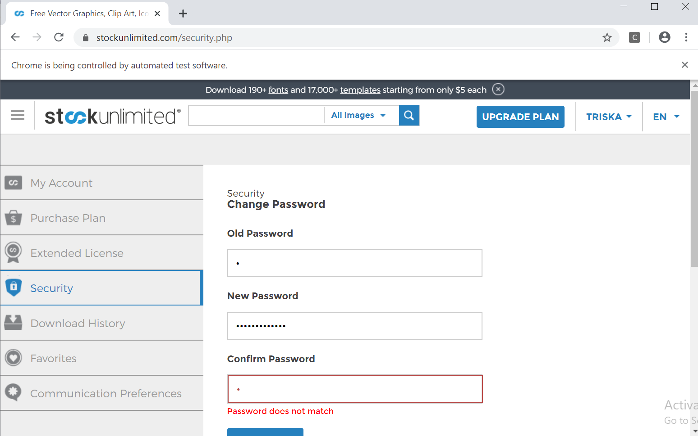

* Test Report

### **Fungsi Security**

### **Scenario**

|  |  |
| --- | --- |
| **Scenario** | **Description** |
| Open Browser | Alamat yang dituju adalah:  https://www.stockunlimited.com/ |
| Click Element | User mengklik elemen *link* “Login” |
| Input Text | User memasukkan *username* pada *text field* |
| Input Password | User memasukkan password pada *text field* |
| Click Element | User mengklik *button* Login |
| Click Element | User mengklik *button* nama account |
| Click Element | User mengklik *button* Select “Security” |
| Input Password | User memasukkan old password pada *text field* |
| Input Password | User memasukkan new password pada *text field* |
| Input Password | User memasukkan confirm password pada *text field* |
| Click Element | User mengklik *button* “Save” |

* **Test Frame**

|  |  |  |  |
| --- | --- | --- | --- |
| **No.** | **Old Password** | **New Password** | **Confirm Password** |
| 1 | Password Valid | Password Valid | Password Valid |
| 2 | Password Valid | Password Invalid | Password Invalid |
| 3 | Password Valid | Password Valid | Password Invalid |
| 4 | Password Invalid | Password Invalid | Password Invalid |
| 5 | Password Valid | Password Invalid | Password Valid |
| 6 | Password Invalid | Password Valid | Password Valid |
| 7 | Password Invalid | Password Invalid | Password Valid |
| 8 | Password Invalid | Password Valid | Password Invalid |

* **Test Fungsi FifthStockUnlimited.v8**



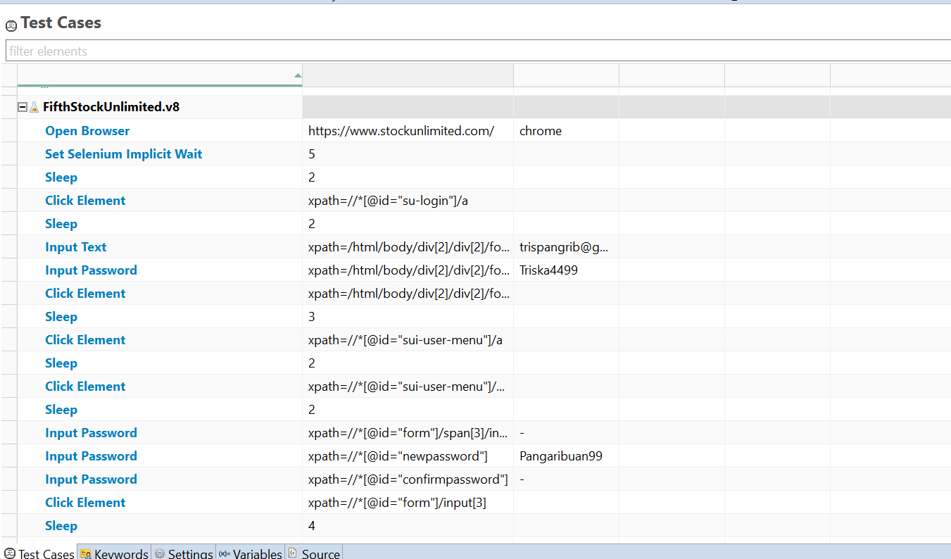

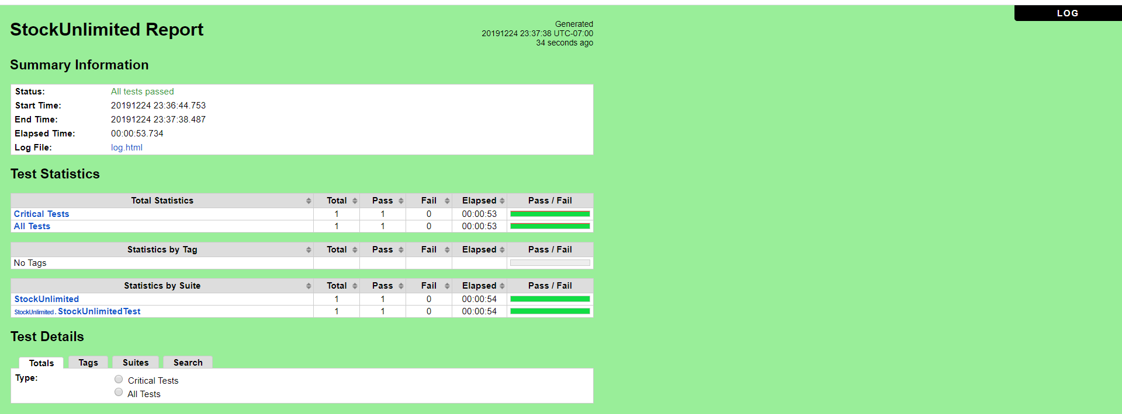

### Fungsi FIND OUT MORE

a. **ButtonOneStockUnlimited** (FIND OUT MORE)

* Scenario

**Open Browser** https://www.stockunlimited.com/ chrome

**Set Selenium Implicit Wait** 5

**Sleep** 2

**Click Element** xpath=//*[@id="su-login"]/a

**Sleep** 2

**Input Text** xpath=/html/body/div[2]/div[2]/form/span[2]/input trispangrib@gmail.com

**Input Password** xpath=/html/body/div[2]/div[2]/form/span[3]/input Triska4499

**Click Element** xpath=/html/body/div[2]/div[2]/form/input[4]

**Sleep** 2

**Click Element** xpath=//*[@id="sueditor-more"]

**Sleep** 4

**Close Browser**

**Log** Test Completed

* Snippet Browser saat Testing







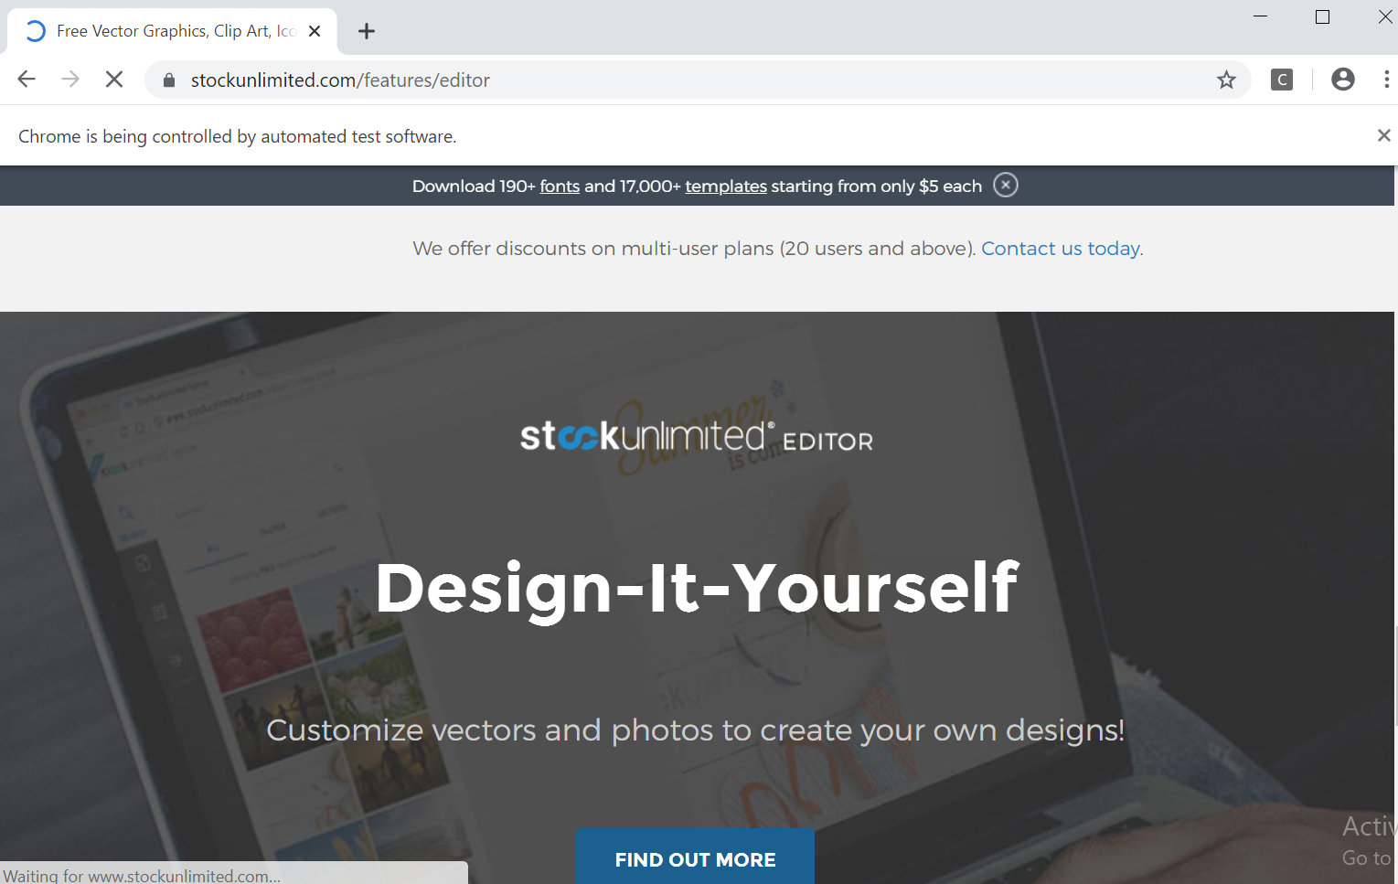

* Test Report

### **Fungsi FIND OUT MORE**

**Scenario**

|  |  |
| --- | --- |
| **Scenario** | **Description** |
| Open Browser | Alamat yang dituju adalah:  https://www.stockunlimited.com/ |
| Click Element | User mengklik elemen *link* “Login” |
| Input Text | User memasukkan *username* pada *text field* |
| Input Password | User memasukkan password pada *text field* |
| Click Element | User mengklik *button* Login |
| Click Element | Untuk mengklik *button* FIND OUT MORE |

* **Test Frame**

| **No** | **Searching** |
| --- | --- |
| 1 | Button FIND OUT MORE Valid |

* **Test Fungsi ButtonOneStockUnlimited**



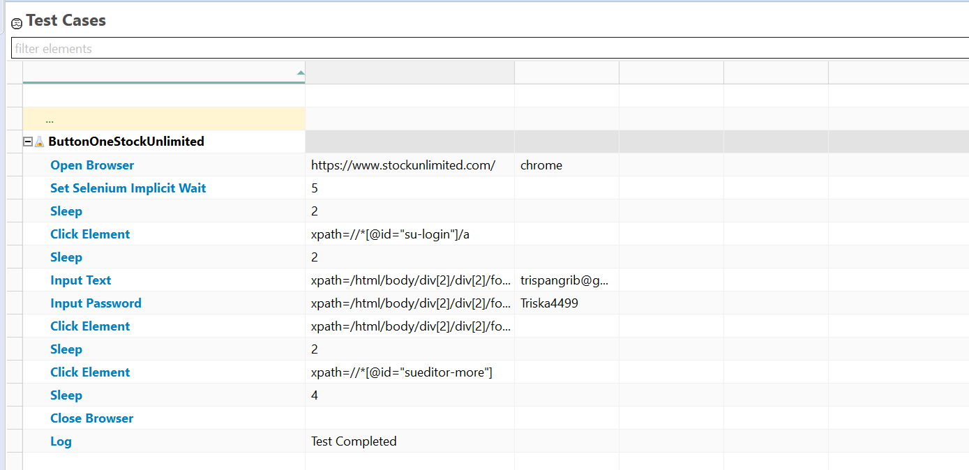

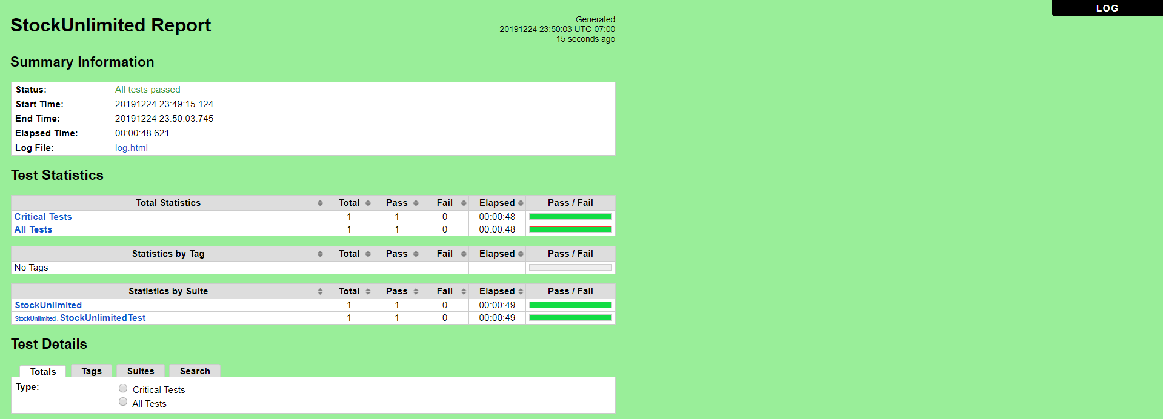

### Fungsi New Images

a. **ButtonTwoStockUnlimited** (New Images)

* Scenario

**Open Browser** https://www.stockunlimited.com/ chrome

**Set Selenium Implicit Wait** 5

**Click Element** xpath=//*[@id="su-login"]/a

**Sleep** 2

**Input Text** xpath=/html/body/div[2]/div[2]/form/span[2]/input trispangrib@gmail.com

**Input Password** xpath=/html/body/div[2]/div[2]/form/span[3]/input Triska4499

**Click Element** xpath=/html/body/div[2]/div[2]/form/input[4]

**Sleep** 2

**Click Element** xpath=/html/body/div[5]/div/div/div[2]/a[1]

**Sleep** 4

**Close Browser**

**Log** Test Completed

* Snippet Browser saat Testing







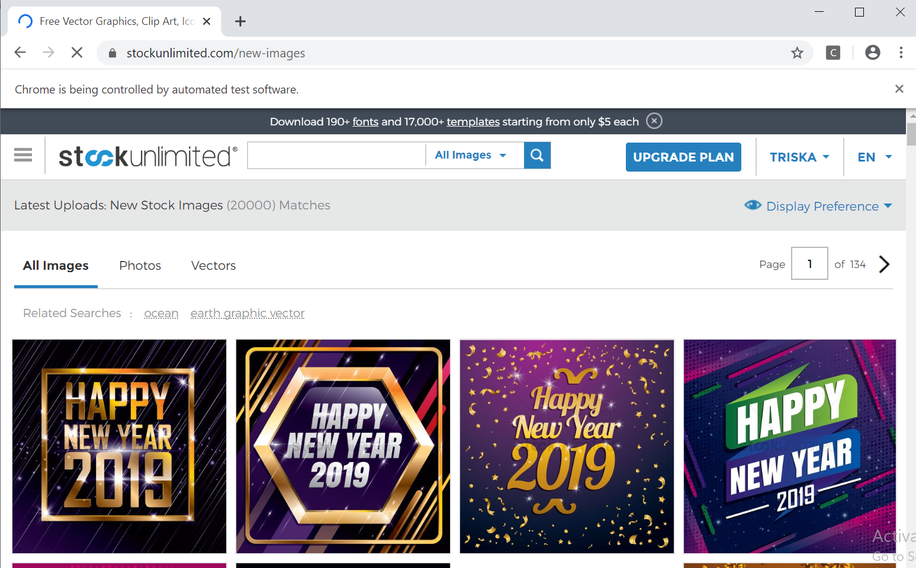

* Test Report

### **Fungsi New Images**

**Scenario**

|  |  |
| --- | --- |
| **Scenario** | **Description** |
| Open Browser | Alamat yang dituju adalah:  https://www.stockunlimited.com/ |
| Click Element | User mengklik elemen *link* “Login” |
| Input Text | User memasukkan *username* pada *text field* |
| Input Password | User memasukkan password pada *text field* |
| Click Element | User mengklik *button* Login |
| Click Element | Untuk mengklik *button* New Images |

* **Test Frame**

| **No** | **Searching** |
| --- | --- |
| 1 | Button New Images Valid |

**Test Fungsi ButtonTwoStockUnlimited**



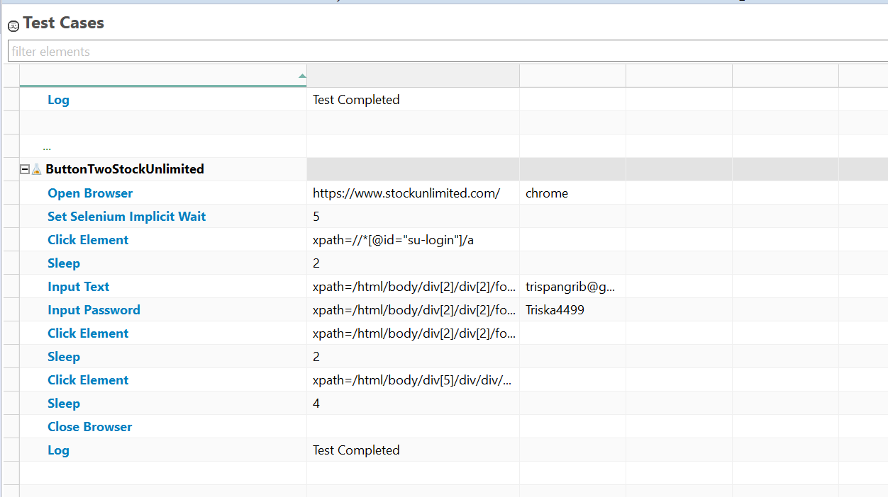

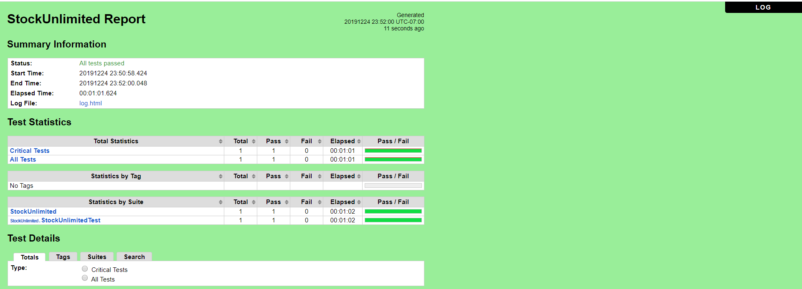

### Fungsi SEE PLANS & PRICING

a. **ButtonThreeStockUnlimited** (SEE PLANS & PRICING)

* Scenario

**Open Browser** https://www.stockunlimited.com/ chrome

**Set Selenium Implicit Wait** 5

**Click Element** xpath=//*[@id="su-login"]/a

**Sleep** 2

**Input Text** xpath=/html/body/div[2]/div[2]/form/span[2]/input trispangrib@gmail.com

**Input Password** xpath=/html/body/div[2]/div[2]/form/span[3]/input Triska4499

**Click Element** xpath=/html/body/div[2]/div[2]/form/input[4]

**Sleep** 2

**Click Element** xpath=/html/body/div[4]/div/span

**Sleep** 4

**Close Browser**

**Log** Test Completed

* Snippet Browser saat Testing







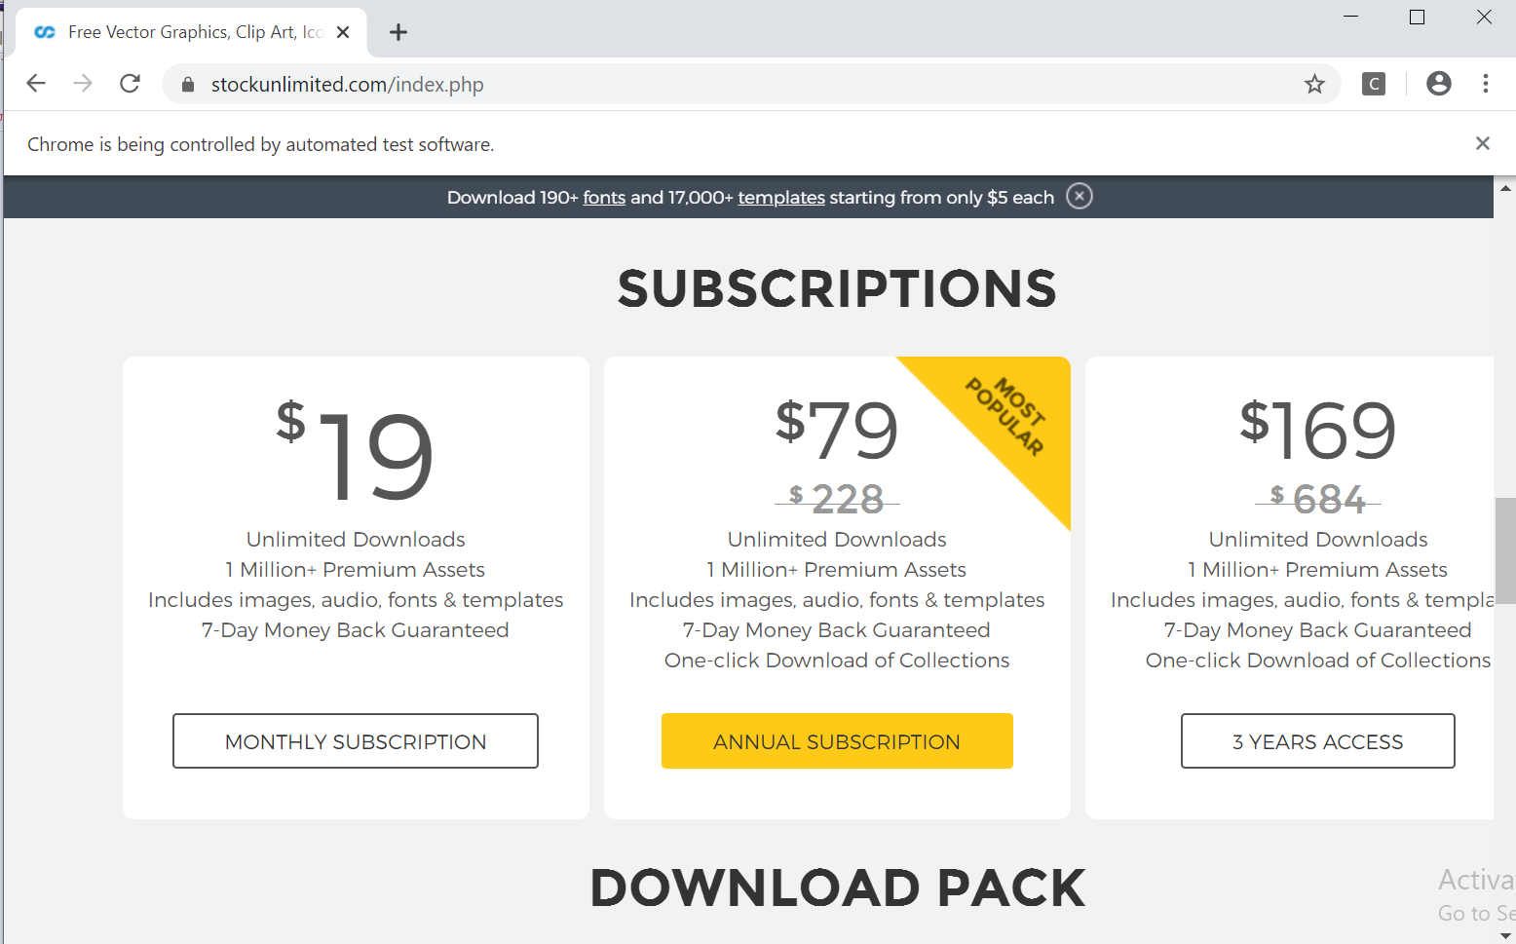

* Test Report

### **Fungsi SEE PLANS & PRICING**

### **Scenario**

|  |  |
| --- | --- |
| **Scenario** | **Description** |
| Open Browser | Alamat yang dituju adalah:  https://www.stockunlimited.com/ |
| Click Element | User mengklik elemen *link* “Login” |
| Input Text | User memasukkan *username* pada *text field* |
| Input Password | User memasukkan password pada *text field* |
| Click Element | User mengklik *button* Login |
| Click Element | Untuk mengklik *button* SEE PLANS & PRICING |

* **Test Frame**

| **No** | **Searching** |
| --- | --- |
| 1 | Button SEE PLANS & PRICING Valid |

**Test Fungsi ButtonThreeStockUnlimited**



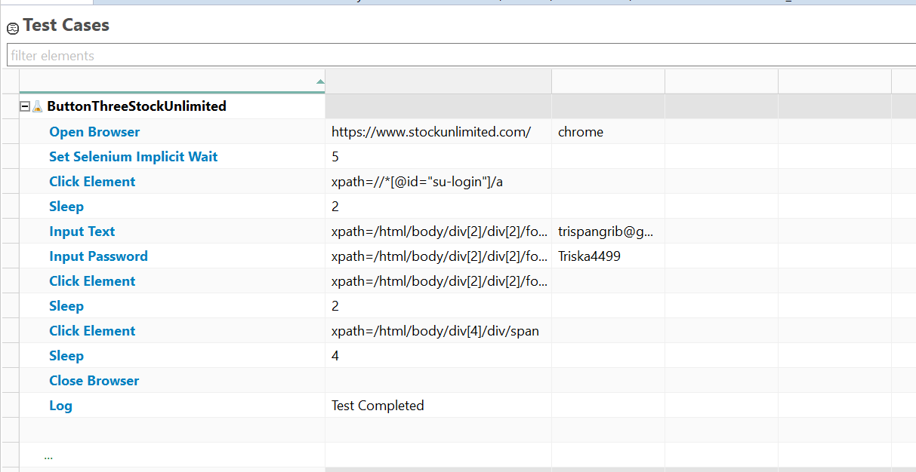

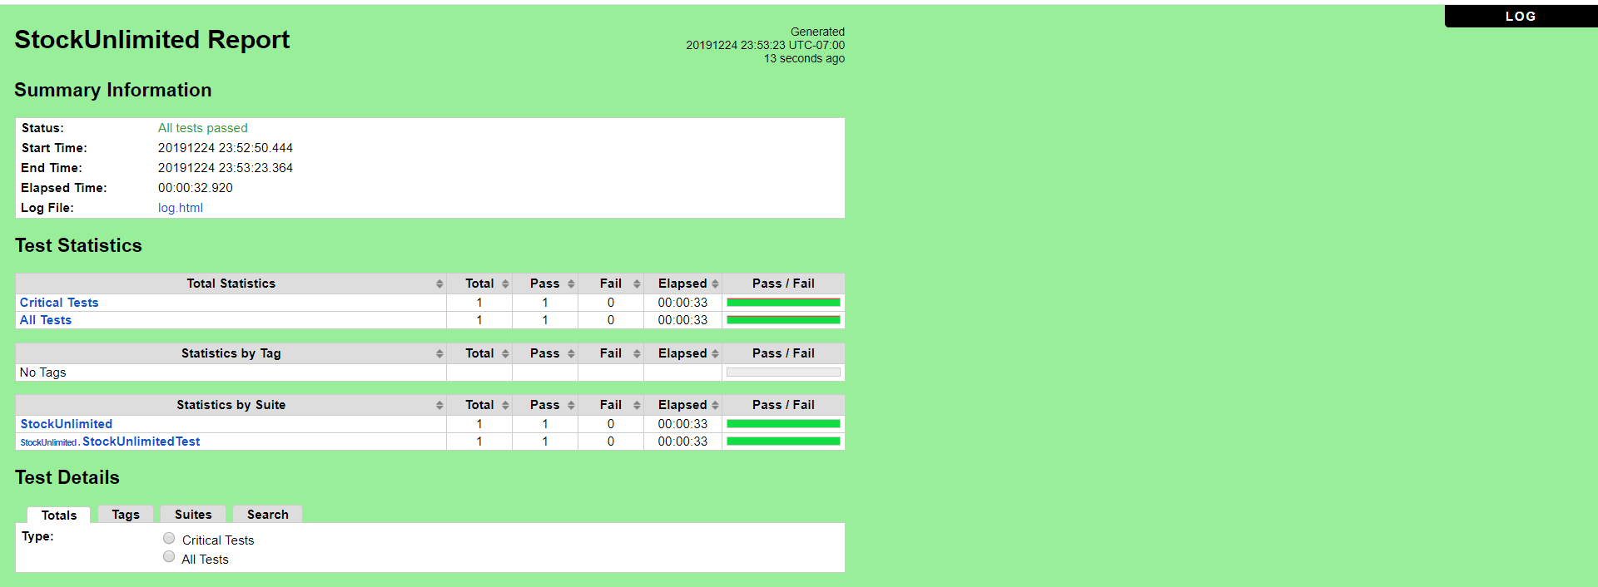

### Fungsi My Account

a. **ButtonFourStockUnlimited** (My Account)

* Scenario

**Open Browser** https://www.stockunlimited.com/ chrome

**Set Selenium Implicit Wait** 5

**Click Element** xpath=//*[@id="su-login"]/a

**Sleep** 2

**Input Text** xpath=/html/body/div[2]/div[2]/form/span[2]/input trispangrib@gmail.com

**Input Password** xpath=/html/body/div[2]/div[2]/form/span[3]/input Triska4499

**Click Element** xpath=/html/body/div[2]/div[2]/form/input[4]

**Sleep** 2

**Click Element** xpath=//*[@id="sui-user-menu"]/a

**Click Element** xpath=//*[@id="sui-user-menu"]/div/a[1]

**Sleep** 4

**Close Browser**

**Log** Test Completed

* Snippet Browser saat Testing
* 
* 
* 

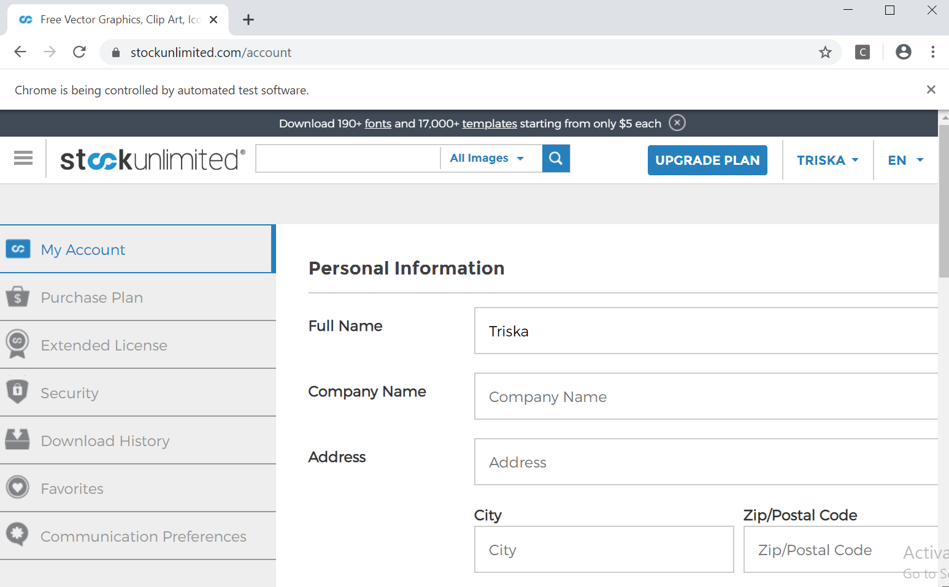

* Test Report

### **Fungsi My Account**

### **Scenario**

|  |  |
| --- | --- |
| **Scenario** | **Description** |
| Open Browser | Alamat yang dituju adalah:  https://www.stockunlimited.com/ |
| Click Element | User mengklik elemen *link* “Login” |
| Input Text | User memasukkan *username* pada *text field* |
| Input Password | User memasukkan password pada *text field* |
| Click Element | User mengklik *button* Login |
| Click Element | Untuk mengklik *button* My Account |

* **Test Frame**

| **No** | **Searching** |
| --- | --- |
| 1 | Button My Account Valid |

**Test Fungsi ButtonFourStockUnlimited**



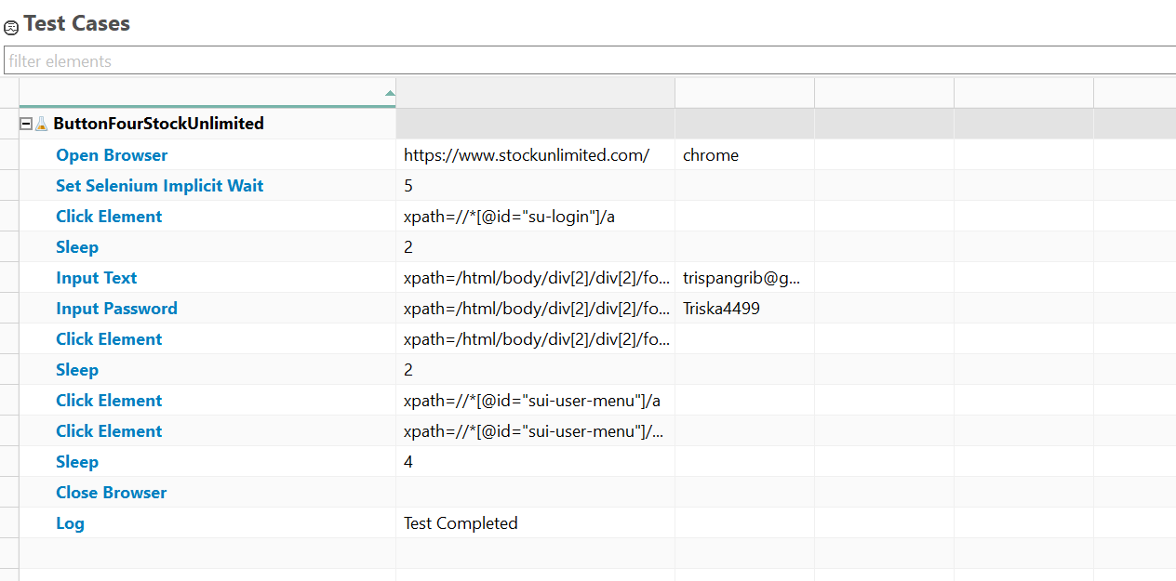

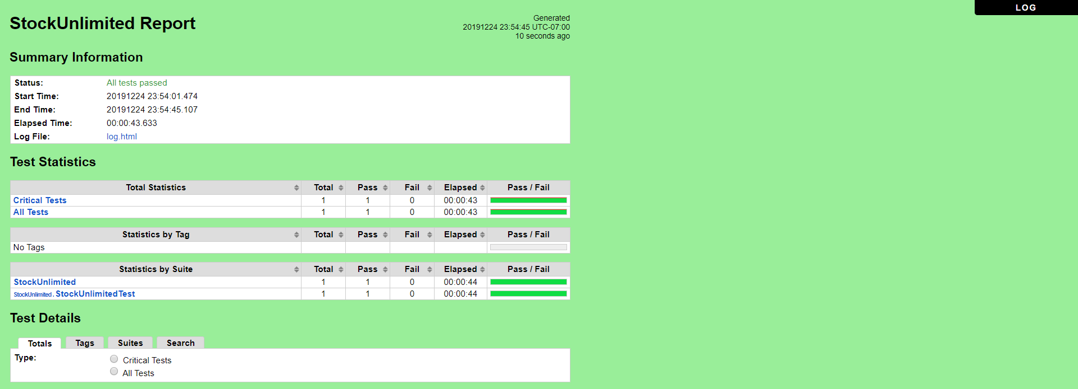

### Fungsi Favorites

a. **ButtonFiveStockUnlimited** (Favorites)

* Scenario

**Open Browser** https://www.stockunlimited.com/ chrome

**Set Selenium Implicit Wait** 5

**Click Element** xpath=//*[@id="su-login"]/a

**Sleep** 2

**Input Text** xpath=/html/body/div[2]/div[2]/form/span[2]/input trispangrib@gmail.com

**Input Password** xpath=/html/body/div[2]/div[2]/form/span[3]/input Triska4499

**Click Element** xpath=/html/body/div[2]/div[2]/form/input[4]

**Sleep** 2

**Click Element** xpath=//*[@id="sui-user-menu"]/a

**Click Element** xpath=//*[@id="sui-user-menu"]/div/a[6]

**Sleep** 4

**Close Browser**

**Log** Test Completed

* Snippet Browser saat Testing
* 
* 
* 

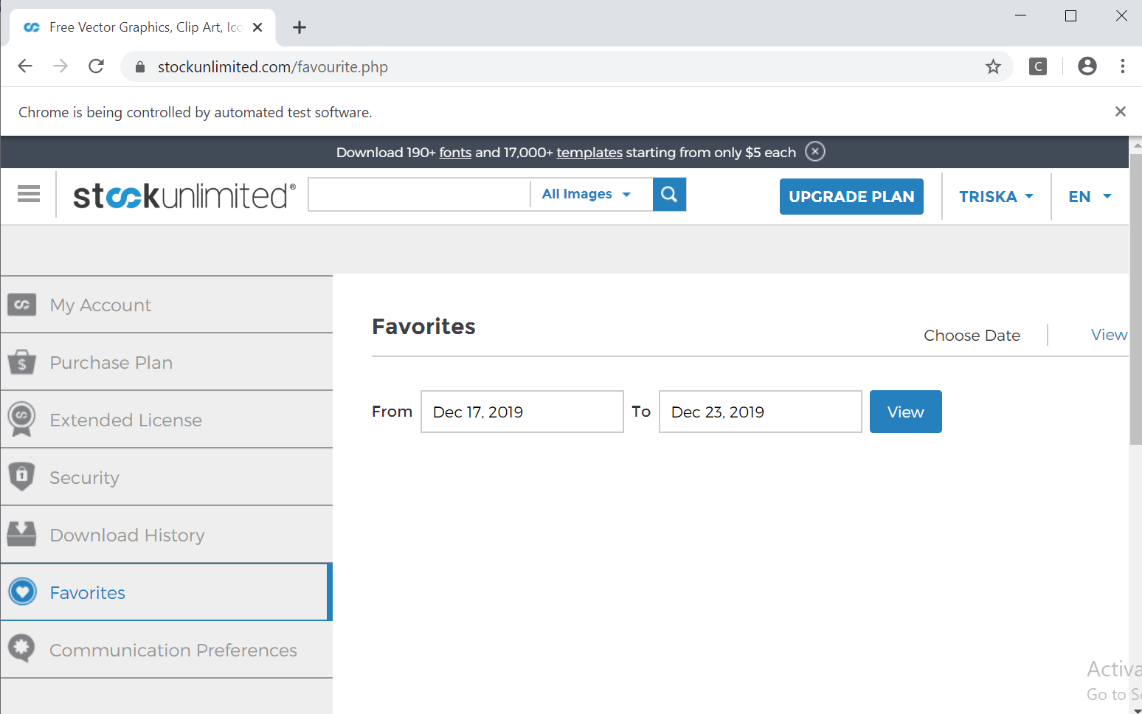

* Test Report

### **Fungsi Favorites**

### **Scenario**

|  |  |
| --- | --- |
| **Scenario** | **Description** |
| Open Browser | Alamat yang dituju adalah:  https://www.stockunlimited.com/ |
| Click Element | User mengklik elemen *link* “Login” |
| Input Text | User memasukkan *username* pada *text field* |
| Input Password | User memasukkan password pada *text field* |
| Click Element | User mengklik *button* Login |
| Click Element | Untuk mengklik *button* Favorites |

**Test Frame**

| **No** | **Searching** |
| --- | --- |
| 1 | Button Favorites Valid |

**Test Fungsi ButtonFiveStockUnlimited**



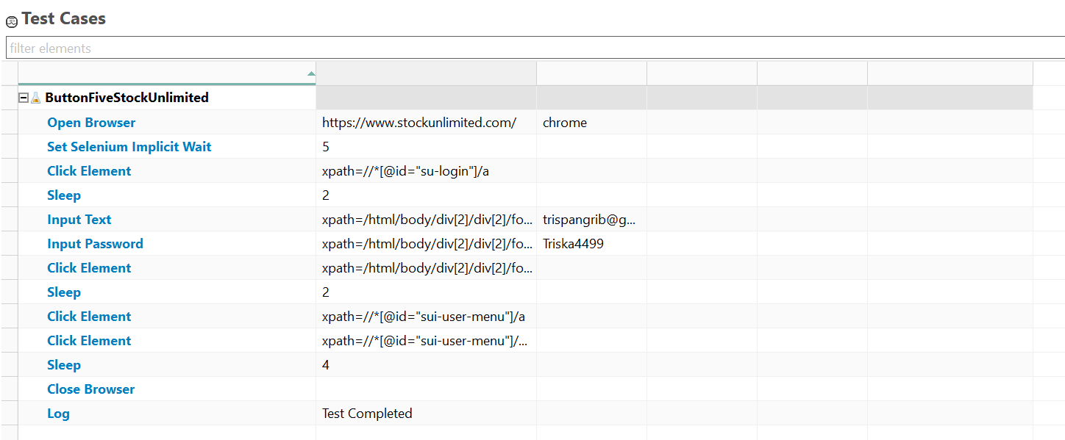

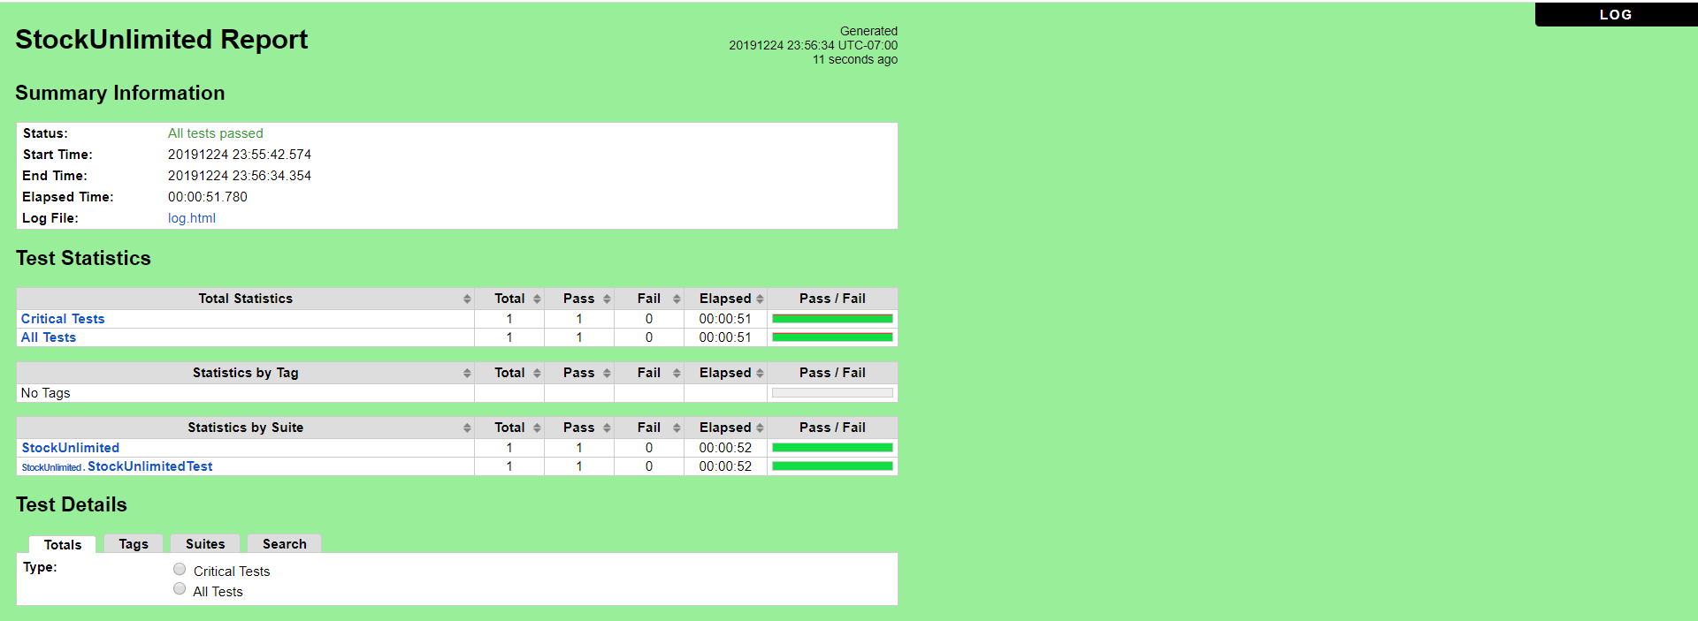

# **Kesimpulan**

### Cucumber

Cucumber adalah *software* yang digunakan oleh programmer untuk menguji *software* lainnya (dalam hal ini kami melakukan pengujian terhadap aplikasi StockUnlimited). Cucumber menjalankan tes penerimaan otomatis yang ditulis dalam *behaviour-driven development* (BDD). Dengan menggunkan bahasa Gherkin, Cucumber memungkinkan *software* behaviour dispesiffikasikan dalam bahasa yang logis yang dapat dioahami oleh customer. Tes Cucumber dibagi menjadi beberapa fitur-fitur dan fitur-fitur ini dabagi menjadi beberapa skenario, yang merupakan urutan tahapan testing. Sebelum Cucumber dapat melakukan tahapan-tahapan tersebu, tahapan tersebut harus didefinisian terleih dahulu melalui definisi tahapan (*smoke test*), bagaimana tahapan tersebut dilakukan.

Kami telah melakukan pengujian terhadap beberapa fitur (*login*, *security*, beberapa fitur search, dan button) pada aplikasi StockUnlimited ini dengan kasus uji yang berbeda-beda. Hal ini kami lakukan untuk memastikan bahwa aplikasi ini apakah sudah sesuai dengan kebutuhan (yang diharapkan) atau belum. Jadi, berdasarkan pengujian yang telah kami lakukan terhadap beberapa fitur (*login*, *security*, beberapa fitur search, dan button) pada aplikasi StockUnlimited ini kami mendapatkan hasil yang sesuai dengan yang kami harapkan (kebutuhan).

### Robot Framework

Robot Framework merupakan sebuah proses otomatisasi pada kerangka uji yang kita lakukan yang open source untuk acceptance testing dengan menggunakan pendekatan *Acceptance Test Driven Development* (ATDD) dan dalam hal ini kami melakukan pengujian terhadap aplikasi StockUnlimited. Robot Framework ini sendiri ditulis dengan menggunakan Bahasa pemograman Python yang dengan menggunakan teks editor seperti Eclipse, IntelliJ, dll. Robot framework juga memberikan result yang dapat kita lihat dengan jelas pada result.xml, report.html, dan log.html.

Dan disini kami telah melakukan pengujian terhadap beberapa fitur , seperti login, security, beberapa fitur search, dan button pada aplikasi StockUnlimited dengan kasus uji yang bervariasi. Hal ini kami lakukan untuk memastikan bahwa aplikasi ini apakah sudah sesuai dengan kebutuhan (yang diharapkan) atau belum. Jadi, berdasarkan pengujian yang telah kami lakukan terhadap beberapa fitur (*login*, *security*, beberapa fitur search, dan button) pada aplikasi StockUnlimited ini kami mendapatkan hasil yang sesuai dengan yang kami harapkan (kebutuhan).